

HiWind 2024 Structural Analysis
Andrew Carlile
4/30/2024
A substantial change was made in February 2024. Changes to the FEA Upper Gondola analysis were: adding the tri-plate, adding all the panels, changing the Margin of Safety Calculation, and an update to the dummy masses including their shape and not just the mass override. In March 2024 the dummy mass models were removed and replaced by remote masses. The total masses were increased slightly. The Starlink antennae estimate was added, and the results are below.

Drawing Requirements

1.Drawings shall show the relative locations and dimensions of all structural and load-bearing gondola members
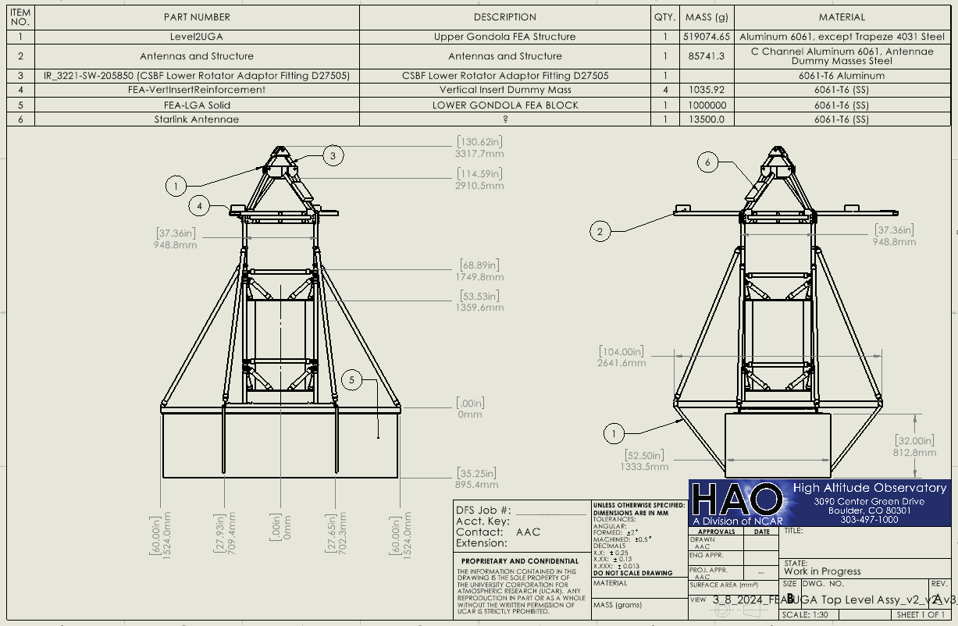
The observatory viewports need to be considered keep out zones for NASA and HAO. Clearance between the baffle tube and other structures should be 6 inch away from the ends of the four baffle tubes and 10 inch behind the ends to avoid scattering light. Dimensions in inches.
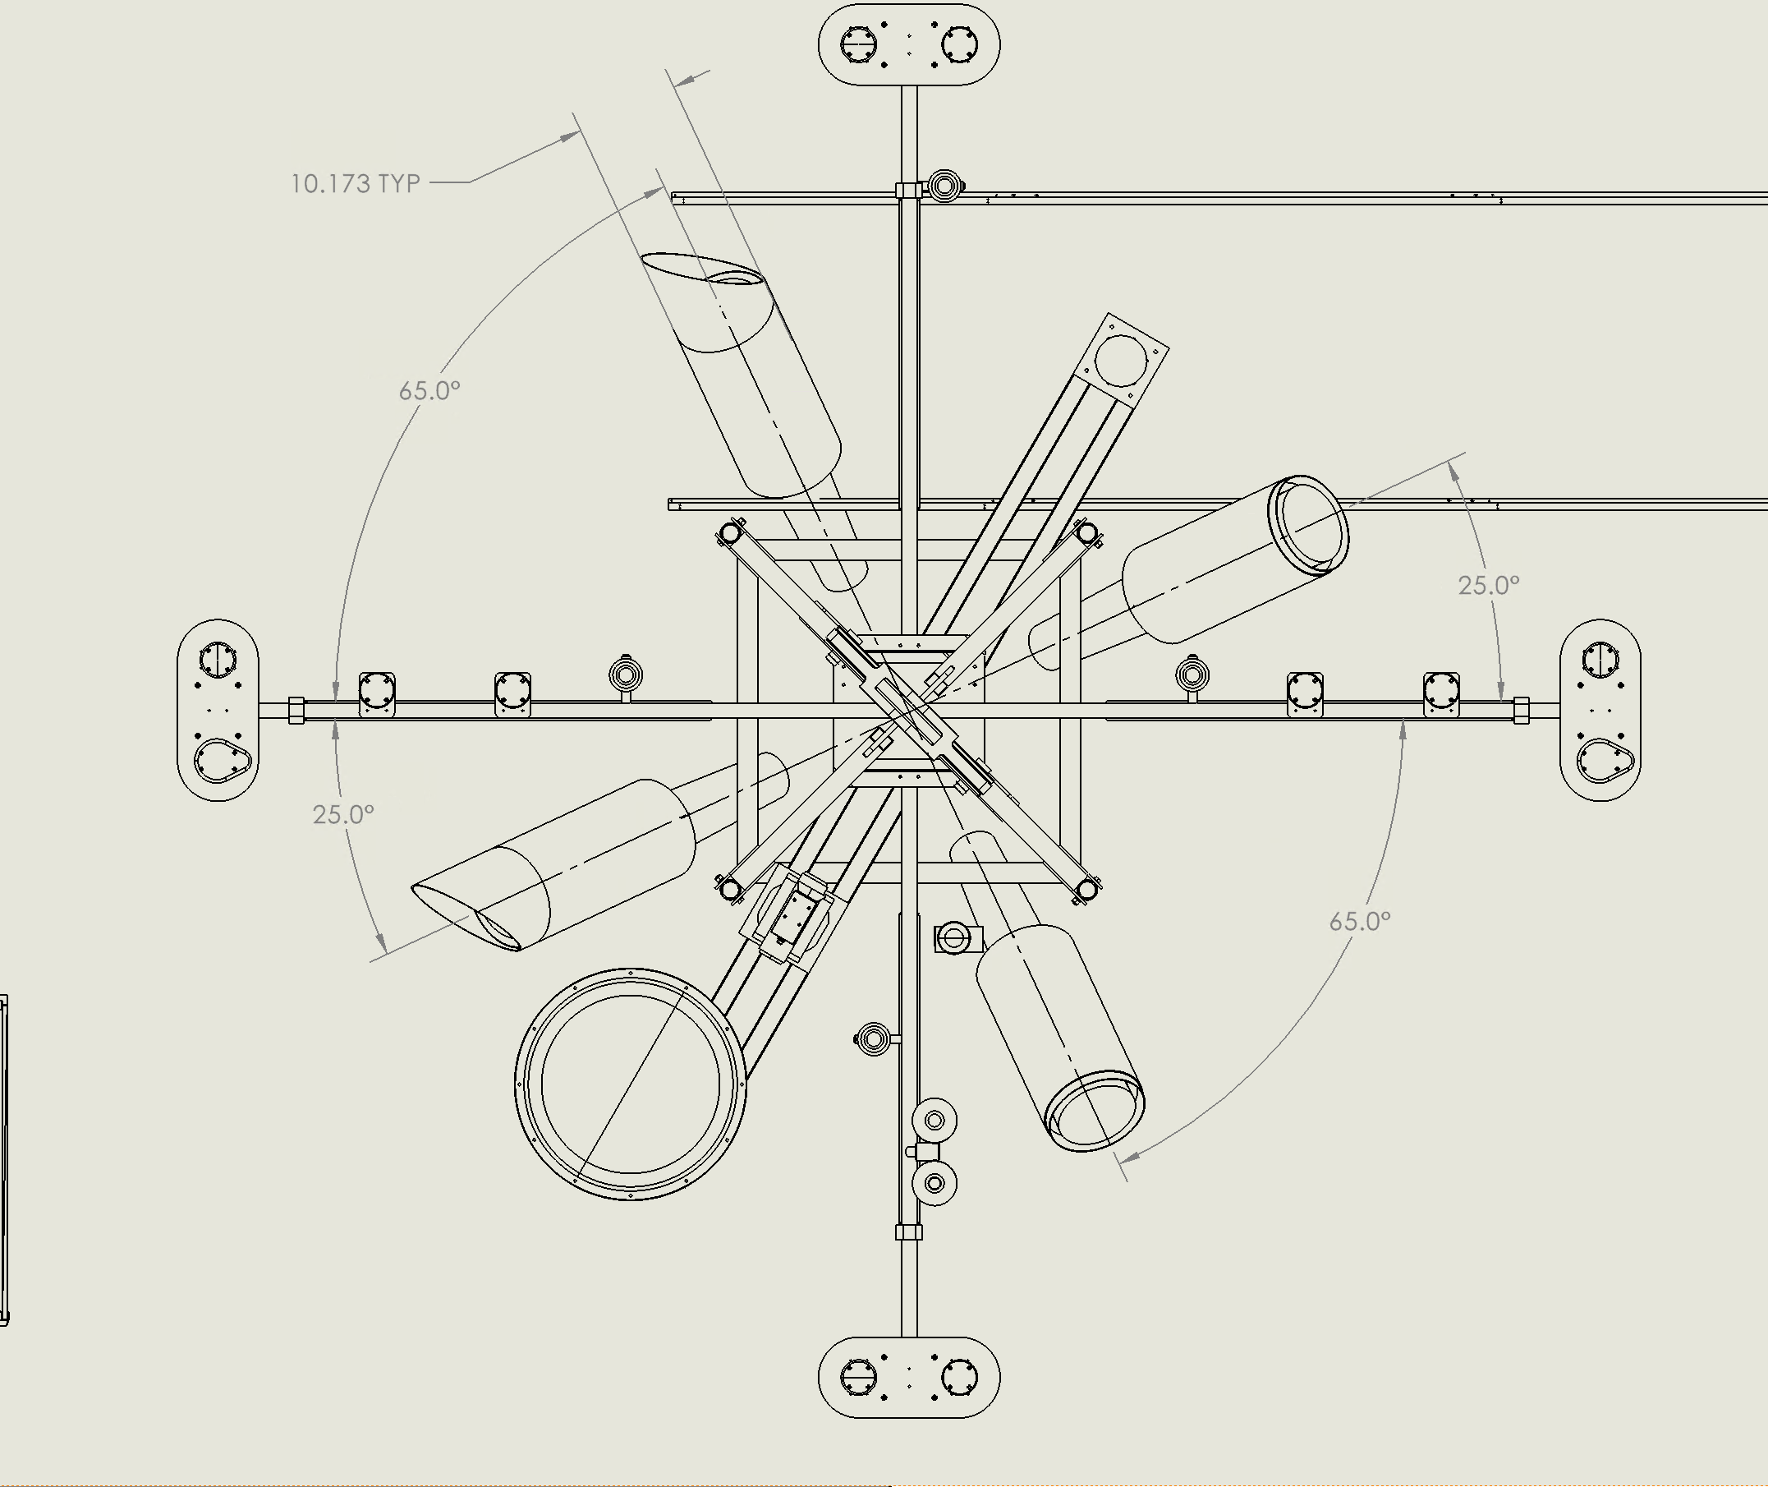
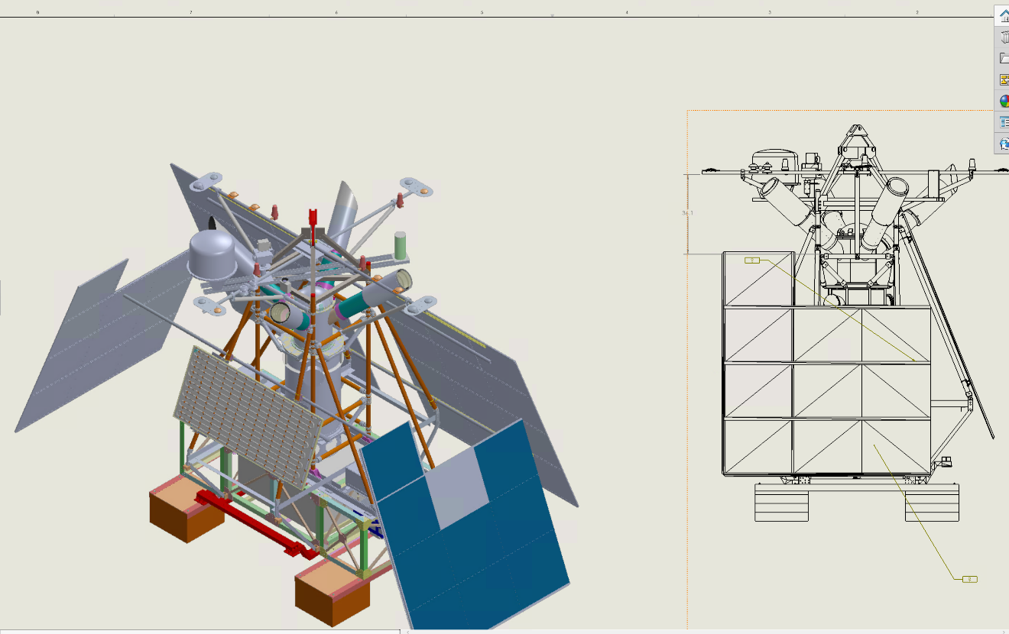
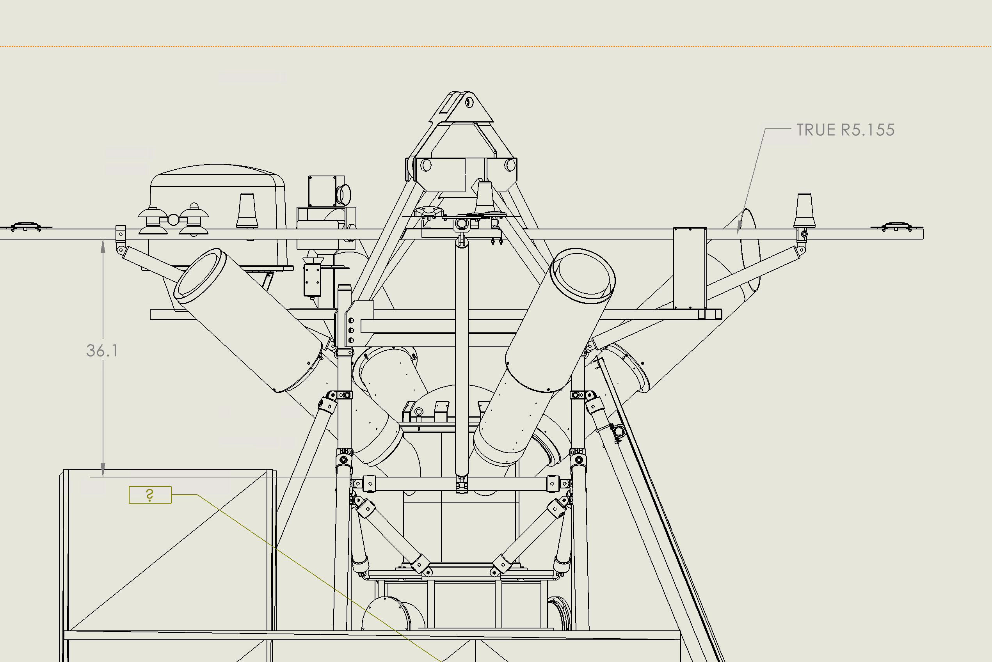
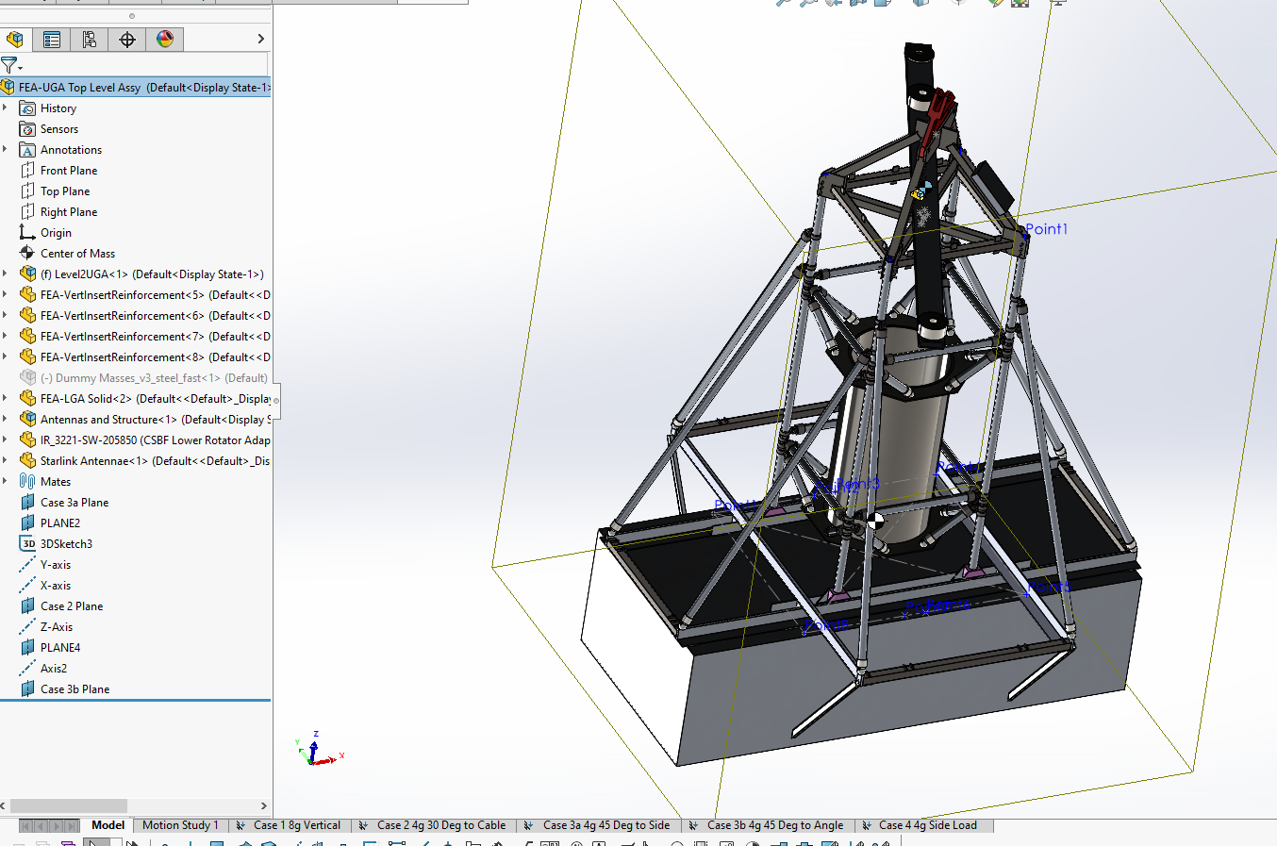

2. Drawings shall identify all the materials used for the construction depicted by the drawing
The tubes are aluminum, with Kee Clamp cast iron for the clamps and connections. The upper gondola is mild steel, and all of the hardware is at least grade 8 steel.

3. Material specifications shall be included in all drawings
All parts in FEA are of one of these 3 materials. The steel cable estimate is described in section 6.

4. At least one complete assembly drawing shall be provided
HAO cannot currently provide this.

5. Working drawings and specifications for all purchased and fabricated mechanical components and assemblies that are part of the gondola (e.g., rotators, swivels, turnbuckles, clevises, rings, and universal joints) shall be provided
HAO can provide most of these drawings at a later date.

6. A stress analysis of all major structural members, including decks and ballast attachment points shall be provided and shall identify the boundary conditions, components, equipment, and weights comprising the loads

Upper Gondola Attachment Points and Boundary Conditions
The upper gondola attaches to the balloon with the trapeze. The attachment point to the balloon is modeled as a fixed constraint at the top of the trapeze, shown below.
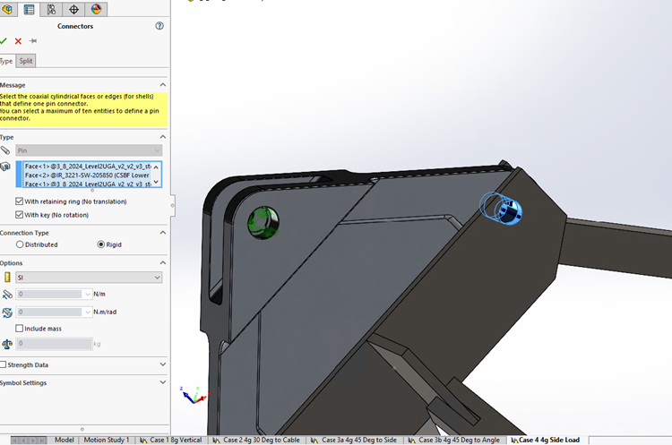
The manually added connectors, either link connector or spring (cable estimate), are shown below.
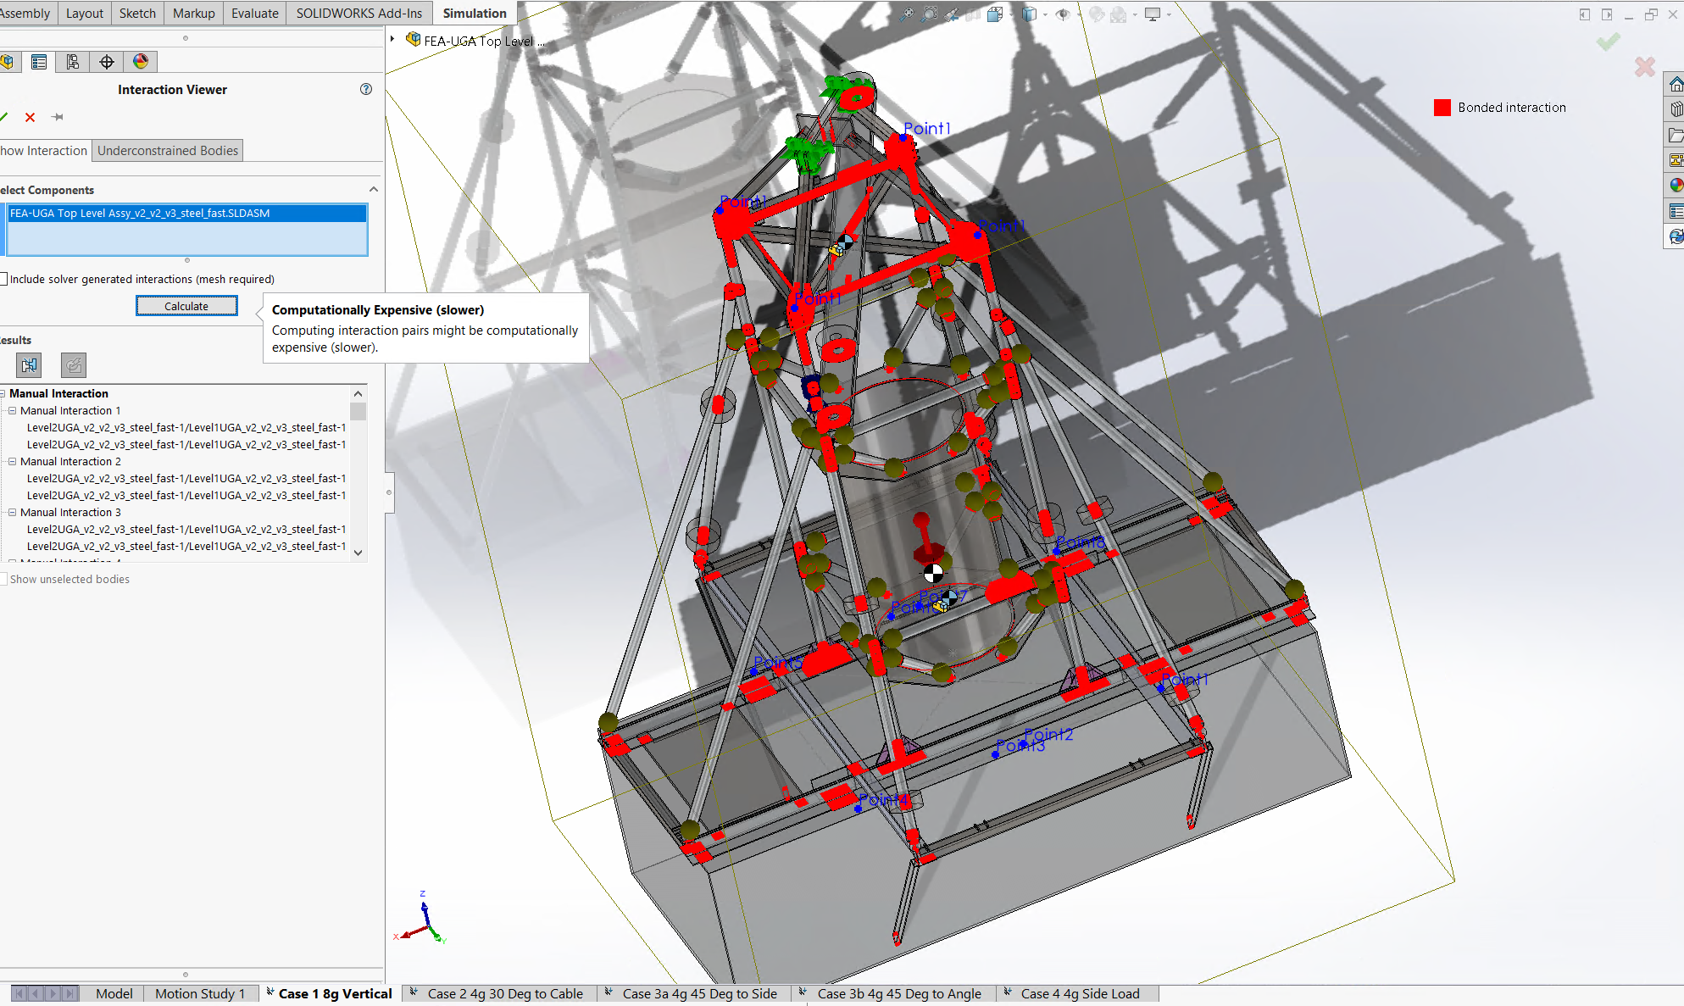

Dummy Mass Changes
As of March 2024, the dummy mass models have been changed to remote masses, except for the antennas and lower gondola assembly.
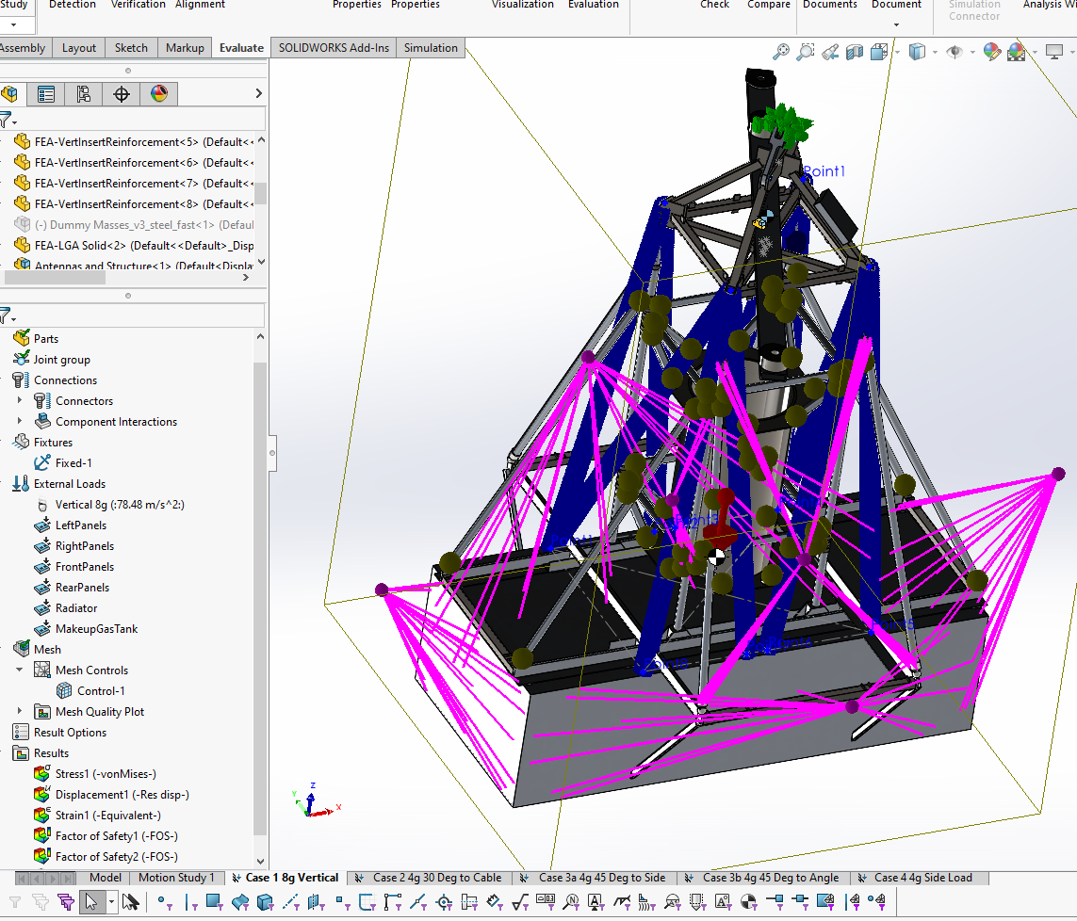

Support Cable Estimation
In order to create the cables as a connection in the FEA model a simple steel model was created with a 3/8” diameter and a 1 N load applied. Then the stiffness value was used to create spring connections in the upper gondola analysis.
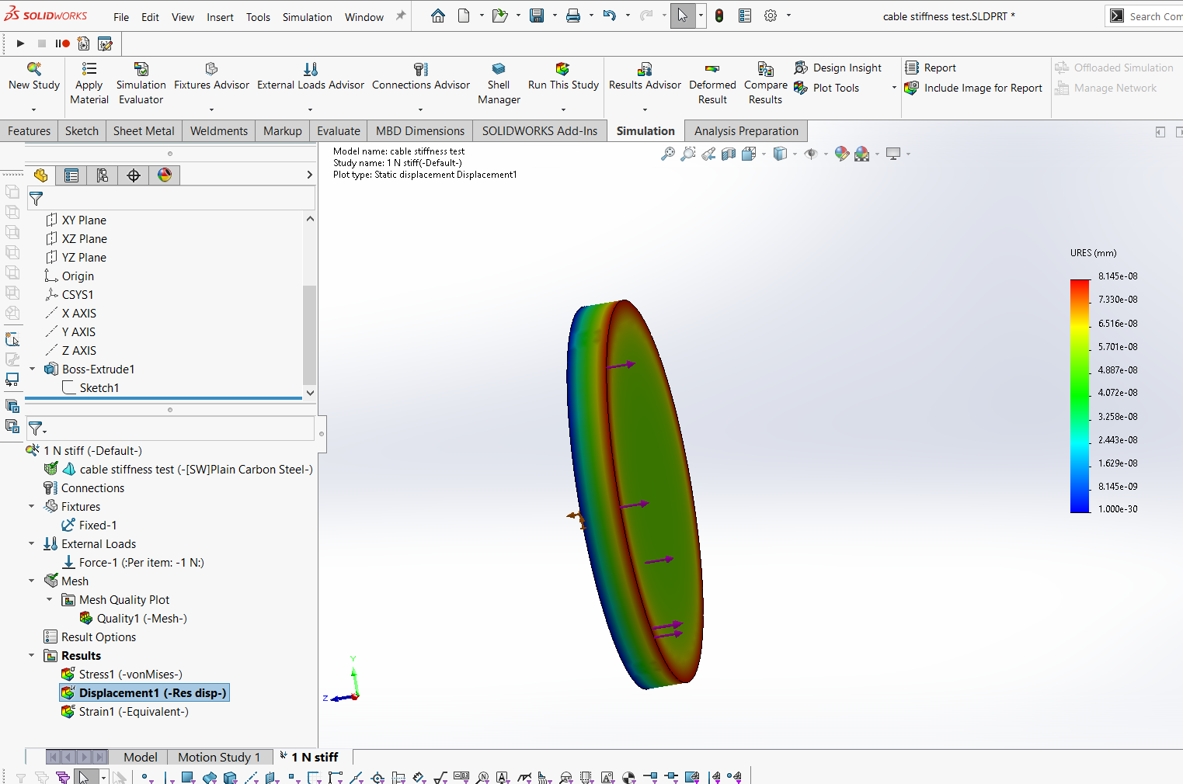
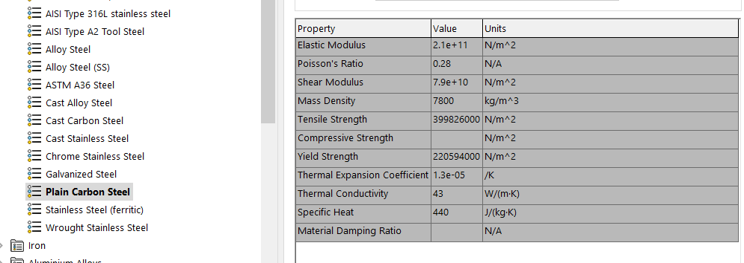

The connection points for the spring connection are shown below:
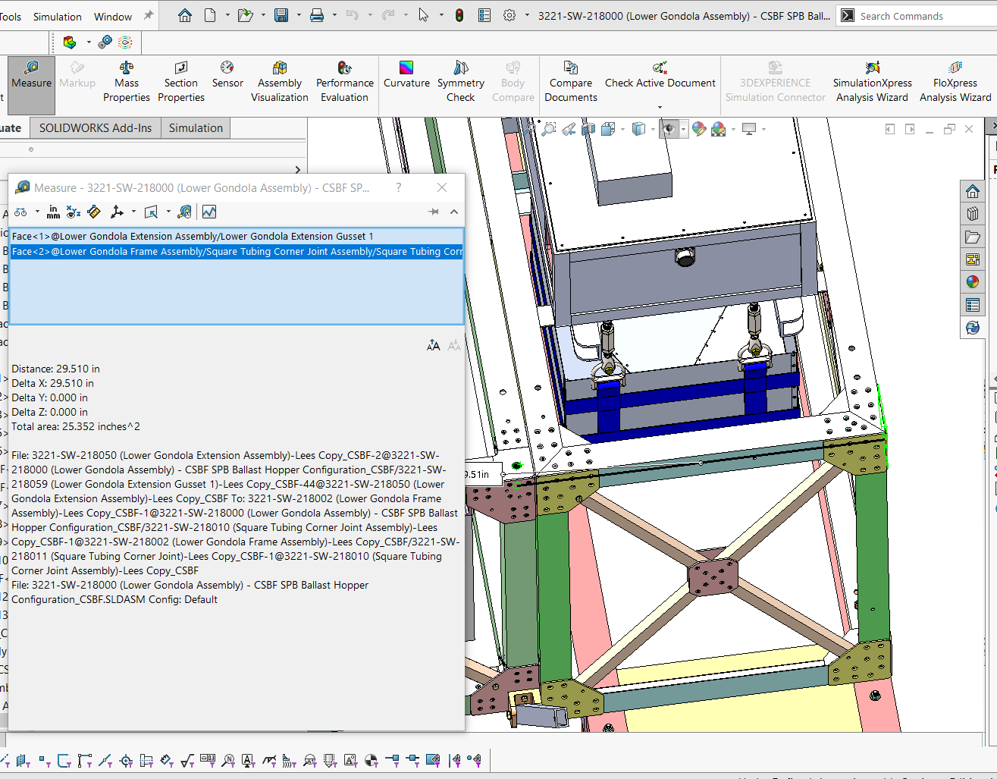
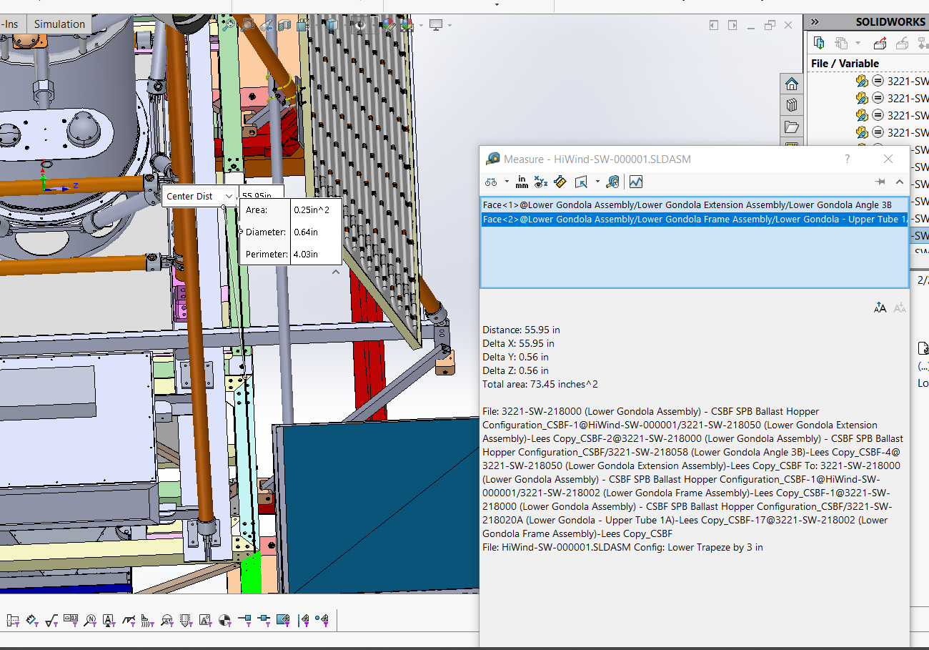
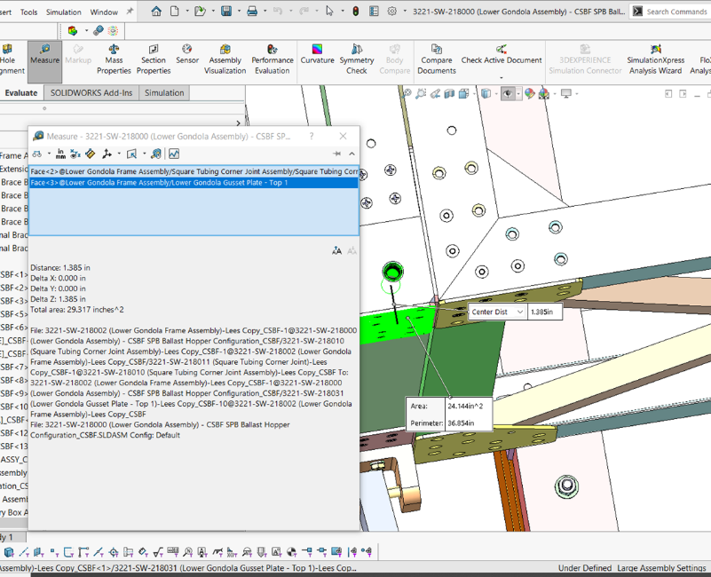
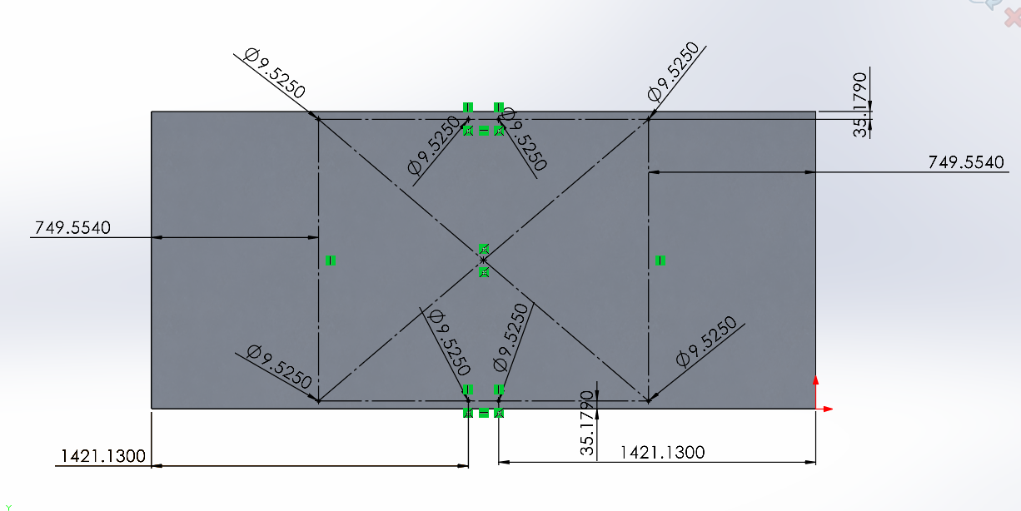

Tri-plate Attachment Fixed Surfaces and Connections to Trapeze
The tri-plate has been imported using the SW default 6061-T6 material. The top holes are fixed, and the connection to the trapeze is set as a solid pin linking the faces, shown below.
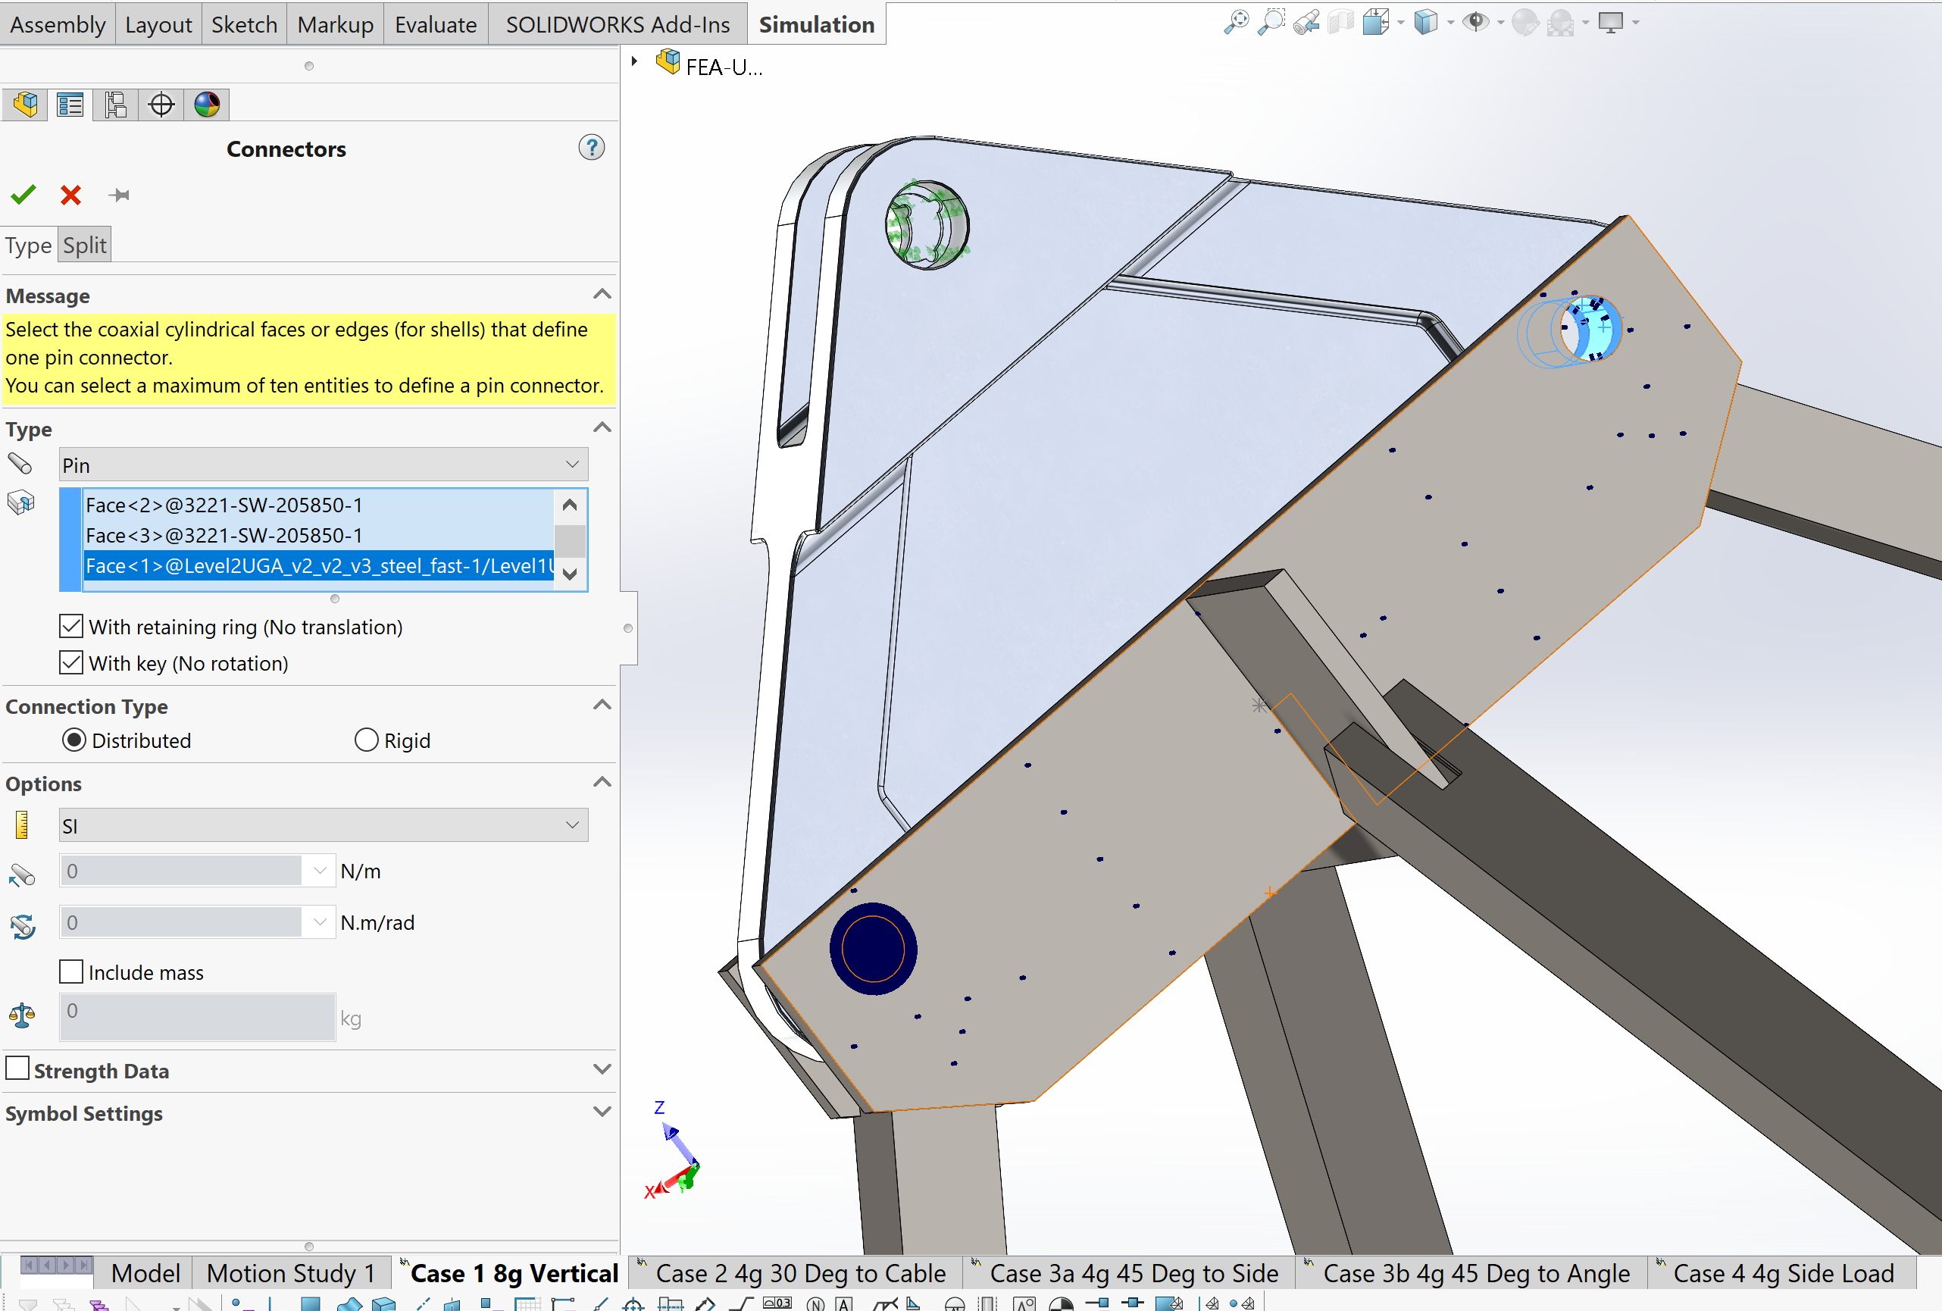
Key details from 820-PG-8700.0.1 Gondola Structural Design Requirements
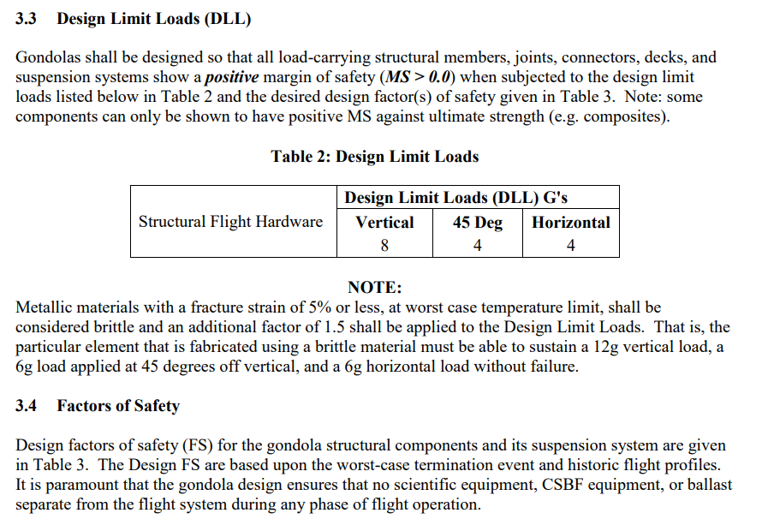
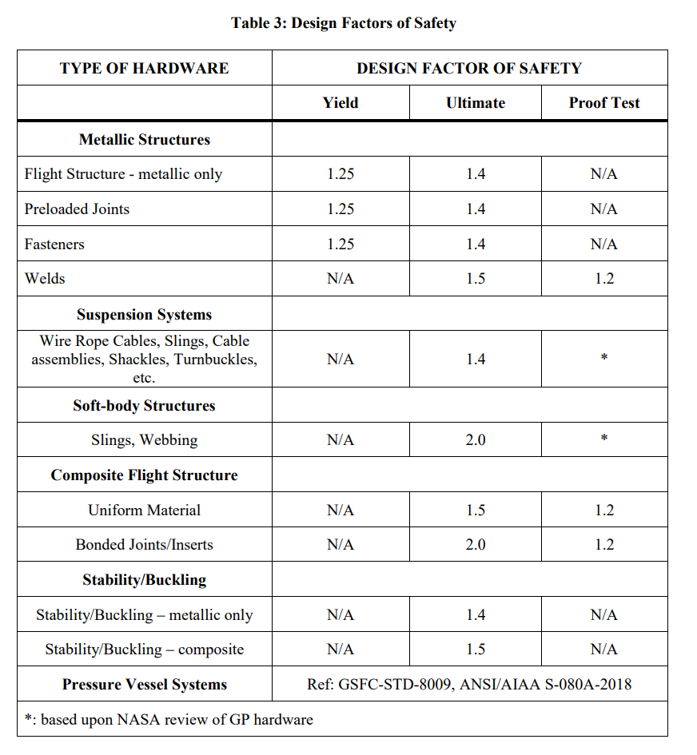
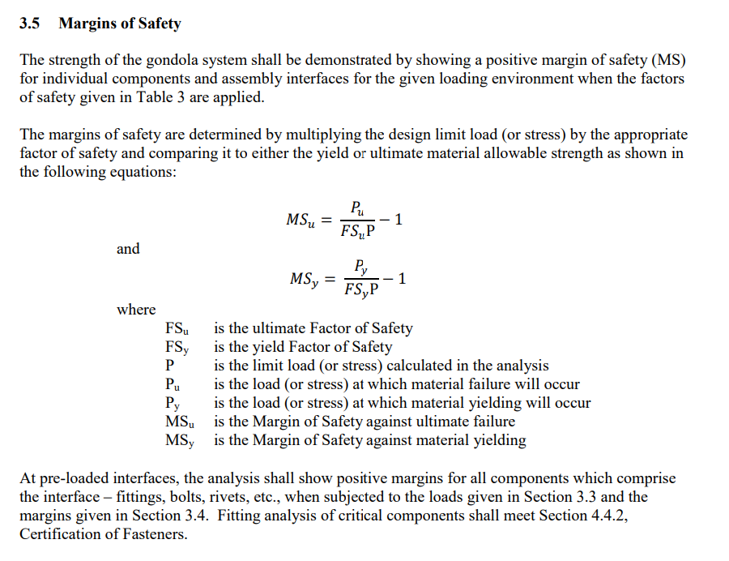

6.1 Load Case 1 8g Vertical

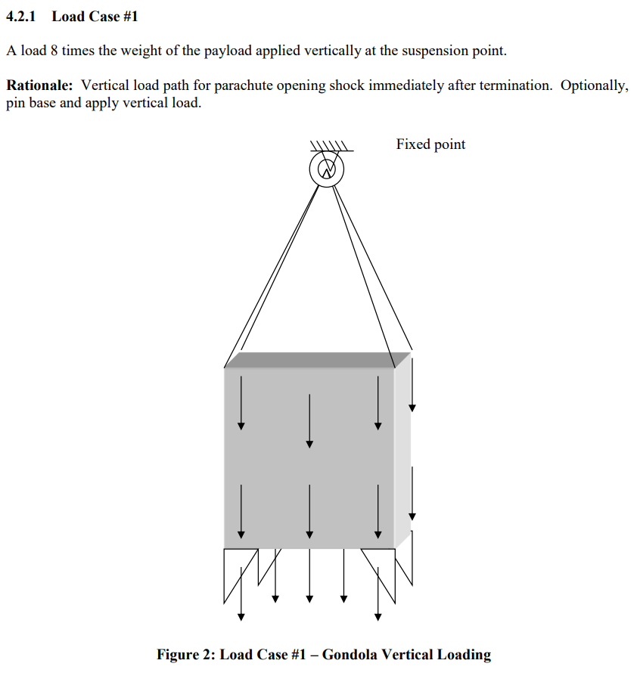

Load Case 1 Lower Gondola
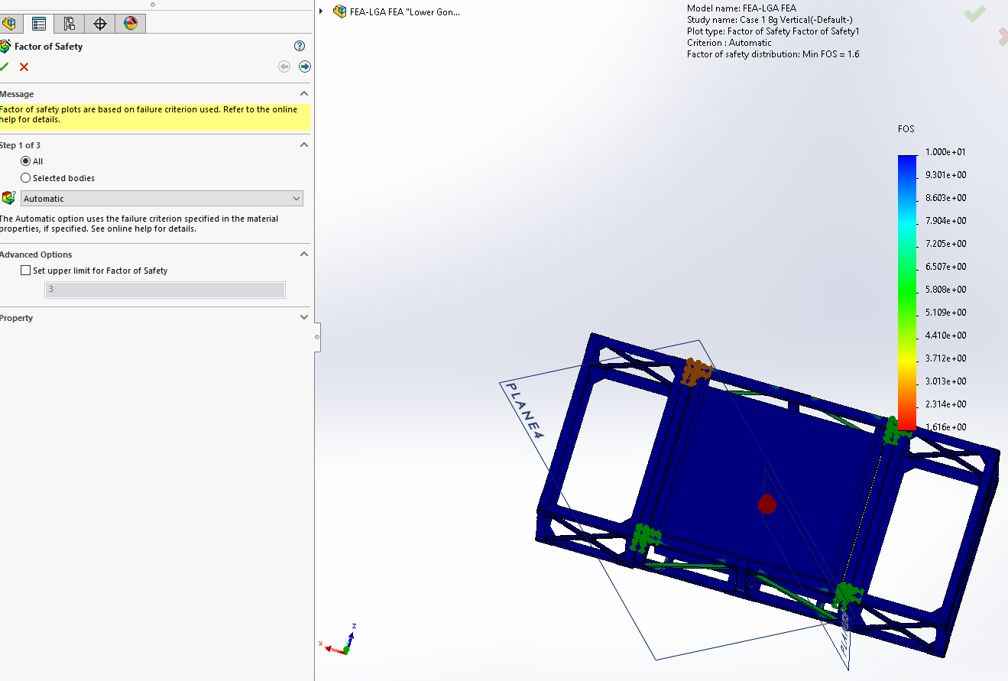
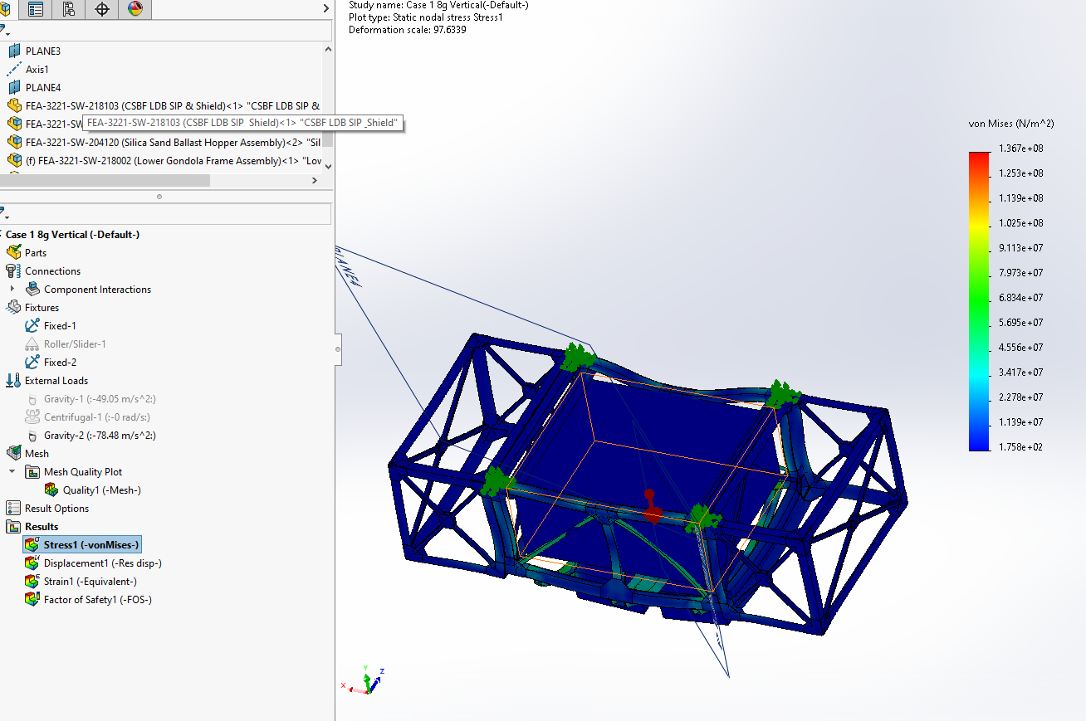

Load Case 1 Upper Gondola
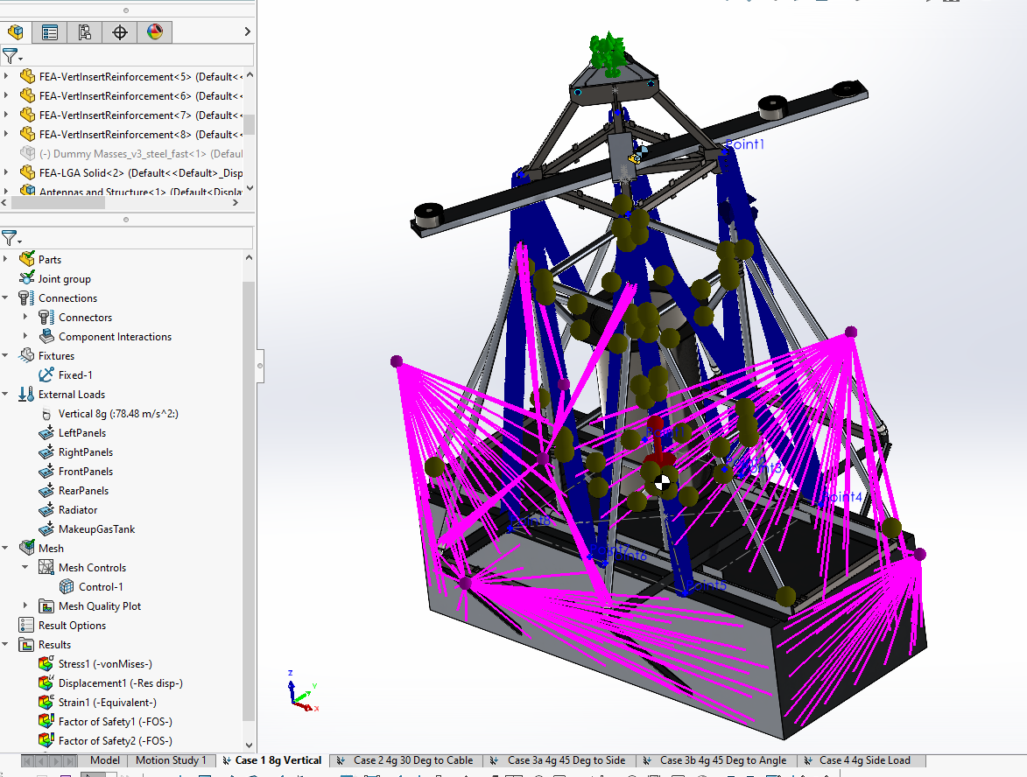
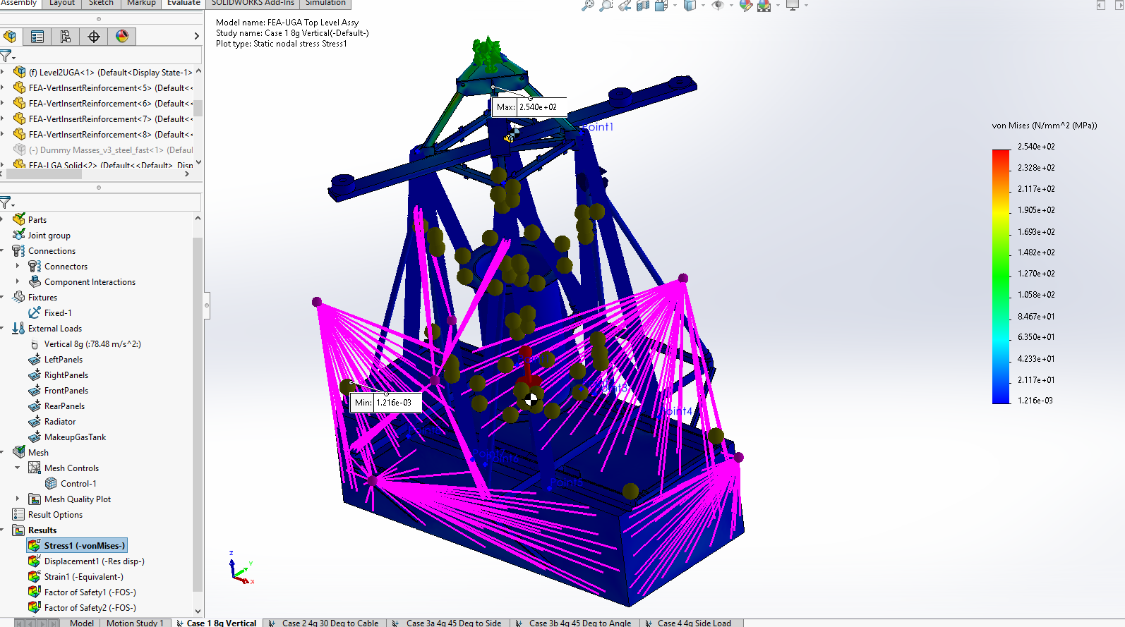

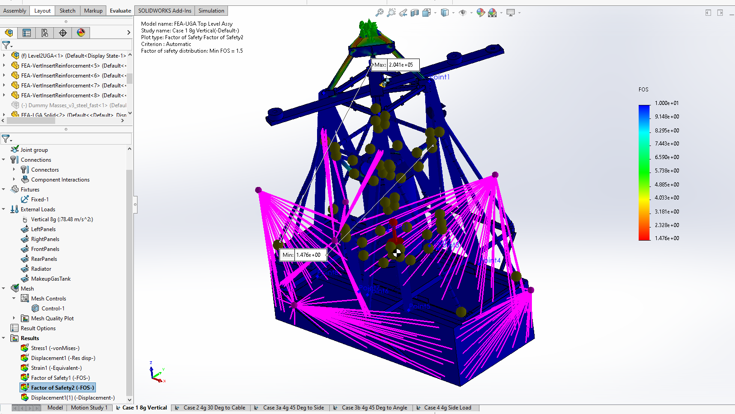

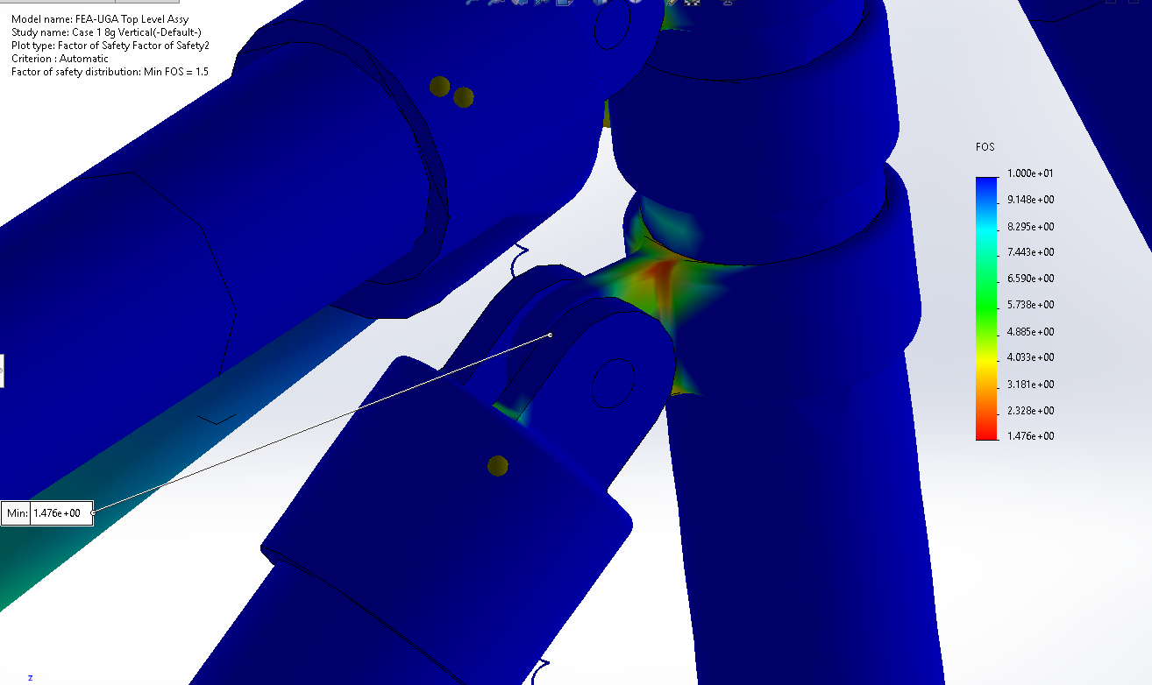
The KeeClamp joining member has a low FOS, the min FOS from the assembly and the max stress of a node in any part will be used in the Safety Factor calculation. Steel is used in the Margin of Safety calculation as the material, as the fastener taking the load is steel.

Load Case 1 Summary

6.2 Load Case 2 4g Angle to Cable

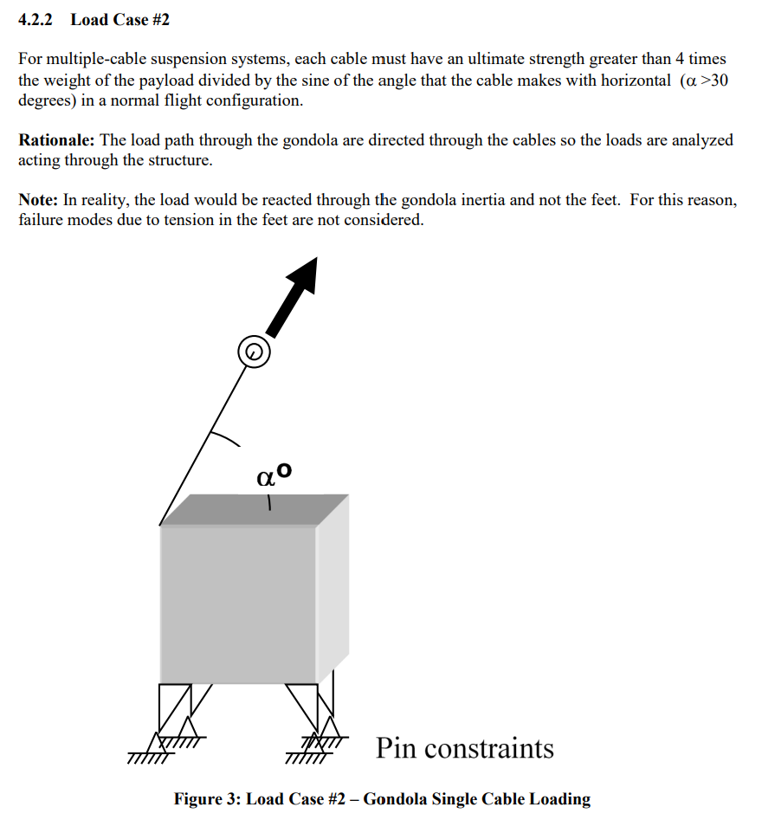

Load Case 2 Lower Gondola
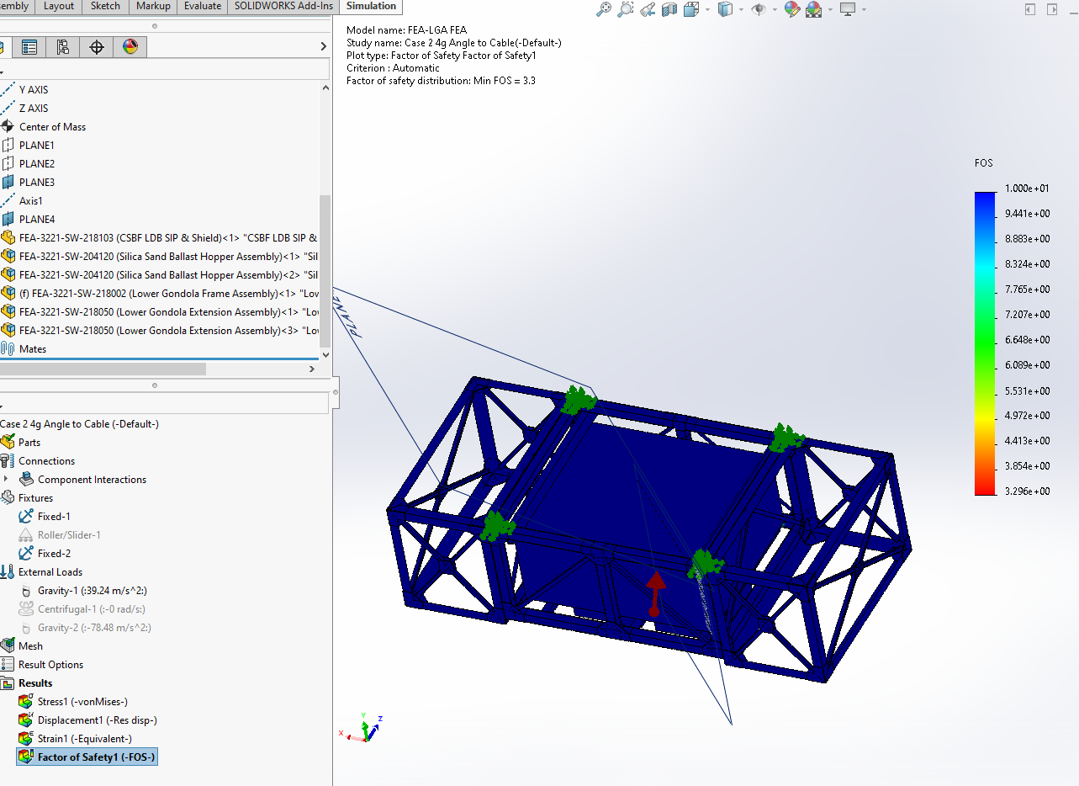
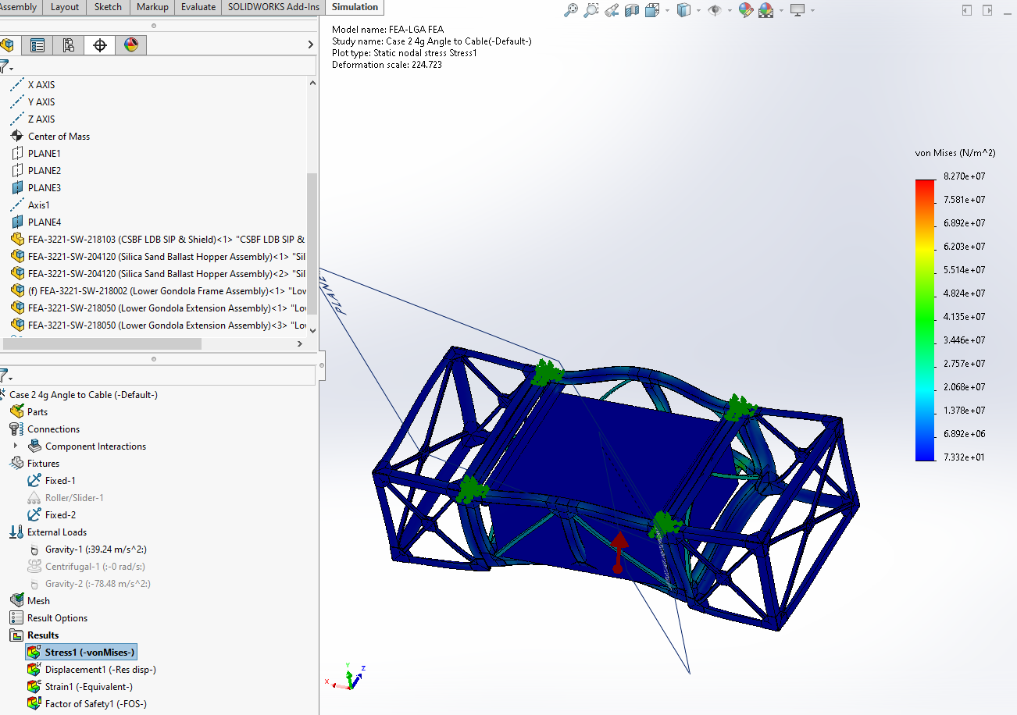

Load Case 2 Upper Gondola
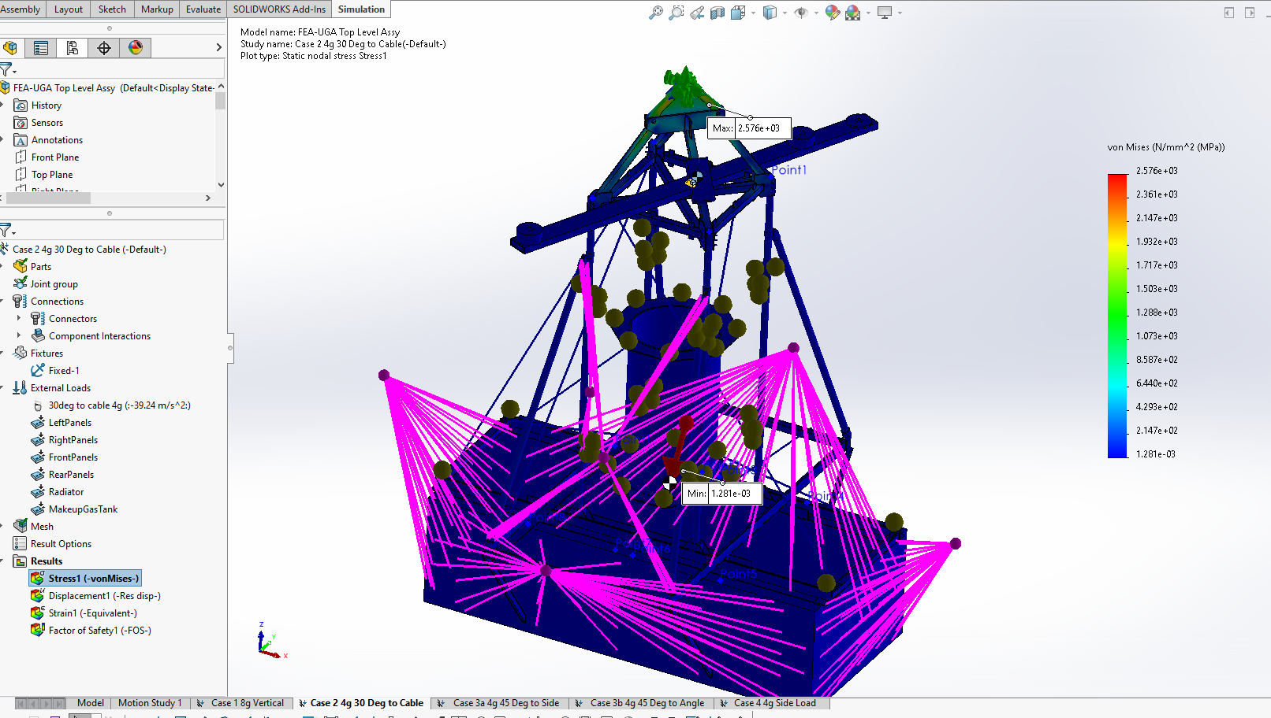
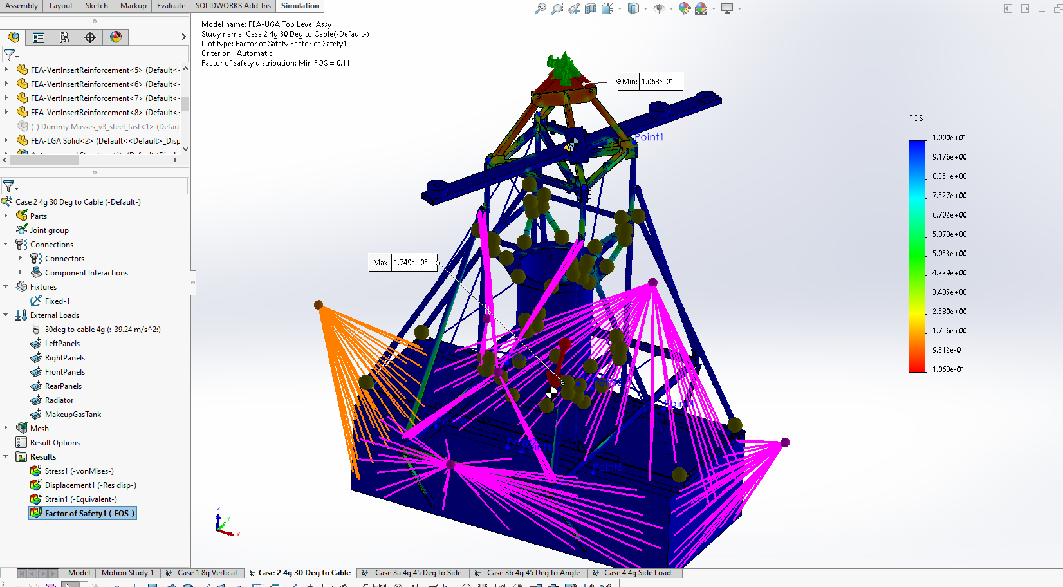

Load Case 2 Summary
The upper gondola does not pass this case. The lowest factor of safety is in the triplate.

6.3 Load Case 3a,b 4g 45 Degree to Vertical

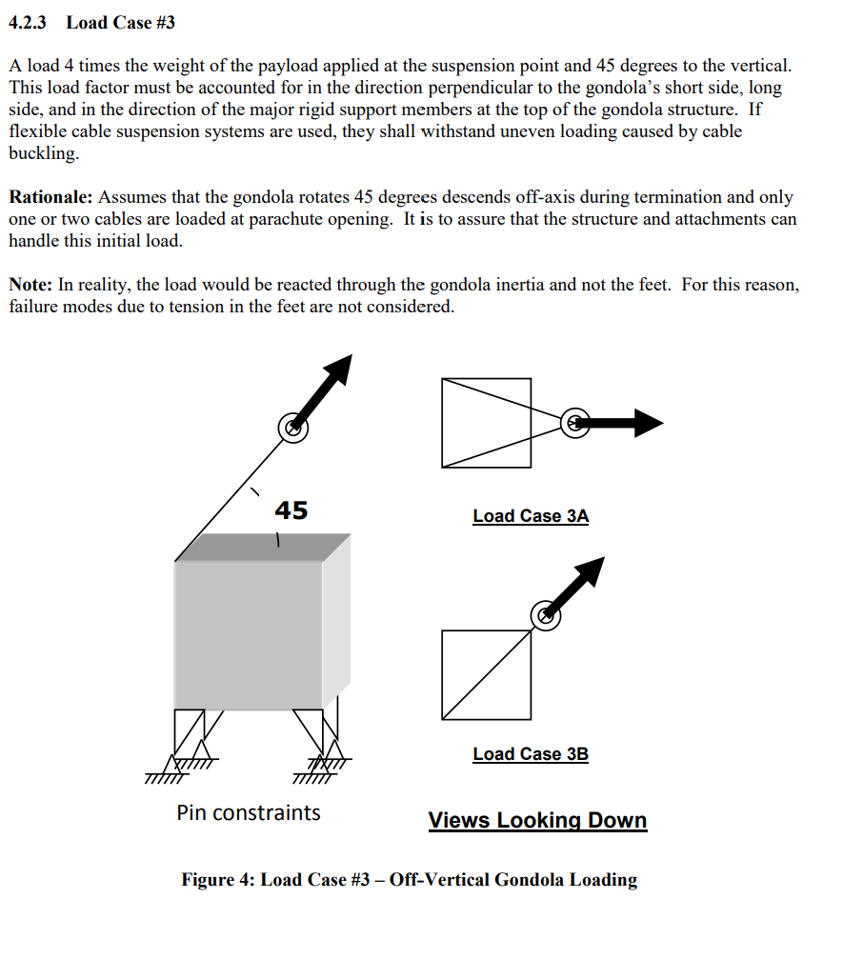

Load Case 3a,b Lower Gondola

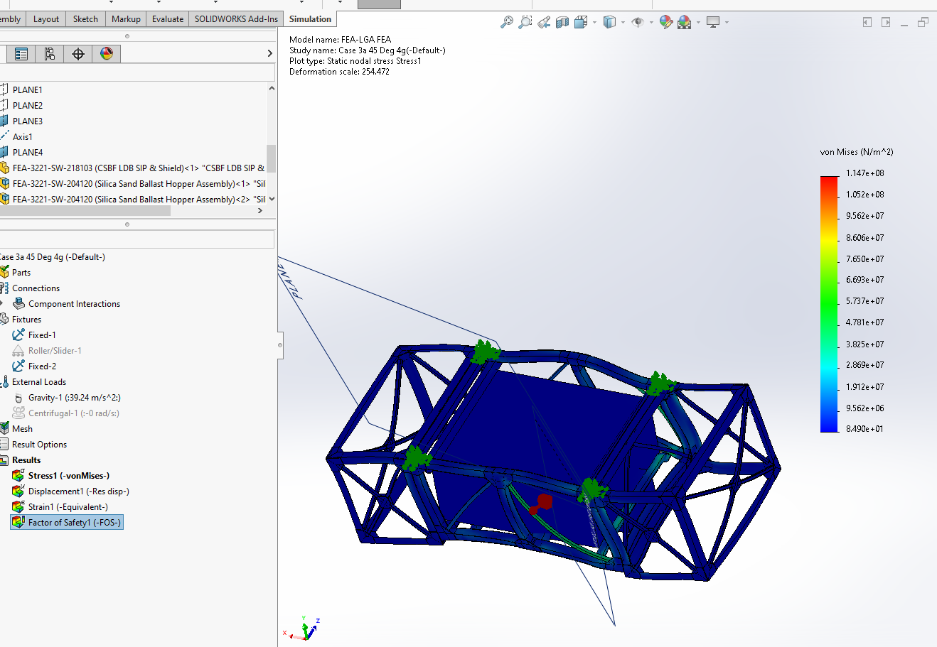
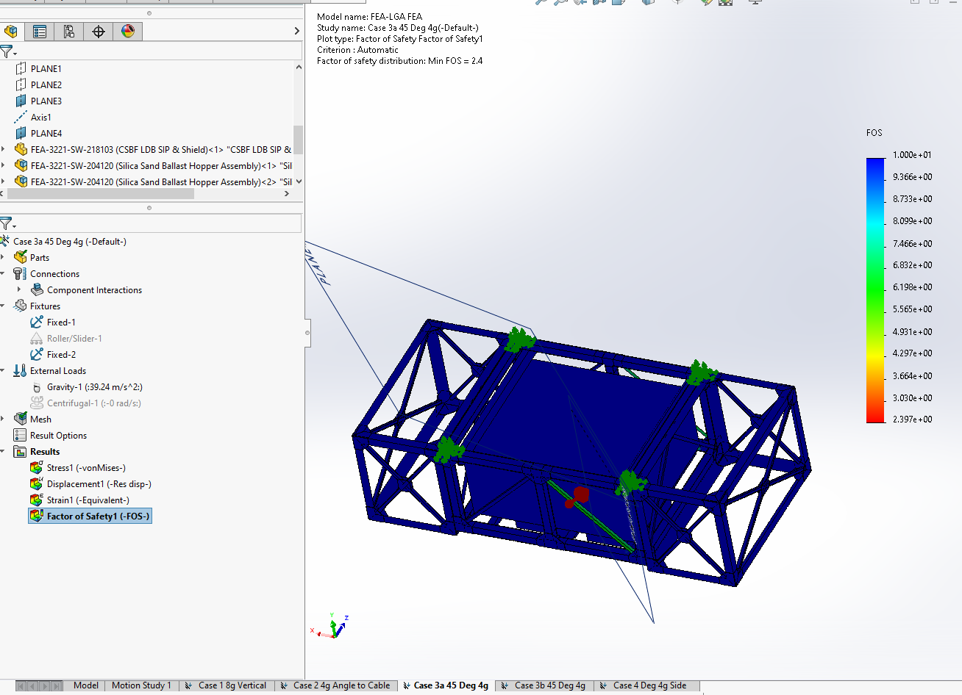
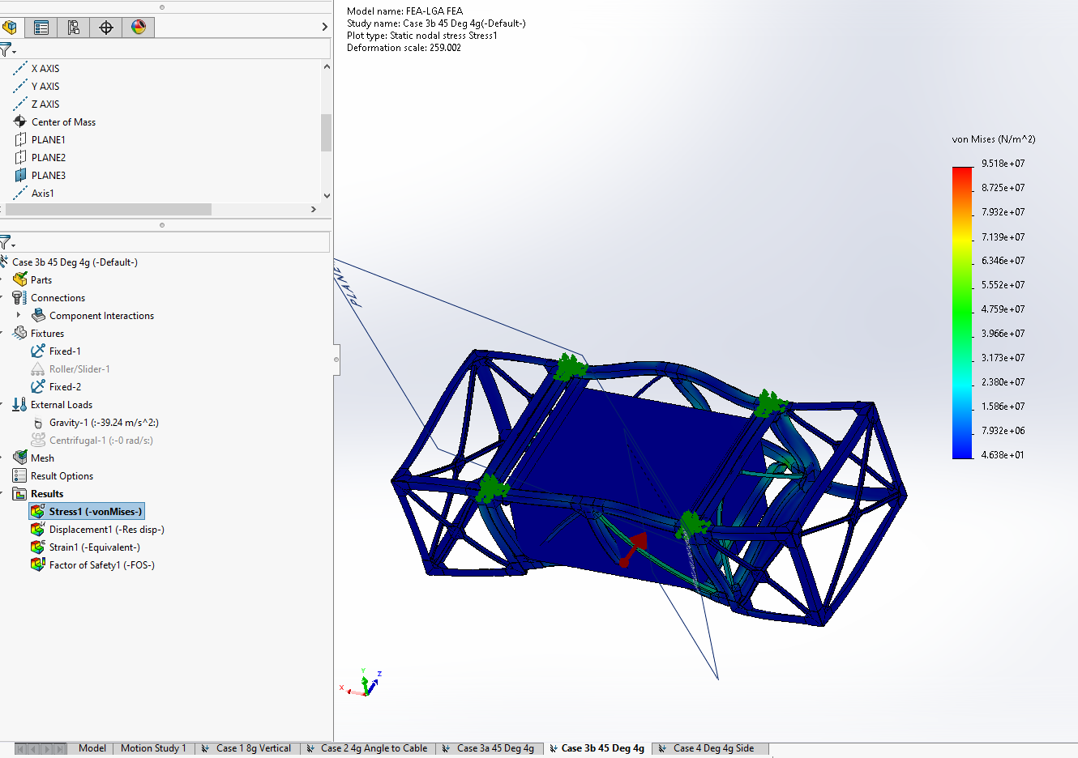
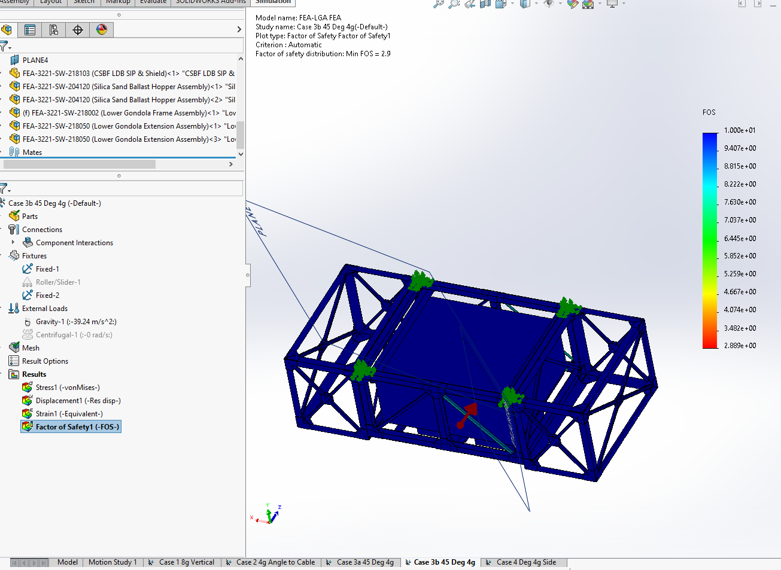

Load Case 3a Upper Gondola
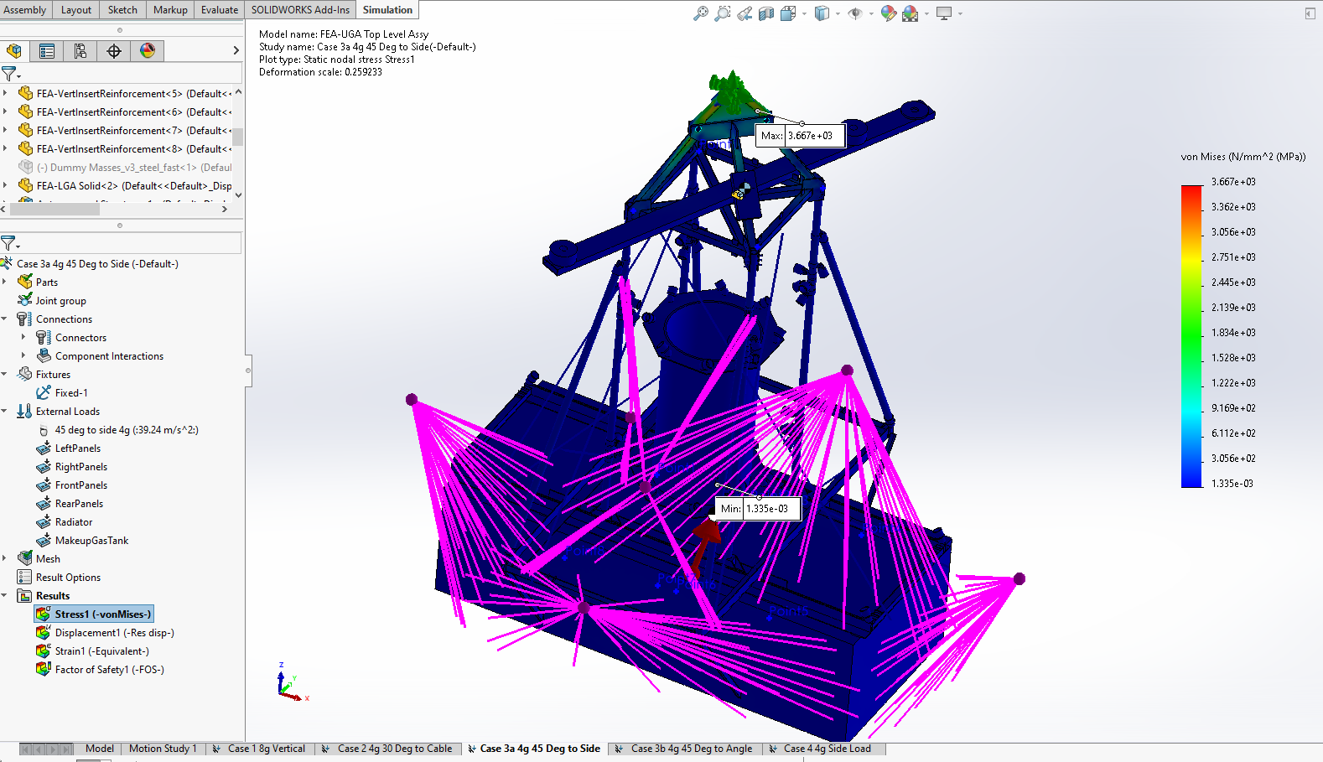
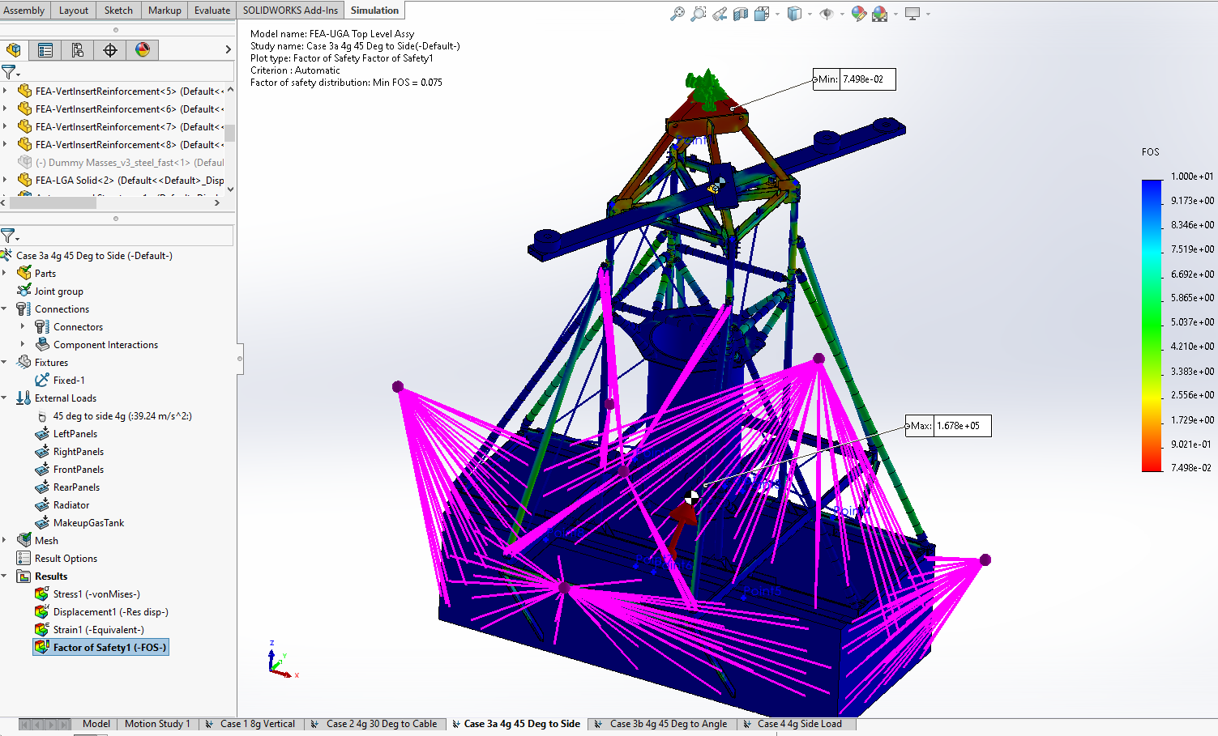

Load Case 3a Summary

Load Case 3b Upper Gondola
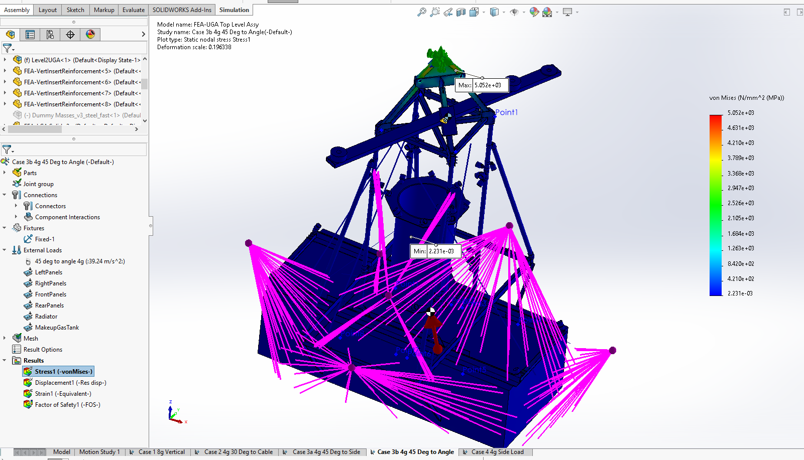
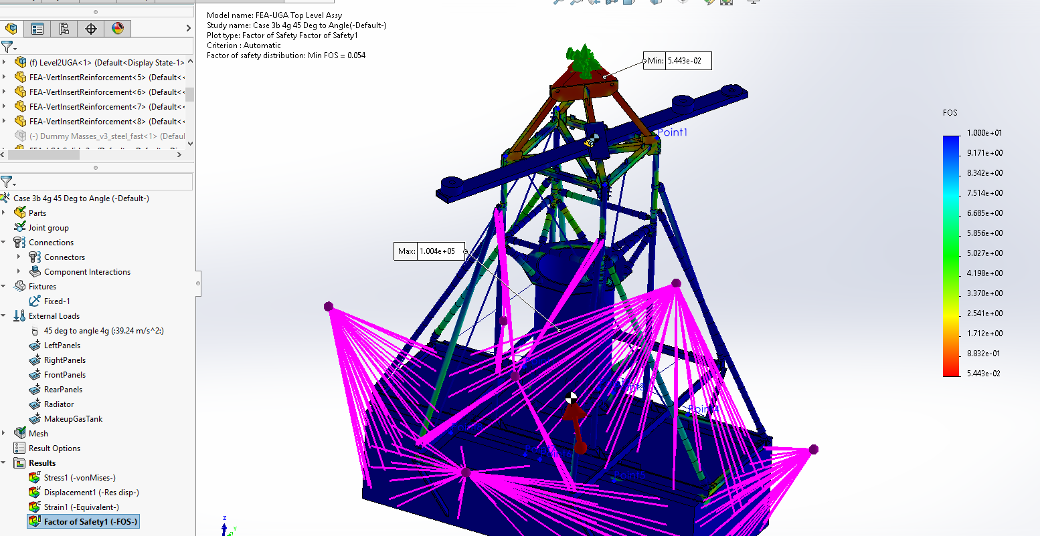

Load Case 3b Summary

6.4 Load Case 4 4g Side Load
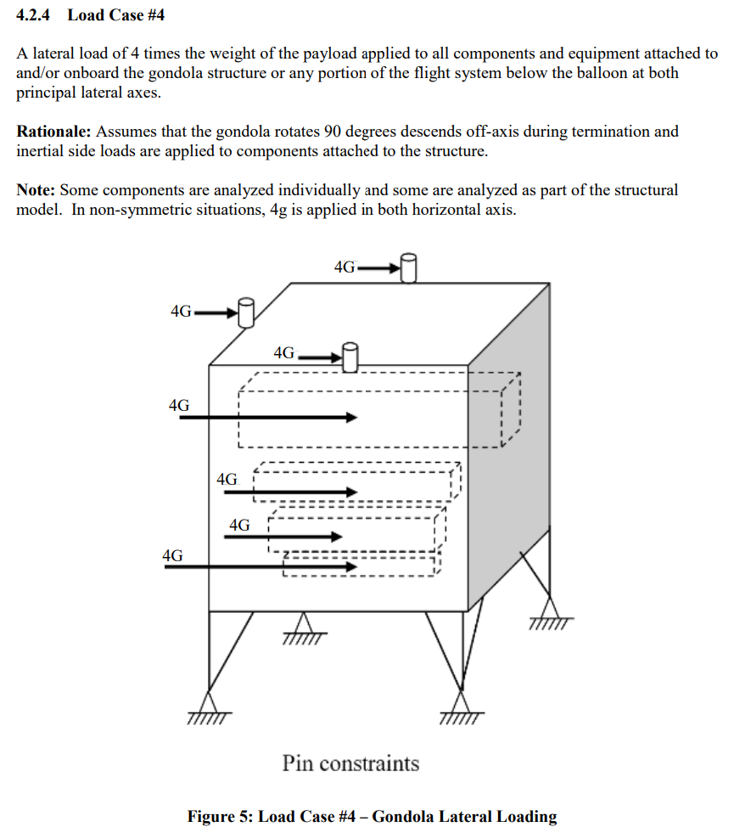

Load Case 4 Lower Gondola
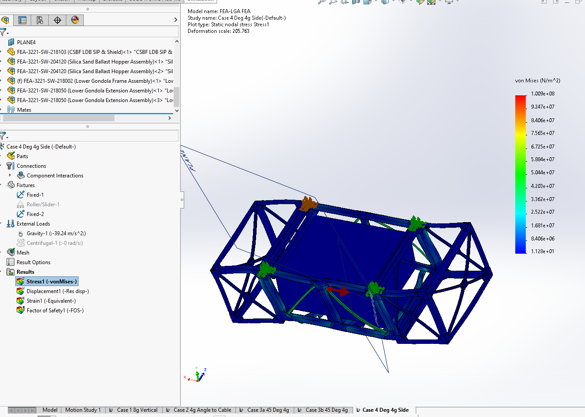
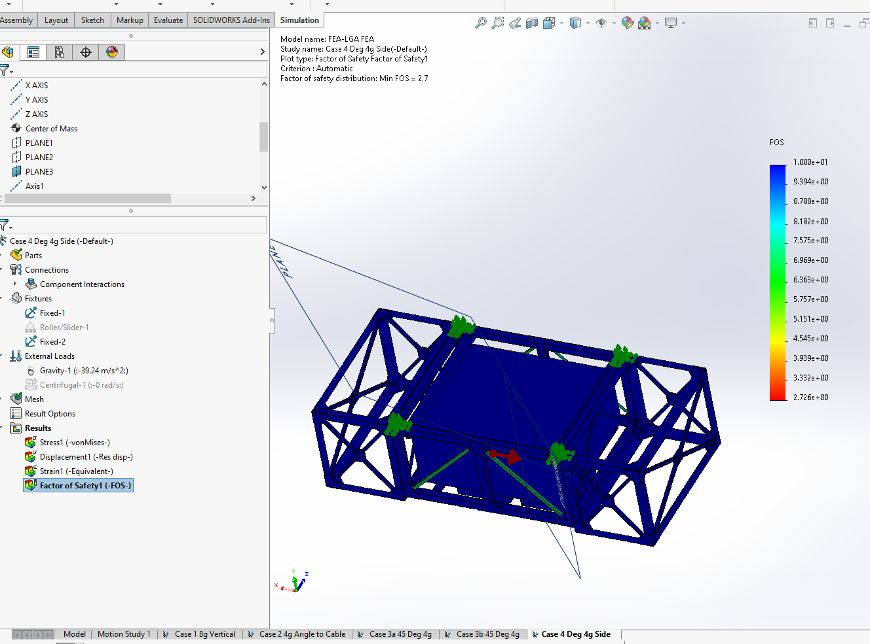

Load Case 4 Upper Gondola
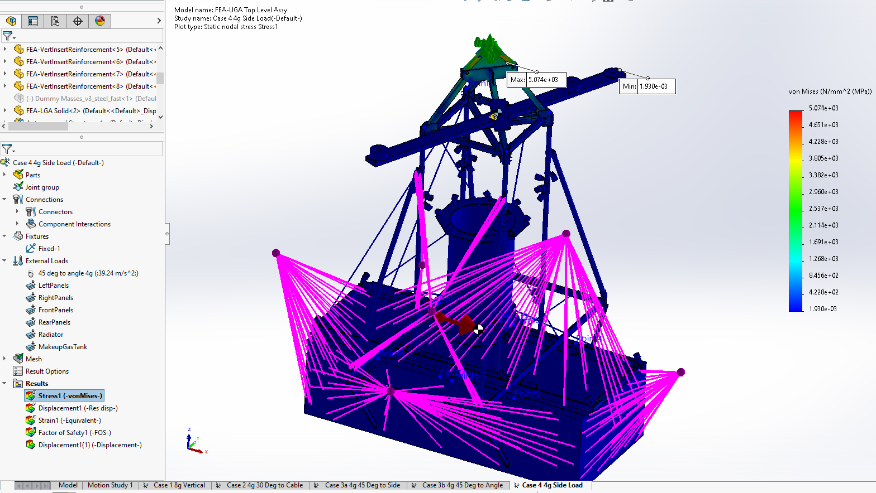
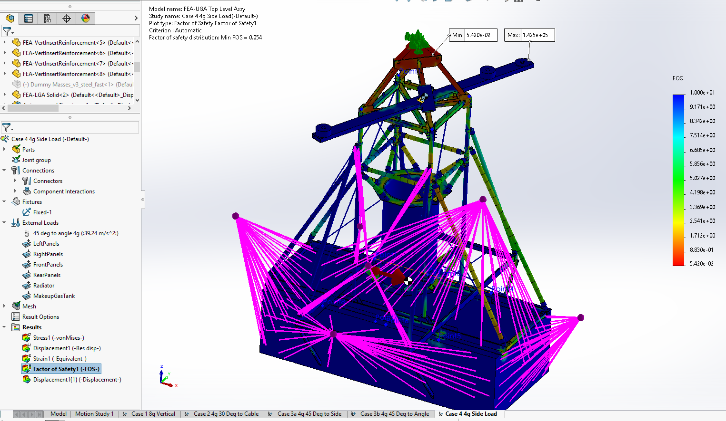

Load Case 4 Summary

6.5 Load Case 5 1.4x Weight on Flight Hardware
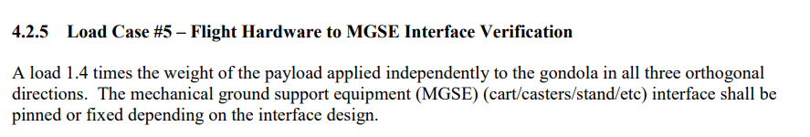
Our design files are not capable of supporting this analysis.

Summary of Safety Factor Calculations
The lower gondola meets quite a few of the margin of safety requirements, but the upper gondola only passes load case 1. This gondola overall does not meet the calculated safety requirements in this report, additionally HAO does not have a complete submission.

Narrative on Analysis Types
The tri-plate being fixed and using the gravity vector load with the dummy masses was used because the inertial relief style of analysis has serious problems meshing and converging on a solution. The high quality mesh never completed an analysis run.

Analysis Errors
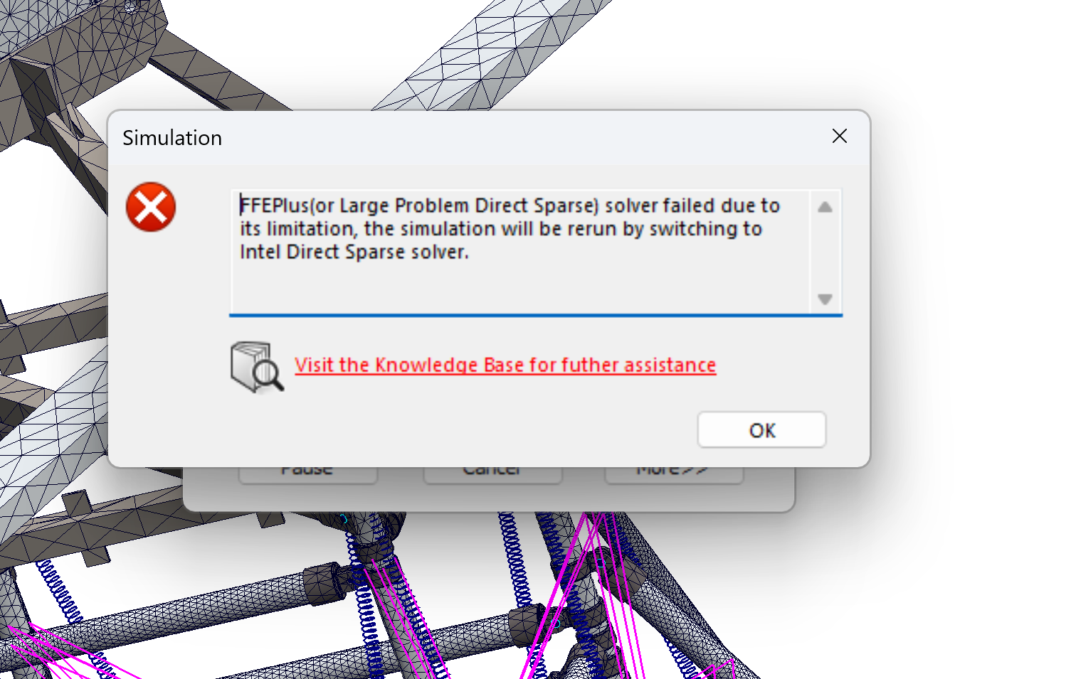
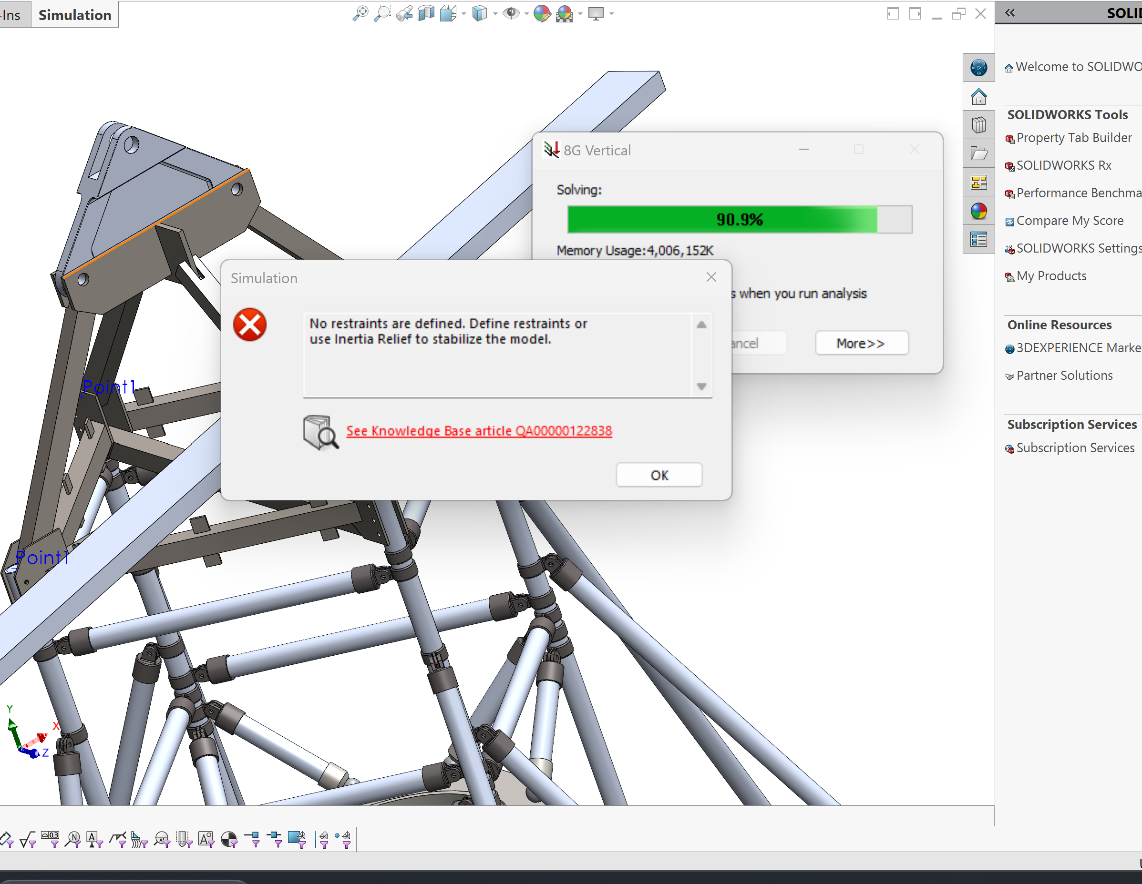
Exception code 0xc0000005 thrown at address 0x1405f7612.
Please send crash data file Z:\2023 Final FEA Design and Analysis\SIMSTACK-V32,5,0,13-240222-135014.dmpl is under such a force
or under marginally imbalance forces, application of Inertia
Relief may alter the characteristics of your model.
Would you like to continue? "Yes" to SOLIDWORKS technical support.
Please press OK to terminate solution
Warning: There is a significant external imbalanced force in
Z-direction which will be balanced by the application of
opposing inertia forces. Unless your model is under such a force
or under marginally imbalance forces, application of Inertia
Relief may alter the characteristics of your model.
Would you like to continue?

7. For critical or single-point failure items material certifications shall be provided in accordance with Section 4.4, Material Requirements for Critical Hardware
To be submitted at a later date.

8. A statement certifying that the aforementioned requirements have been met; the statement shall be signed by the principal investigator and the engineer responsible for the design and analysis of the gondola structure. Qualifications of the engineer responsible shall be submitted in the form of a brief résumé
HAO cannot provide a statement saying these requirements have been met because they are not. Only Load Case 1 is acceptable.
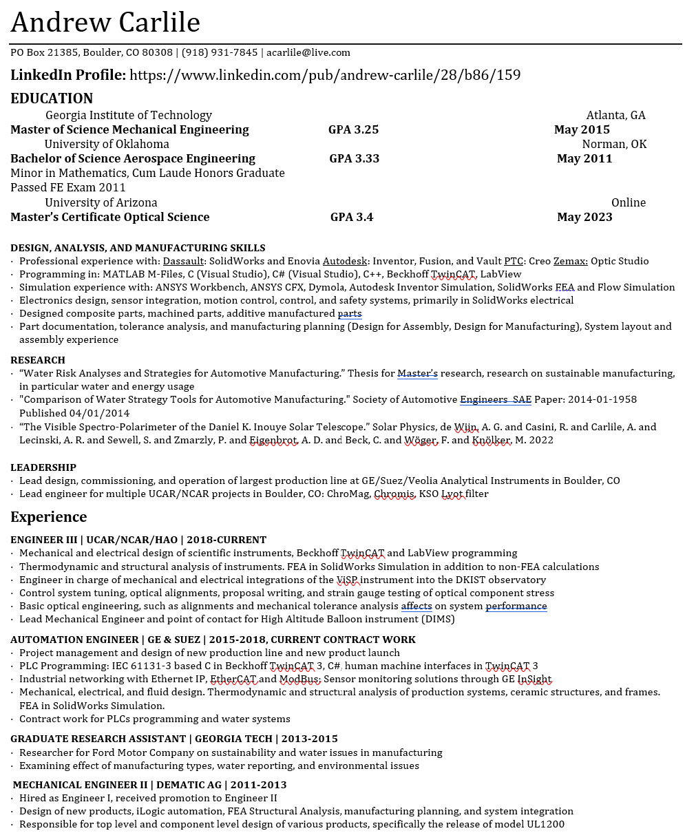
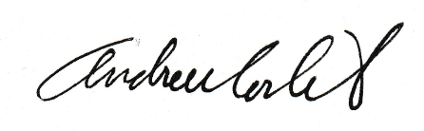

9. Any changes to analytical models following submittal of deliverable shall be submitted to NASA as soon as practical. Scope and timing of changes may impact review and certification for flight.
Not applicable.

10. Triplate Analysis Requested April 2024
Request email, from Justin Marsh:
Marsh, Justin L. (WFF-820.0)[PERATON INC]
Wed, Apr 24, 7:46 AM (6 days ago)
to me, Qian
Andrew,

The structural review team asked that I do an independent analysis of the trapeze for all load cases. I’ve finished with that and it shows good margins. They’re requesting that you perform a similar analysis to verify my results. I believe they’ll ask for this to be presented at the final PIR as a way to allow us to certify the gondola for flight in FY25.
Thanks,
Justin

Narrative on Trapeze Analysis from HAO (Andrew Carlile):
This analysis doesn't consider any of the antennae specific loads and combines those antennae loads with the total mass. The tri-plate is aluminum, so it is the softest part in the entire assembly and it’s bending will affect the load paths. This model is a simple check to be compared with Justin’s results with similar assumptions.

Trapeze 8g Case
From Justin:
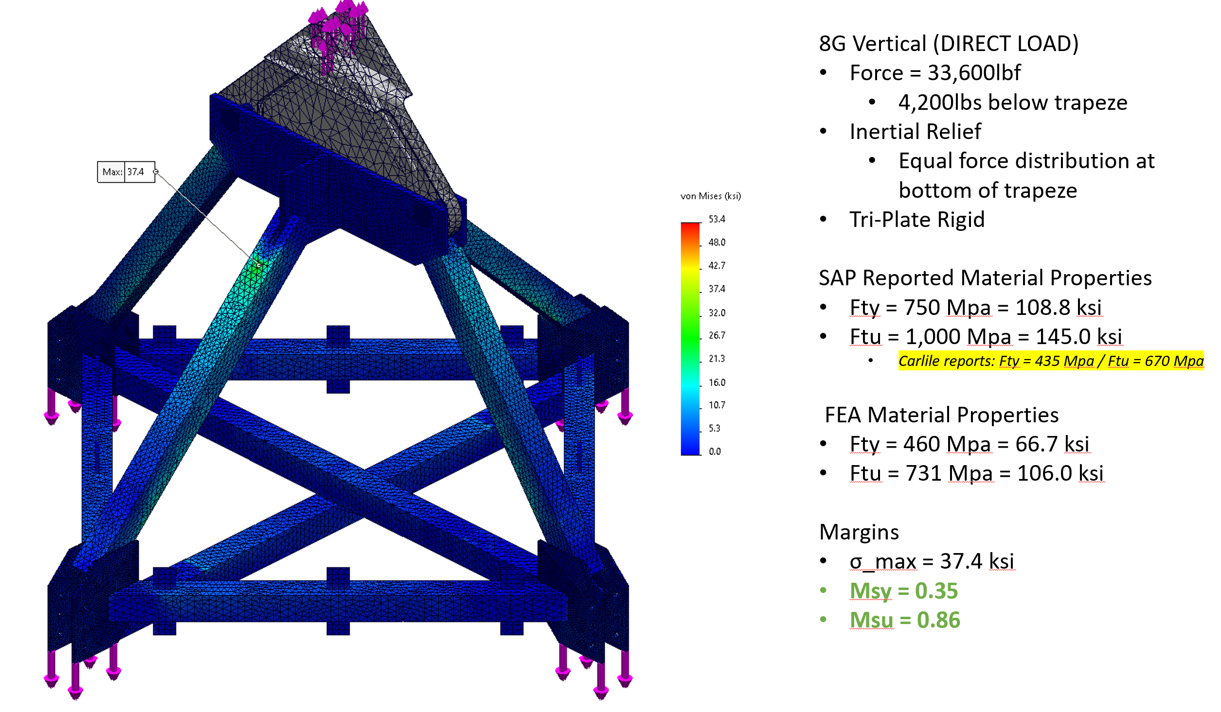
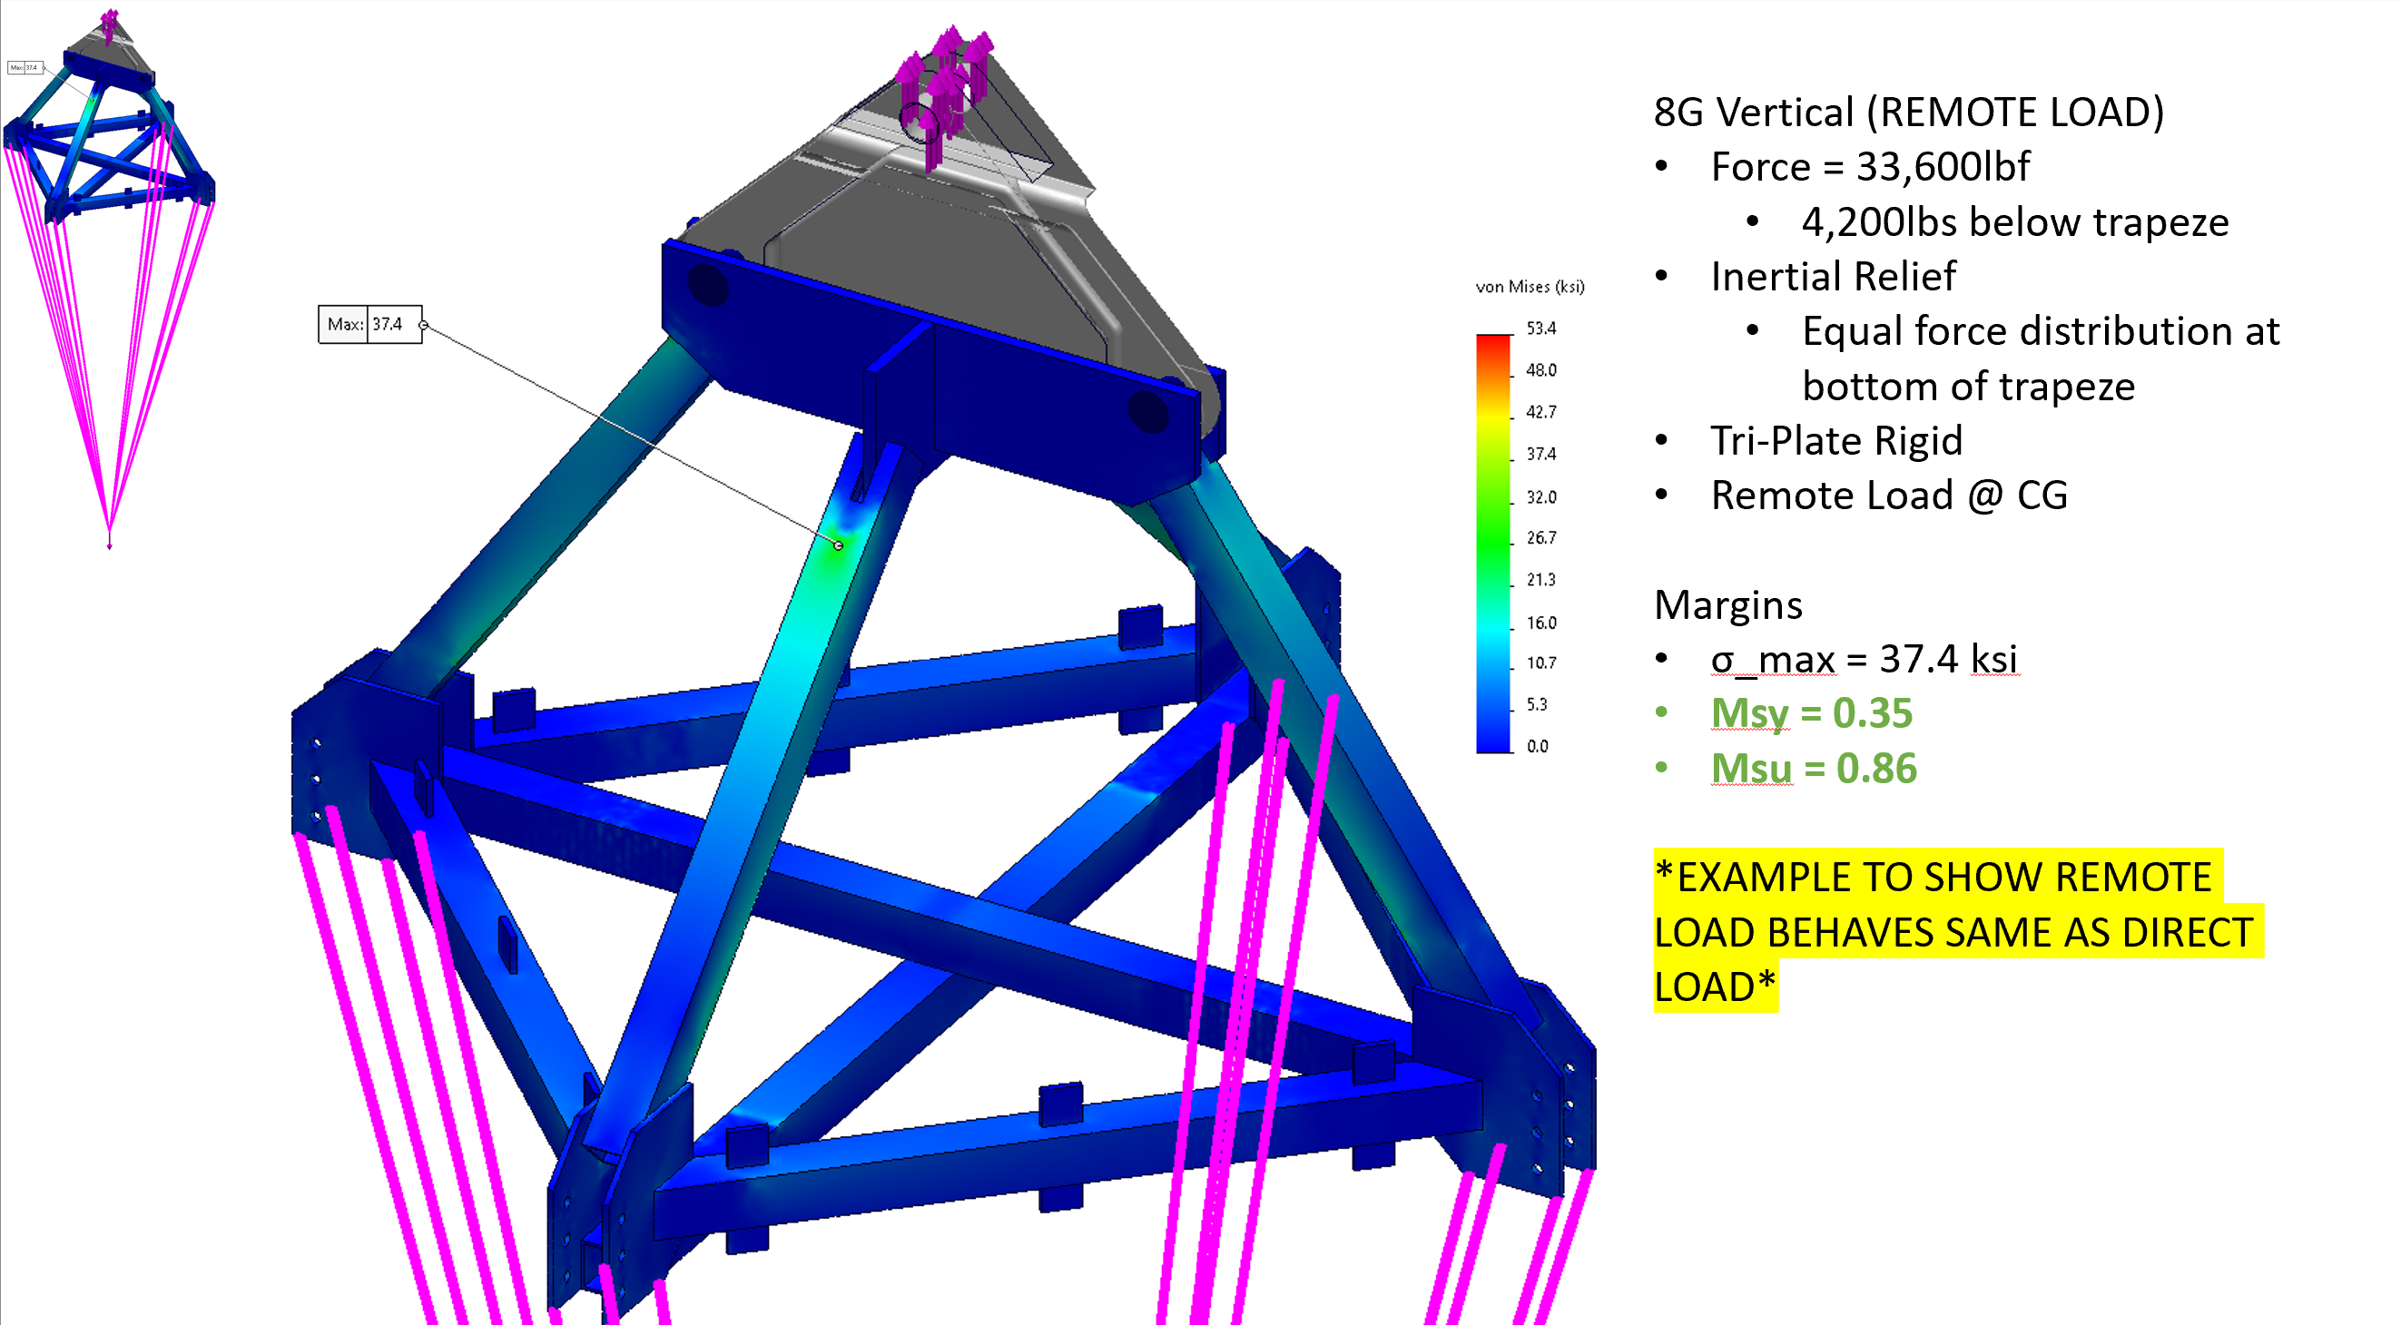
From HAO:
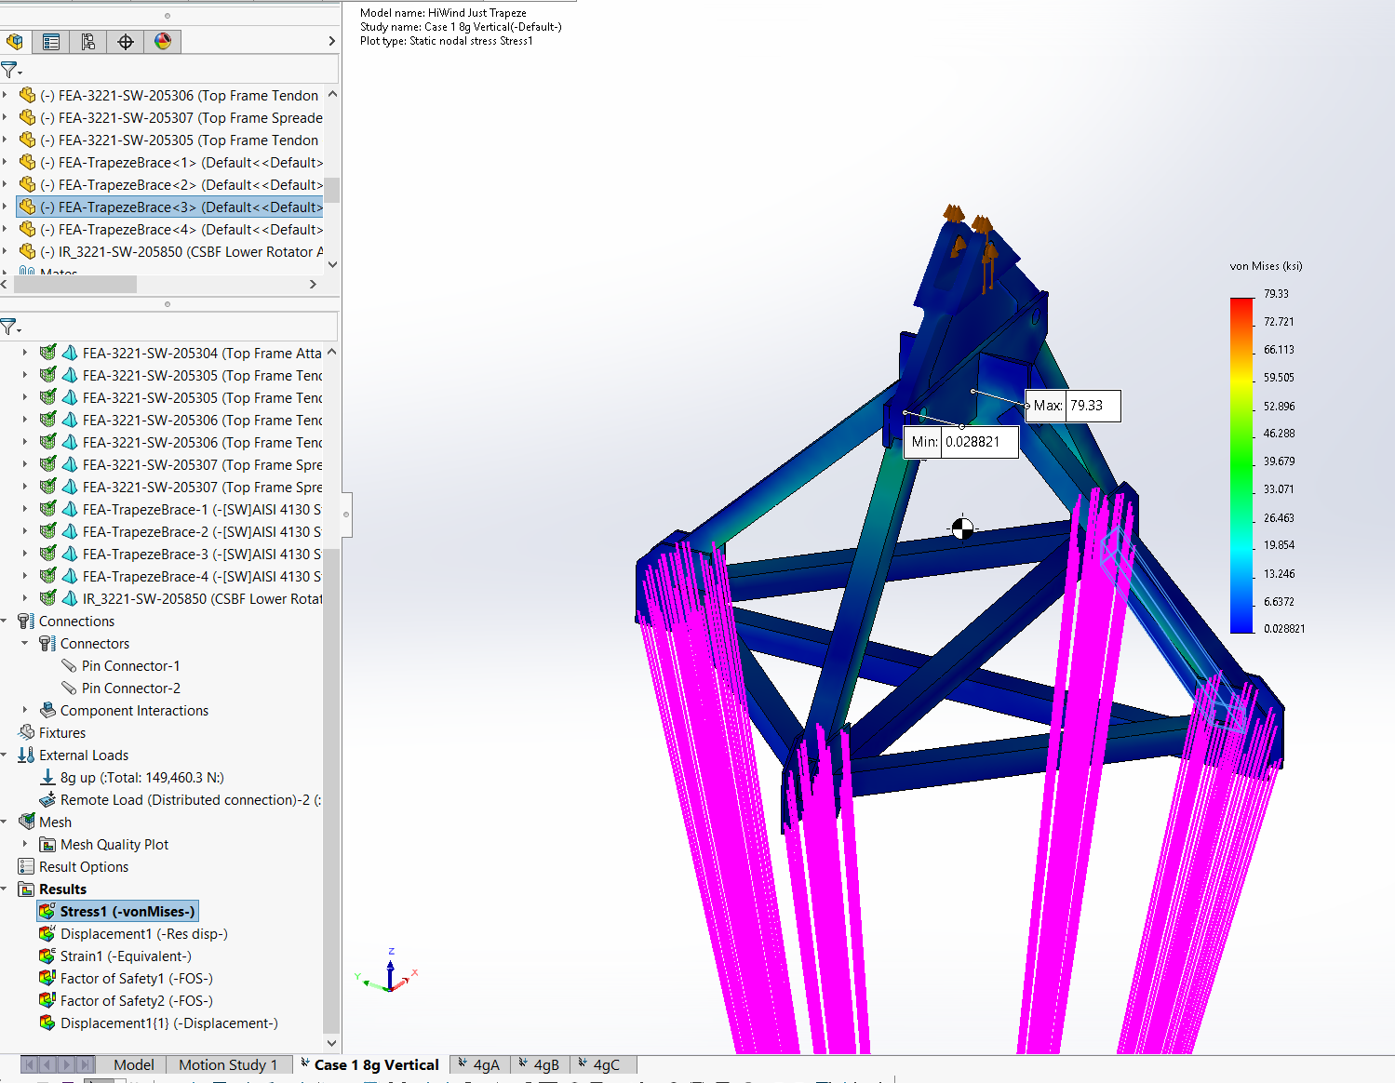

Trapeze 4gA Case
From Justin:
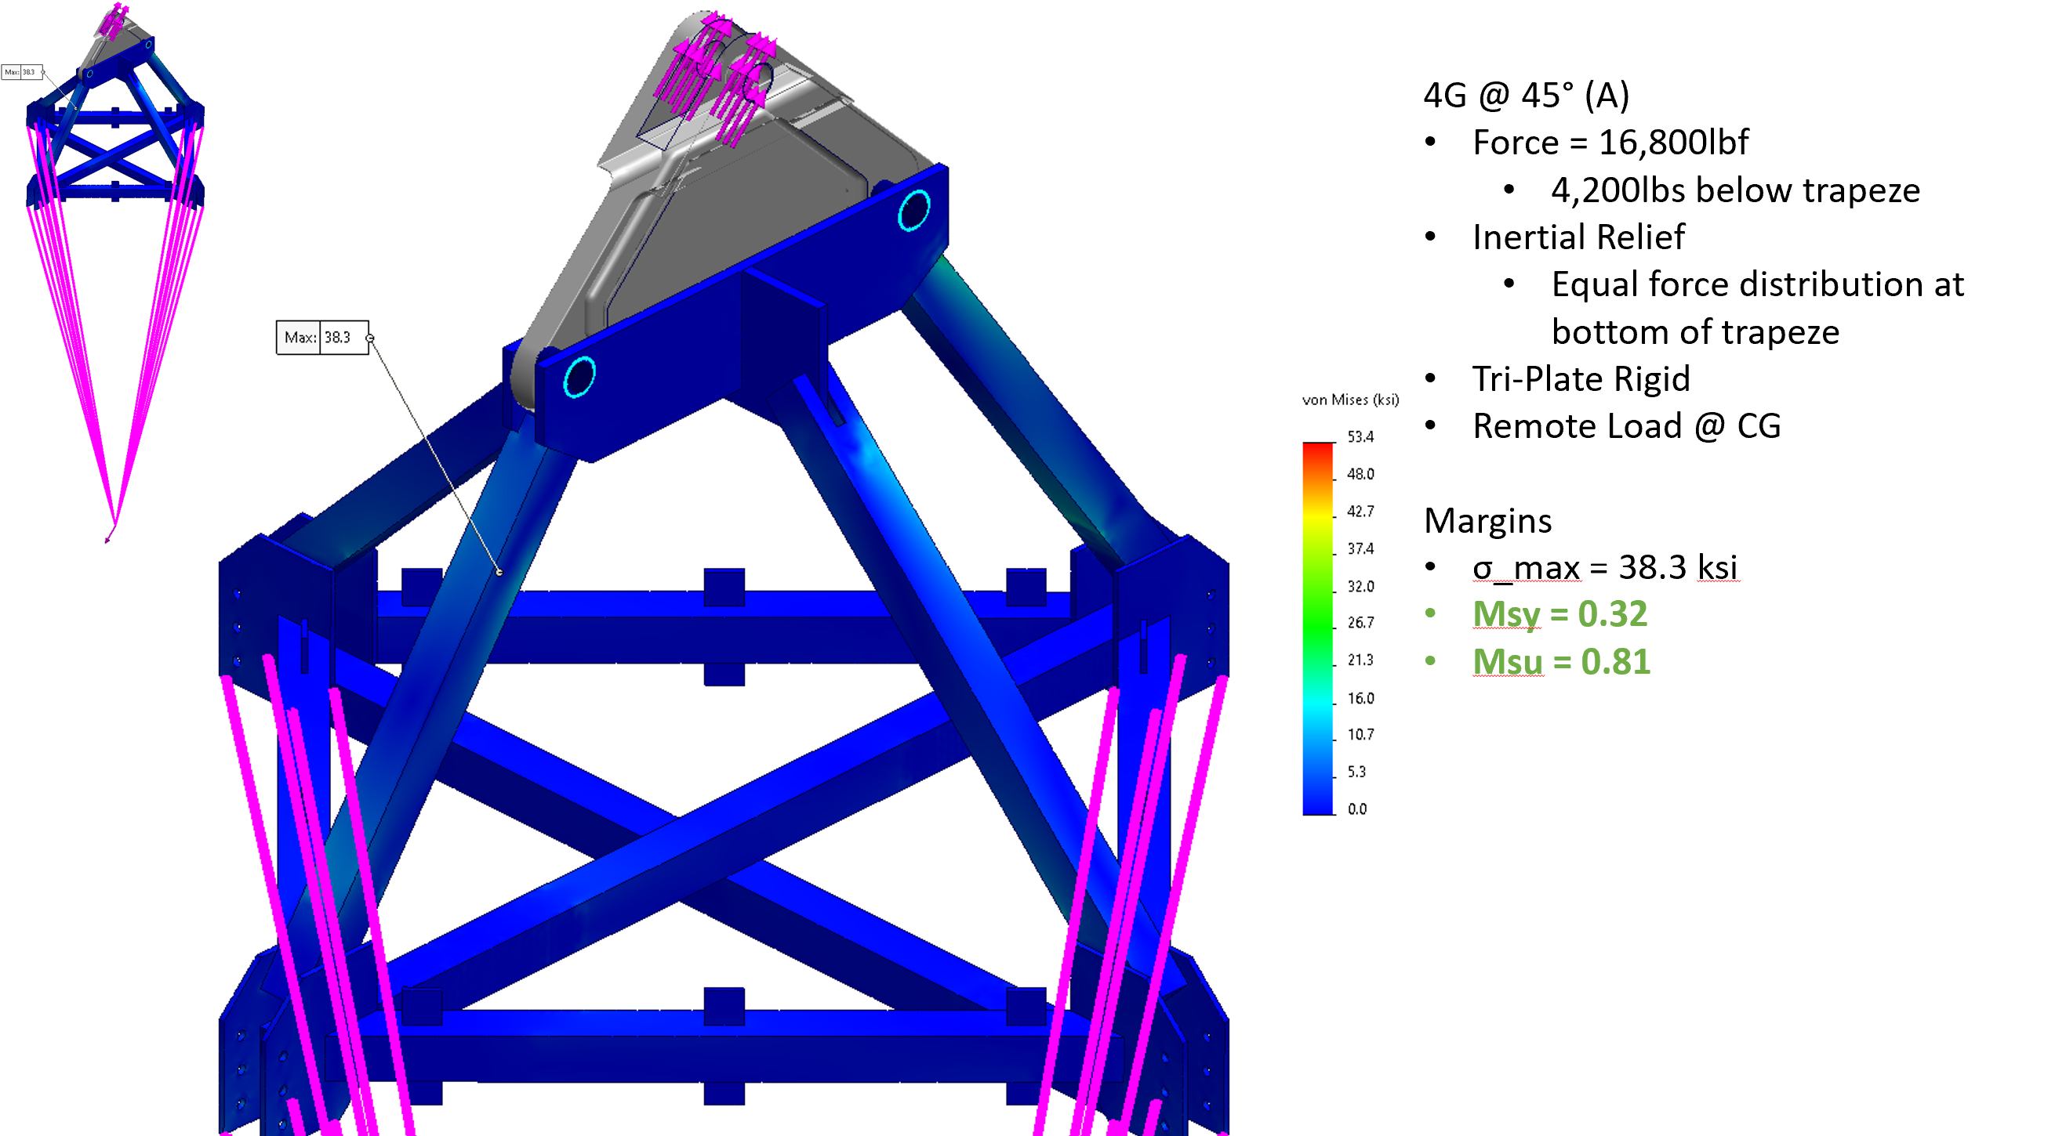
From HAO:
Setup of remote load:
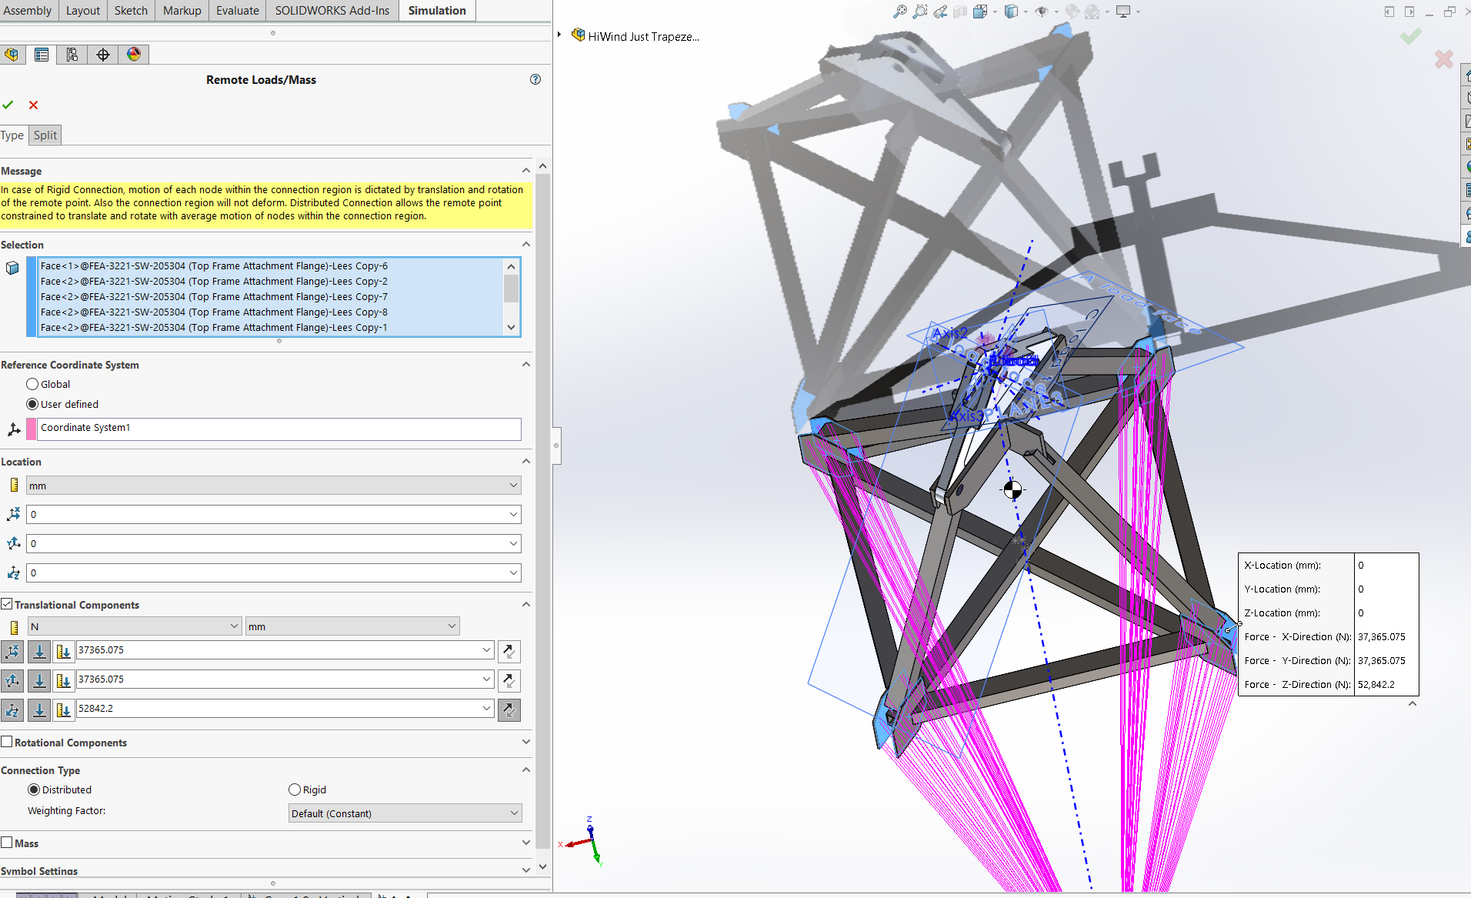
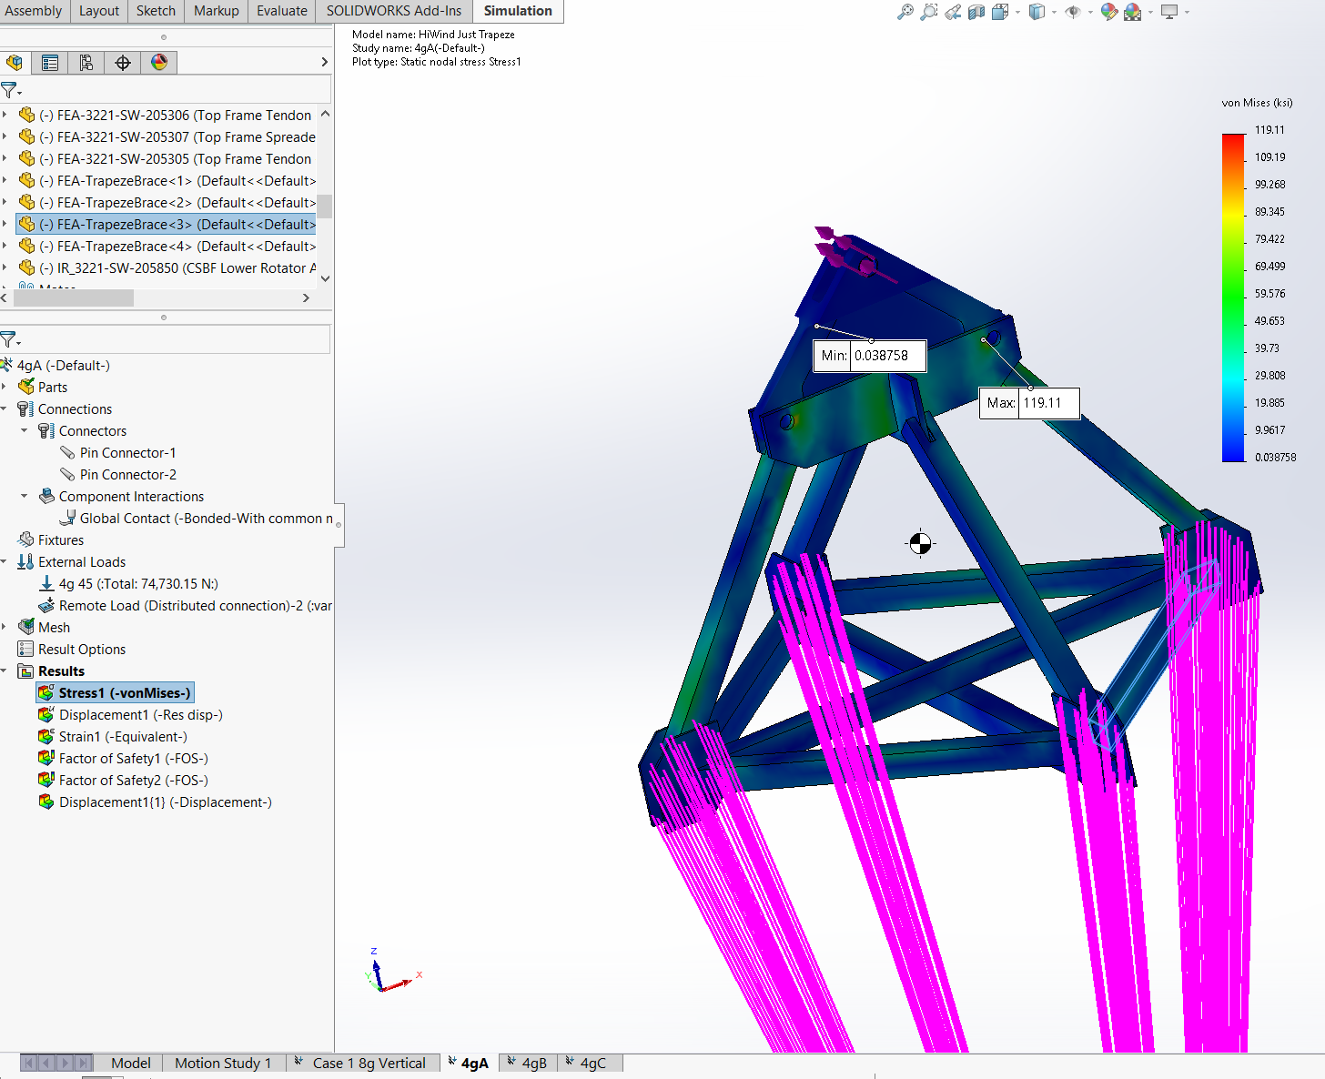

Trapeze 4gB Case
From Justin:
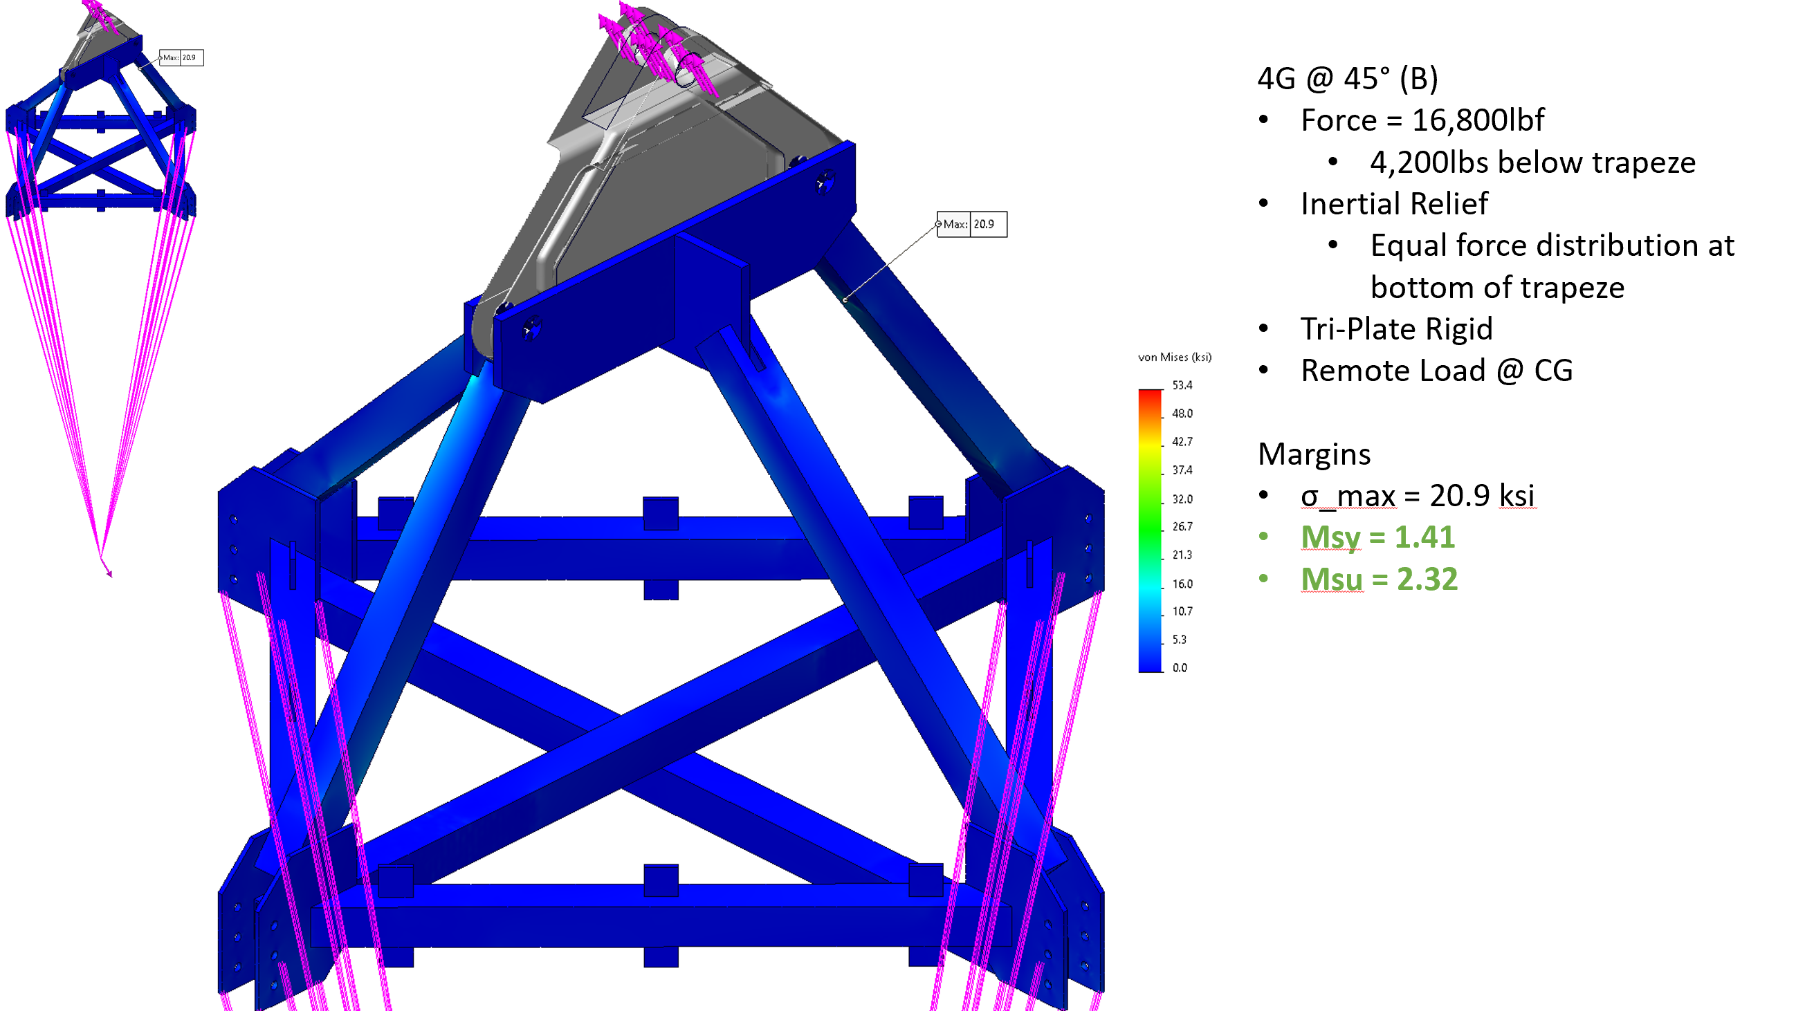
From HAO:
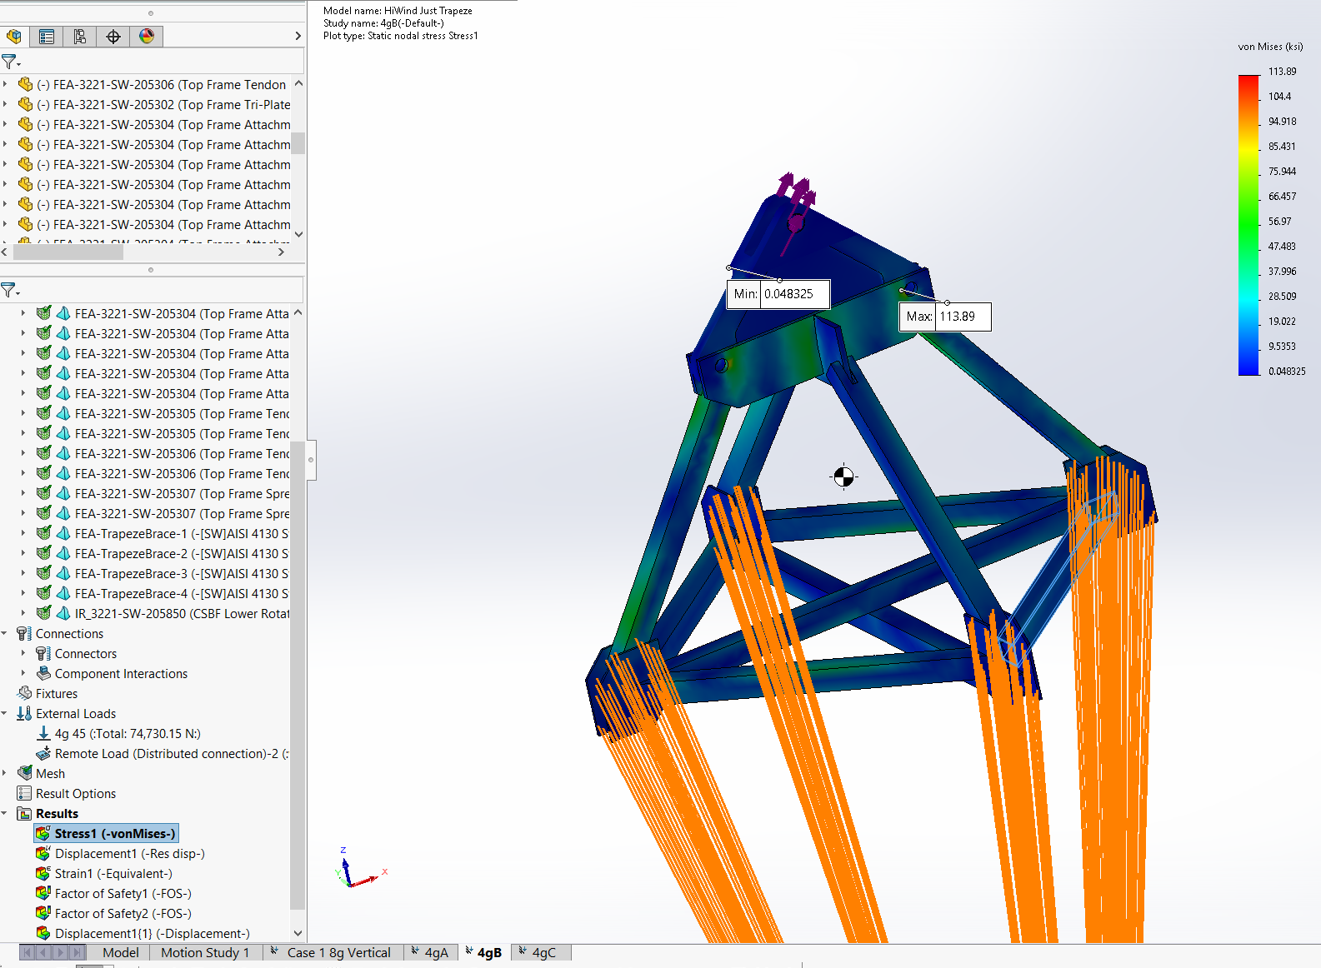

Trapeze 4gC Case
From Justin:
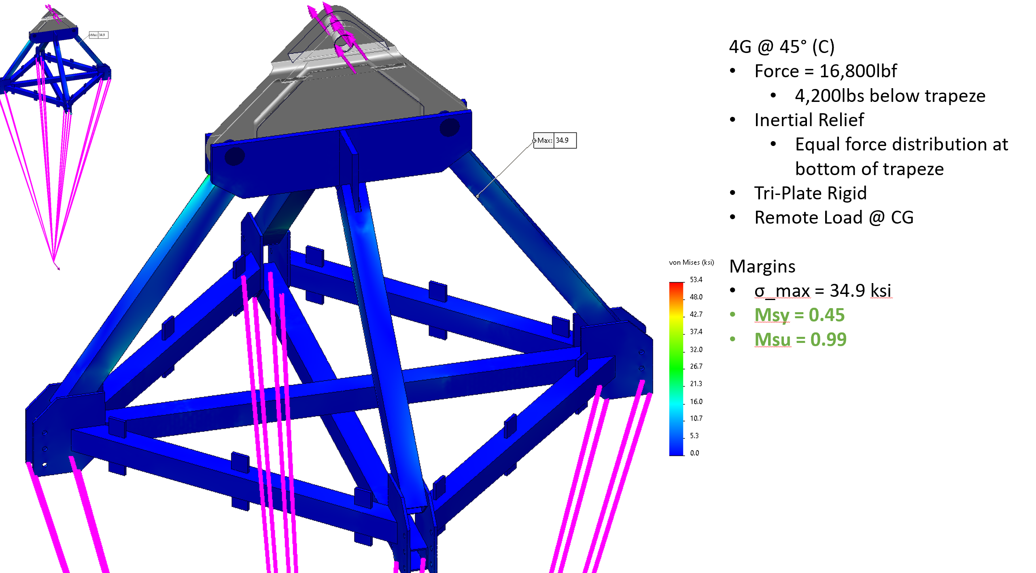
From HAO:
