KSO Lyot Filter Interface Control Document
5/13/21

Central Wavelength: 656.28 nm (H-alpha, see Figure 1)
• Passband fwhm: 0.05 nm
• Field-of-View: ±1.1 Rsun
• Tunable by temperature over a range of ±0.15nm from line center
• Compatible with the existing KSO H-alpha telescope (2000mm focal length, 100mm
diameter objective lens)

Figure 1 . Plot of the solar spectrum over a 0.5 nm range centered on H-alpha from the KPNO solar

atlas is shown for reference

Design
These requirements can be met with a 4-stage wide-field Lyot filter with pairs of calcite crystals
10.8, 5.4, 2.7 and 1.35 mm in thickness.

Size:
Weight:
Power:

Mount Interface:
Clear Aperture:
Angular FOV (design acceptance angle):
Temperature Controller

Questions
English or Metric HW?
ROHS Compliance

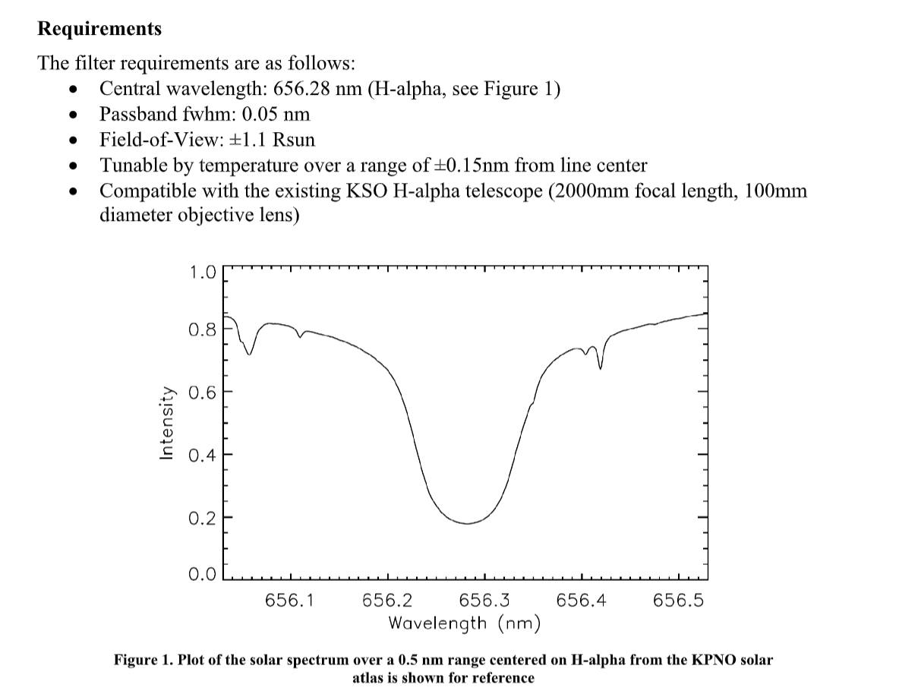

Just some graphics I am grabbing to get a feel for what we are building and what has been done.
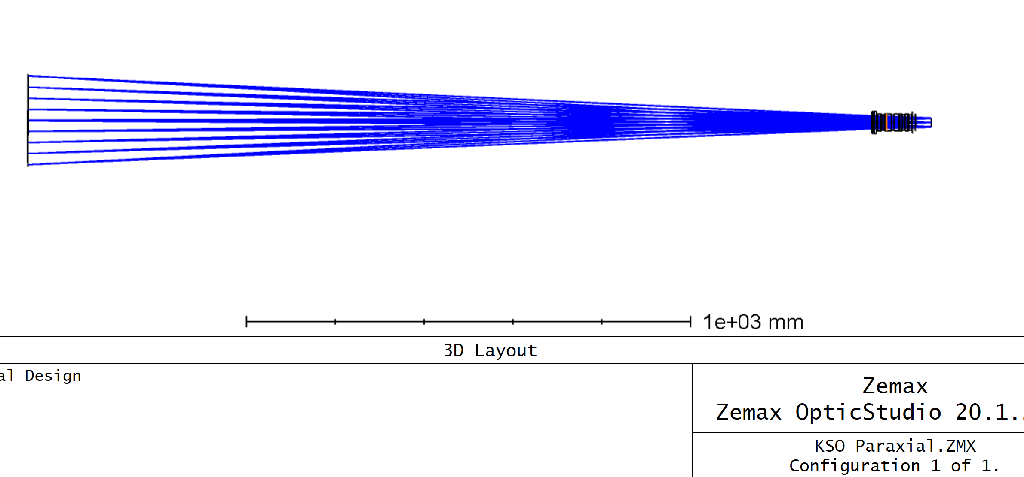
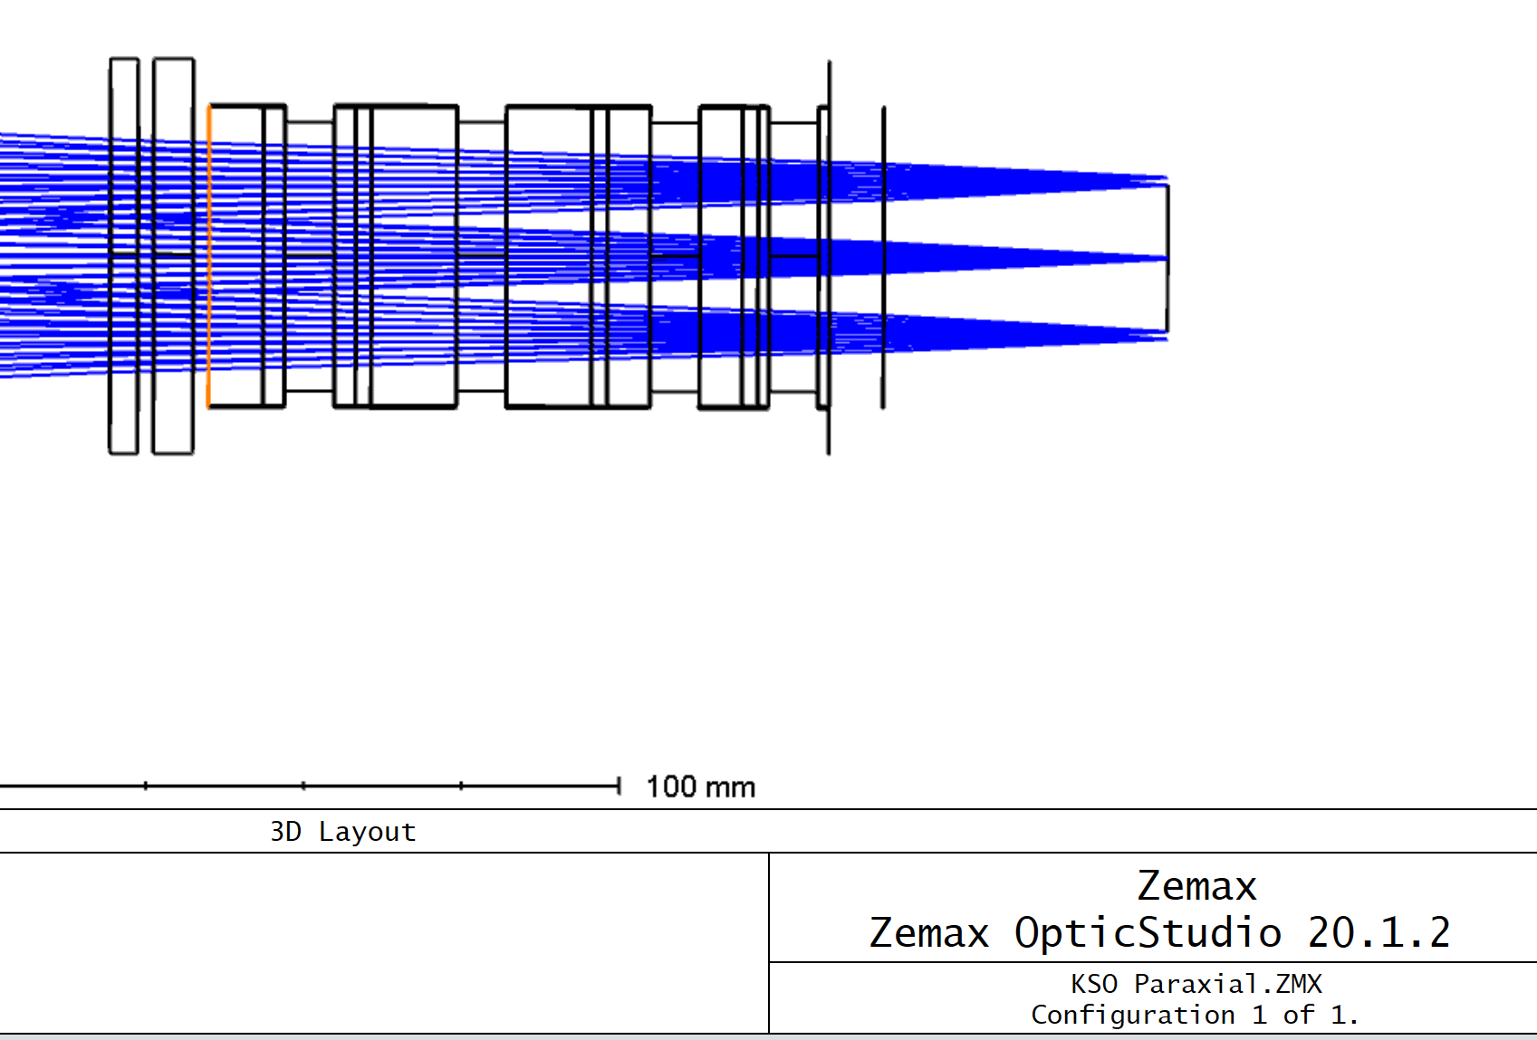
The two leftmost optics are Heat Rejection Filter, then prefilter, highlighted surface begins 1st calcite of Lyot filter

