

KSO H-Alpha Lyot Filter Operations & Characterization

Version Table
Date | Changes | Authors | Version
2024-04-17 | Release | Andrew Carlile, Damon Burke,  Scott Sewell,  Steve Tomczyk | 1

Table of Contents
Contents
Table of Contents
Version Table 1
Table of Contents 2
1. Introduction 3
2. Lyot Filter Requirements 3
3. Theoretical Performance 3
4. Opto-Mechanical Assembly 5
Order Selecting Pre-Filter 7
5. Quad Channel Heater Controller (QHC) 9
Sending Commands to the QHC 10
6. KSO Characterization Experimental Setup 12
7. KSO Characterization Data & Results 14
Filter Free Spectral Range 14
Filter Transmission Bandwidth 15

Introduction
This document details the operations guide for the KSO H-Alpha Lyot (Birefringent) Optical filter. It also documents the as-built performance of the filter as tested prior to delivery to the University of Graz in March of 2024.

Lyot Filter Requirements
  - Central wavelength: 656.28 nm
  - Transmission Passband: 0.05 nm
  - Temperature Tuned over a range of +/- 0.15 nm from line center.
  - Field of View (FOV) +/- 1.1Rsun
  - Compatible with KSO H-Alpha Telescope (2000mm focal length, 100mm diameter objective lens)

Theoretical Performance
Figure 1 Plot of the solar spectrum over a 0.5 nm range centered on H-alpha from the KPNO solar atlas is shown for reference.
Figure 2 Modeled transmission profile for the KSO Lyot Filter.
Model calculations predict that tuning over a wavelength range of ±0.15nm around H-alpha (656.28nm) will require a temperature range of approximately ±4.5C and that tuning will be linear through this range. Increasing filter temperatures will result in a blue shift of this channel spectrum towards shorter wavelengths at a rate of ~0.03nm/C.

Opto-Mechanical Assembly
A full drawing package has been included with this manual entitled “zip file name from Andrew”. Shown here are just a top-level cross-section of the filter and a photograph of the as-built assembly.
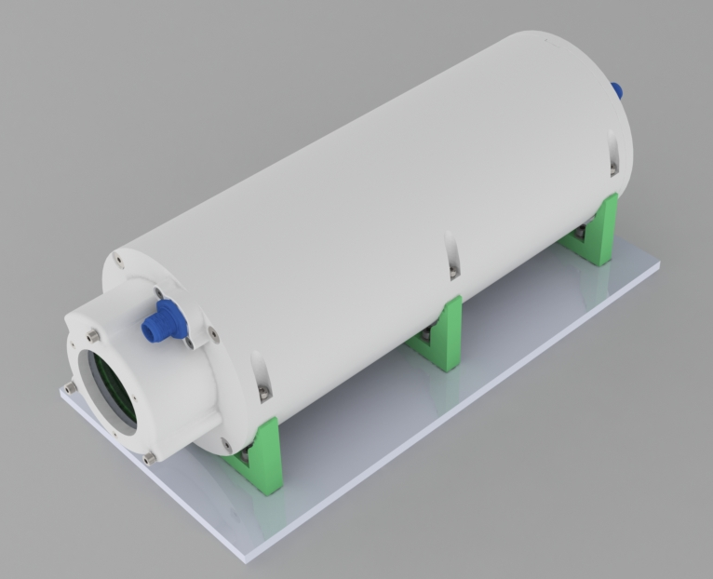
Figure 3 Model rendering of KSO H-Alpha filter.
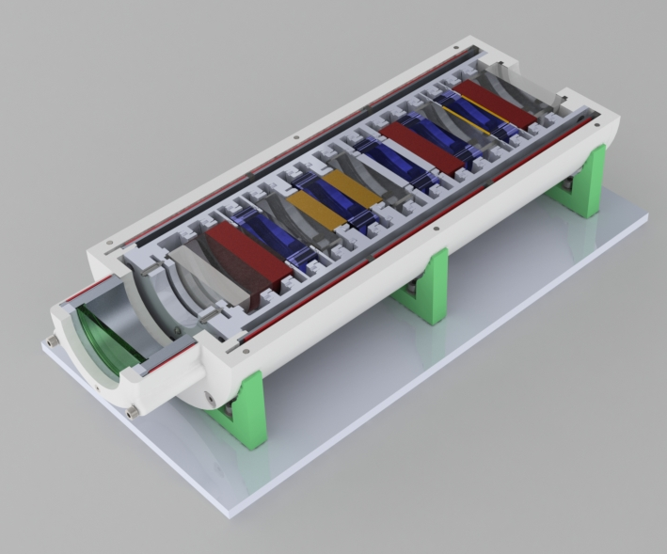
Figure 4 Tilted cross-section view of KSO filter
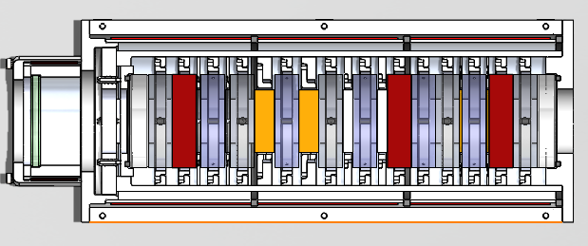
Figure 5 Normal cross-section view.

Order Selecting Pre-Filter
In order to isolate a specific transmission peak from transmission spectrum shown in Figure 2 the KSO filter birefringent stack is preceded by an ultra-narrowband pre-filter (Alluxa 11221) with a Center Wavelength (CWL) = 656.35 +/- 0.1 nm and a Full Width Half Height (FWHH) transmission of 0.49 +/- 0.05 nm. The filter’s FWHH is approximately half the free spectral range (FSR) of the filter itself in order to sufficiently isolate a single transmission order of the channel spectrum (see Figure 2 and Figure 13)
- Link to Alluxa Data Sheet: Internal Spec: 11221 Description: 656.35-0.49 OD6 Ultra Narrow BP

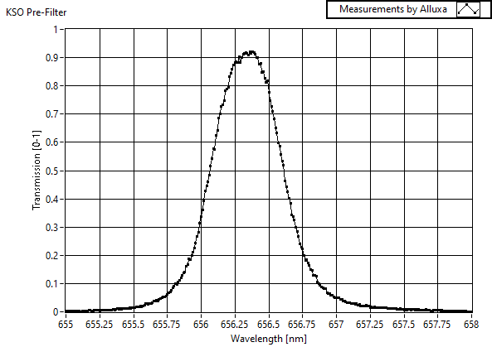
Figure 6 Measurements of the Alluxa ultra-narrowband pre-filter transmission (Part #11221) used to isolate a single order of the KSO Lyot Filter’s channel spectrum.
The prefilter is designed for a 1.38/2 (0.7 degree cone half-angle (CHA) at 0 degrees angle of incidence (AOI). See https://alluxa.com/optical-filter-specs/cone-half-angle-cha/ for more information. Increasing CHA tends to blue-shift the pre-filter bandpass but will be extremely slight for the expected 0.7 degree CHA within the KSO H-Alpha telescope system.
This filter has a CWL dependence of less than 0.0025nm/C and higher operating temperatures will result in a red-shift of the CWL. Since the KSO filter will be operated at a nominal temperature of 36C, this dependence was measured in the laboratory and shown below. The measured value of the pre-filter CWL red-shift is 0.0018nm/C signifying that this pre-filter will not introduce a noticeable change in the overall KSO filter performance over its operating temperature range. The pre-filter temperature dependence is about 20 times less than that of the Lyot-Filter and in the opposite direction.
Figure 7 HAO Measurement of KSO Pre-filter transmission stability against changing operational temperatures. Measured CWL red-shift is only 0.0018 nm/C (17px). Filter specification is <0.0025 nm/C. For context, H-Alpha line at 656.28nm is centered at pixel 2162 +/- 10px.

Quad Channel Heater Controller (QHC)

Shown below is the filter’s temperature controller board. The QHC uses a microcontroller to provide four independent channels of PWM heater control. The non-conductive plastic enclosure and has 4 external connections:
- Sheathed heater/sensor cable for the front of the KSO, carrying the temperature sensor connections for channel 1 (the pre-filter assembly attached to the sunward side of the Lyot Filter) and the wires for all four heaters
- Sheathed heater/sensor cable for the back of the KSO, carrying the temperature sensor connections for channels 2-4 (measuring the temperature of each of the three internal wide fielded optical stages comprising the Lyot Filter)
- Barrel connection for the external power supply (6A@12VDC) (Part Number : PPL90U-120)
- USB connection for changing the PID or set point parameters of the filter temperature controller

The QHC will tolerate a wide voltage range but the delivered configuration works best at 12V. A USB connection is not required for operation.

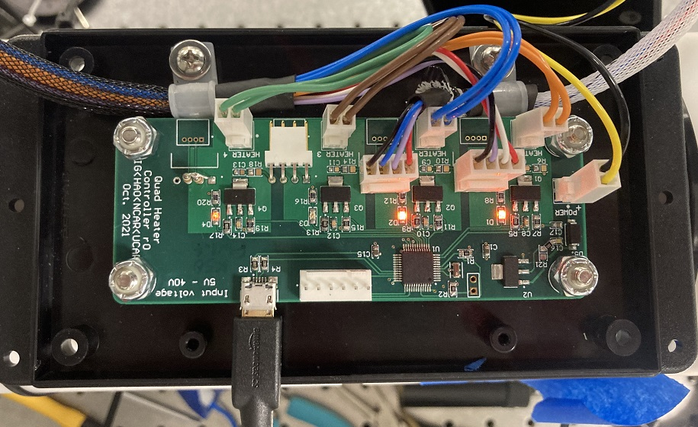
Figure 8 Quad Heater Controller (QHC). ). The LEDs were removed before delivery.
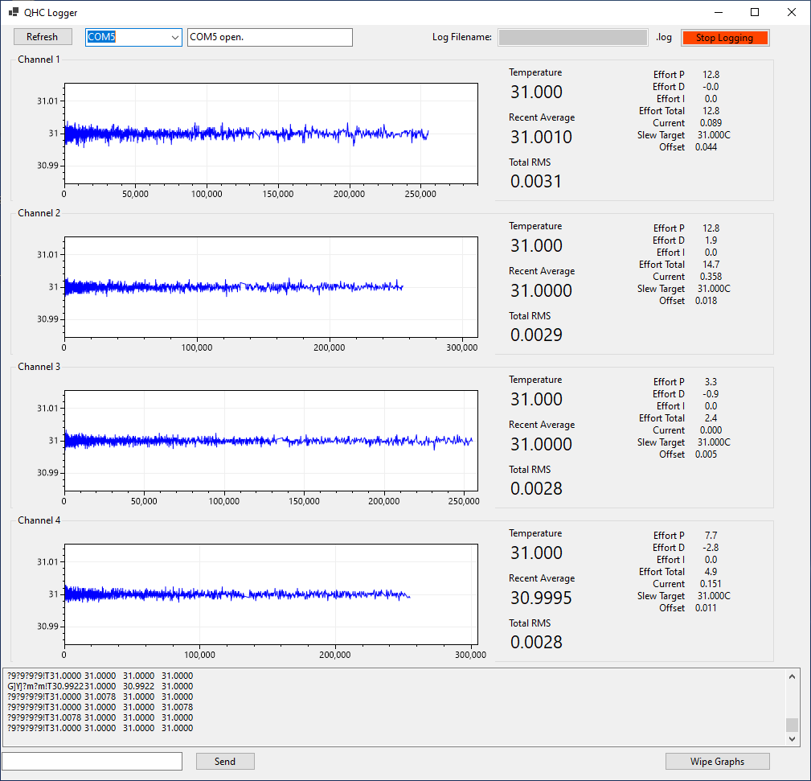
Figure 9 Quad (Zone) Heater Controller (QHC) laboratory performance over a 72-hour period. Lab environmental temperatures varied over +/- 2 degrees during this period.

Sending Commands to the QHC
Commands may be sent to the QHC through the text box shown in the lower left hand corner of Figure 2. Sending command “?” returns a list of all possible commands. Use the scroll bar on the right hand side of the display window to view earlier output which has scrolled out of view. Commands can be upper or lower case. Spaces are ignored.
The four channels of the QHC are completely independent. Changes are made by first selecting the desired channel (if not already selected) and then entering the command.

Some particularly useful commands are:
- C1 (or C2,C3,C4) will select a heater zone and display the values for that heater zone
- EC “Enable Channel” will enable power output of the currently selected channel
- TG# “Target” will set the desired target temperature for the selected channel (e.g. TG36.9)
- SV will “Save” the current configuration which will run automatically the next time the QHC is powered on
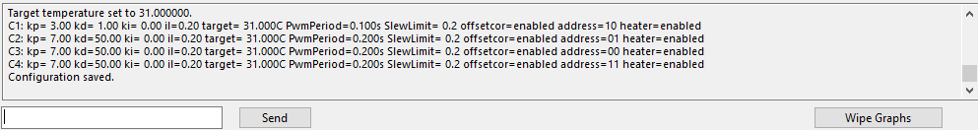
Figure 10 Response from QHC following a series of commands to display the configurations currently saved to channels 1,2,3 and 4 (the complete filter)
In QHC Firmware v2.1 a complete list of possible commands include:
- C n -- selects a controller to configure (and show configuration)
- AD nn -- sets the address of the temperature sensor (00, 01, 10, or 11)
- KP n.nn -- sets the proportional gain
- KD n.nn -- sets the derivative gain
- KI n.nn -- sets the integral gain
- IL n.nn -- sets the integral limit (0-1)
- TG n.nn -- sets the target temperature
- PP n -- sets the PWM period (in milliseconds, 20ms resolution, 1000ms max)
- TO n -- sets the watchdog timeout in seconds
- SL n.nn -- sets the slew limit in degrees per minute
- EC -- enable controller (heater output)
- DC -- disable controller (heater output)
- EO -- enable offset correction
- DO -- disable offset correction
- U -- shows the status of all of the controllers
- R -- shows an easily parsable version of Update
- Wipe -- wipes the existing configuration and loads the defaults
- Bounce -- performs a power-cycle / reboot on the system
- LD -- reloads the previously saved values (automatic at power-on)
- SV -- saves the currently configured values
- -- toggle automatic data flood

Delivered Configuration
The configuration parameters at delivery can be restored with the following commands:
C1  KP 3  KD 1  KI 0  IL 0.2  AD 10  PP 100  SL 0.25  TG 36.24  EC  EO | C2  KP 7  KD 50  KI 0  IL 0.2  A 01  PP 200  SL 0.25  TG 36.24  EC  EO | C3  KP 7  KD 50  KI 0  IL 0.2  A 00  PP 200  SL 0.25  TG 36.24  EC  EO | C4  KP 7  KD 50  KI 0  IL 0.2  A 11  PP 200  SL 0.25  TG 36.24  EC  EO

All four channels are intentionally restricted to a rate of change of 0.25 degrees Celsius per minute. The PWM period of channel one is reduced due to the much lower thermal mass. The software watchdog (set with the TO command) should not be used with KSO. There is a hardware watchdog which will reset the QHC after 8 seconds if the main thread stops running.

KSO Characterization Experimental Setup

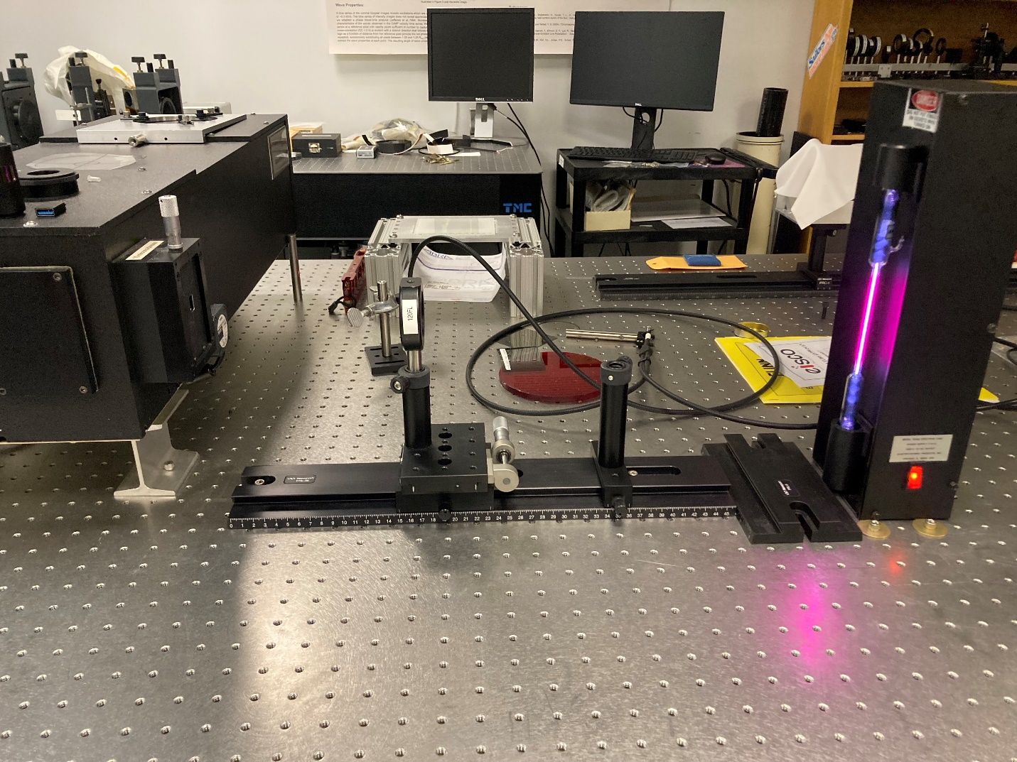
Figure 11: Emission line measurement comprises a suitable gaseous capillary tube and a lens of approximately 120mm focal length. The Acton slit can be opened to 10 microns to aid in the alignment of the capillary tube/lens but is then reduced to ~3-4 microns to match the ZWOASI1600MM camera pitch of 3.6 microns. This setup was used to characterize the KSO H-Alpha filter throughout this report.

In the above setup, the 120mm focal length lens is placed ~185mm from the slit with the capillary discharge tube located ~600mm from the slit. The discharge tube power supply is held against an orthogonally oriented 6” rail and also against two ¼-20 screws and washers locked to the table in order to fully constrain its position (more or less). The two degrees of freedom are the distance between the lens and the slit (nominally about 185mm in this photo) and its transverse position which is controlled to a few microns with the cross-mounted micrometer driven stage. The slit width itself has been adjusted to ~4 microns to match the pixel pitch on the ZWO ASI1600MM camera.

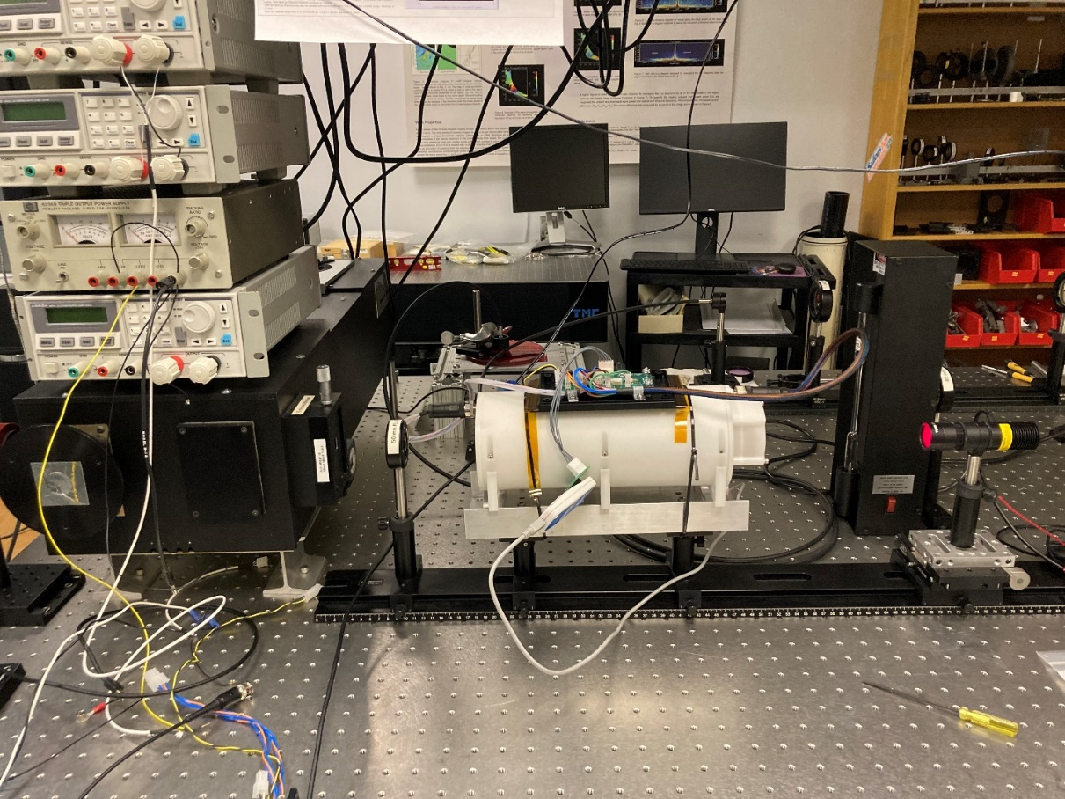
Figure 12 Spectral characterization of KSO H-Alpha Filter in front of Acton SpectraPro 2750 monochromator (2400lpmm grating). Near collimated light source is a Thorlabs LED with a 20nm emission halfwidth.
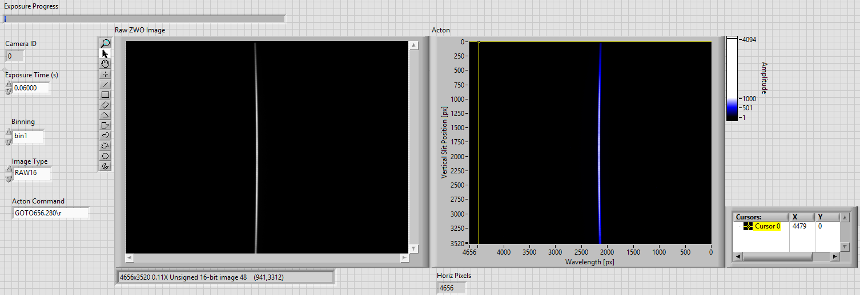
Figure 13: Image on the left is the raw image acquired by the ZWO in the focal plane of the Acton spectrograph. The figure on the right has been inverted to correctly show wavelengths increasing from left to right. Action Center is at 656.28nm and a 60ms integration time was used (slit width was 3.0 microns). This measurement exhibits a fair bit of wavelength curvature in the focal plane but repeated independent measurements and selecting a limited region of the slit image for analysis result in a standard error in the line center determination of 1.2 pixels and a standard error in the determination of the FWHM of 2.3 pixels. The dispersion of the Action spectrograph is 924 pixels nm⁻¹.

KSO Characterization Data & Results

Filter Free Spectral Range

Figure 14 Measurement of KSO Filter Free Spectral Range. KSO Transmission (2024-Feb-26) - No Prefilter.xlxs. As discussed in Section 4, the ultra-narrowband prefilter from Alluxa was specified to isolate a single order of this channel spectrum.

Figure 15 Line centers of adjacent orders were observed at 2911 and 2138 pixels. Using the nominal spectrometer dispersion of 924px/nm demonstrates a Free-Spectral Range (FSR) of 0.84nm.

Filter Transmission Bandwidth

Figure 16 Measured KSO filter transmission profiles. For comparison, a model profile is shown in Figure 2.

Figure 17 Measured KSO filter transmission profiles superimposed over a measured spectrum from a hydrogen discharge lamp (656.28nm). The FWHM of the KSO filter transmission in 0.049nm (requirement is < 0.050nm)

Figure 18 Calibration of the KSO Lyot filter transmission wavelength vs. equilibrium body temperature. The red line indicates the position of H-alpha at 656.28nm. The slope of the indicated trendline demonstrates a tuning rate of 0.037nm/C, (in agreement with the predicted value of 0.033 nm/C). The graph also demonstrates the filters’ ability to tune through +/-0.15nm about 656.28nm. The setpoint temperature for H-alpha line center measurements is 36.24C.
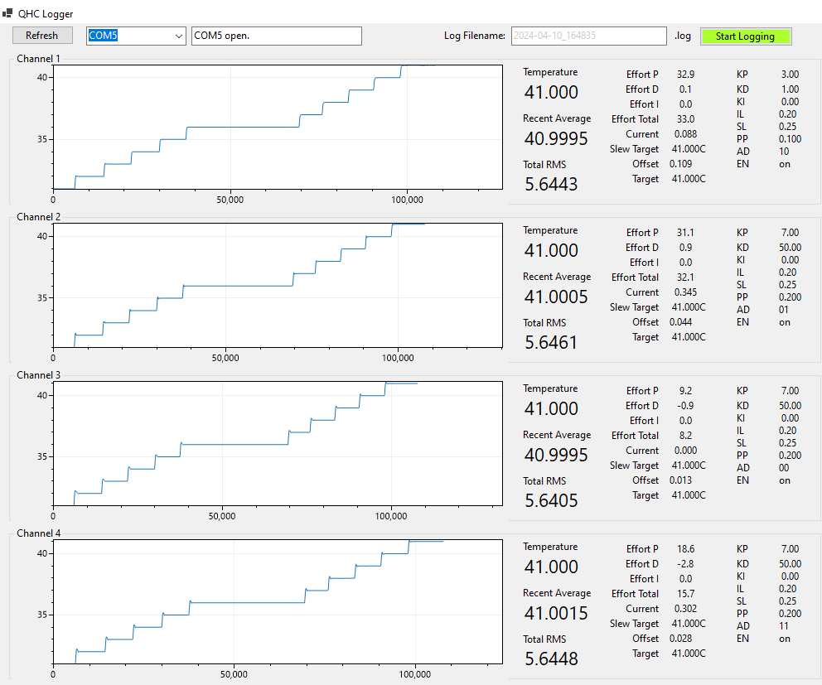
Figure 19 Temperature plateaus at which each of the transmission spectra were obtained. Equilibrium control of the KSO filter is estimated to require 60 minutes for a 1 degree C step increase. Calibration data were acquired after waiting a full two hours for equilibrium to be reached throughout the entire optical filter.

