KSO Assembly notes
9-27-22
Andrew Carlile
Uses pictures and information from: ..\KSO-HAO H-Alpha Filter Design Review.pptx

Design
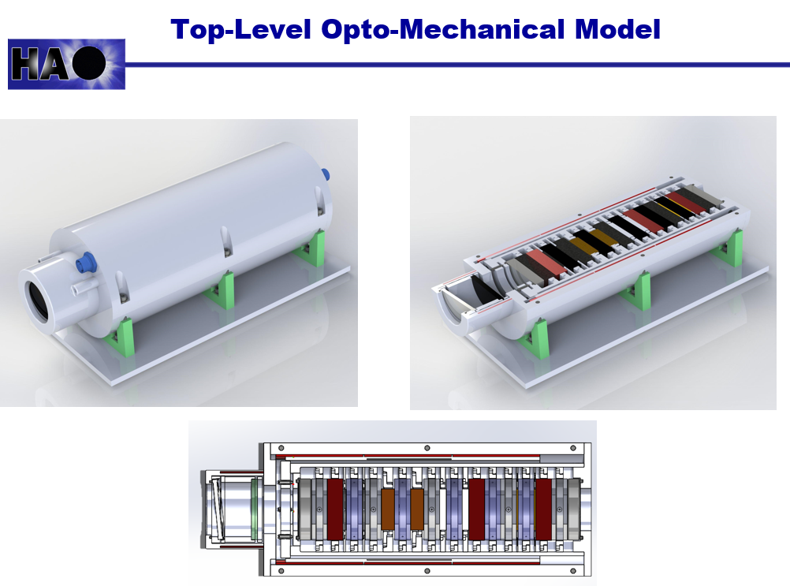
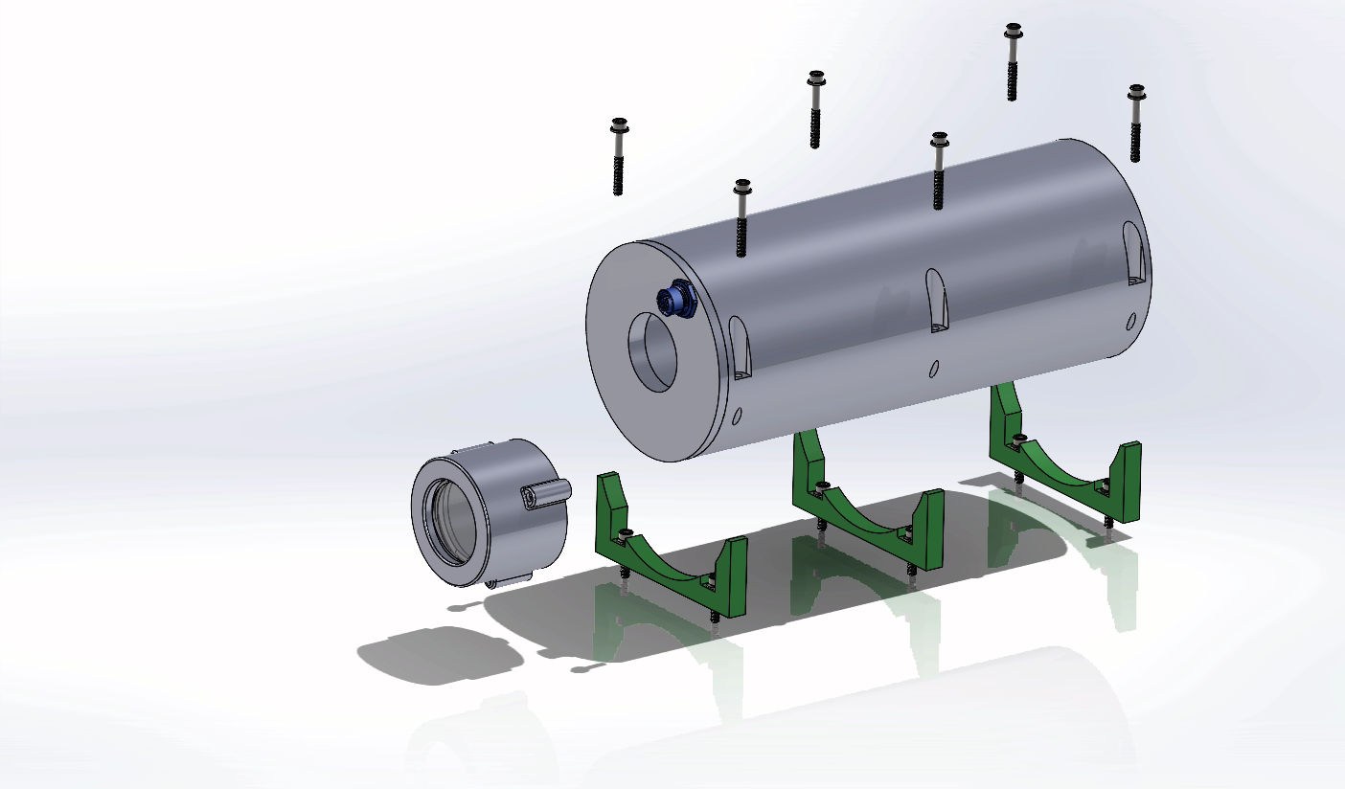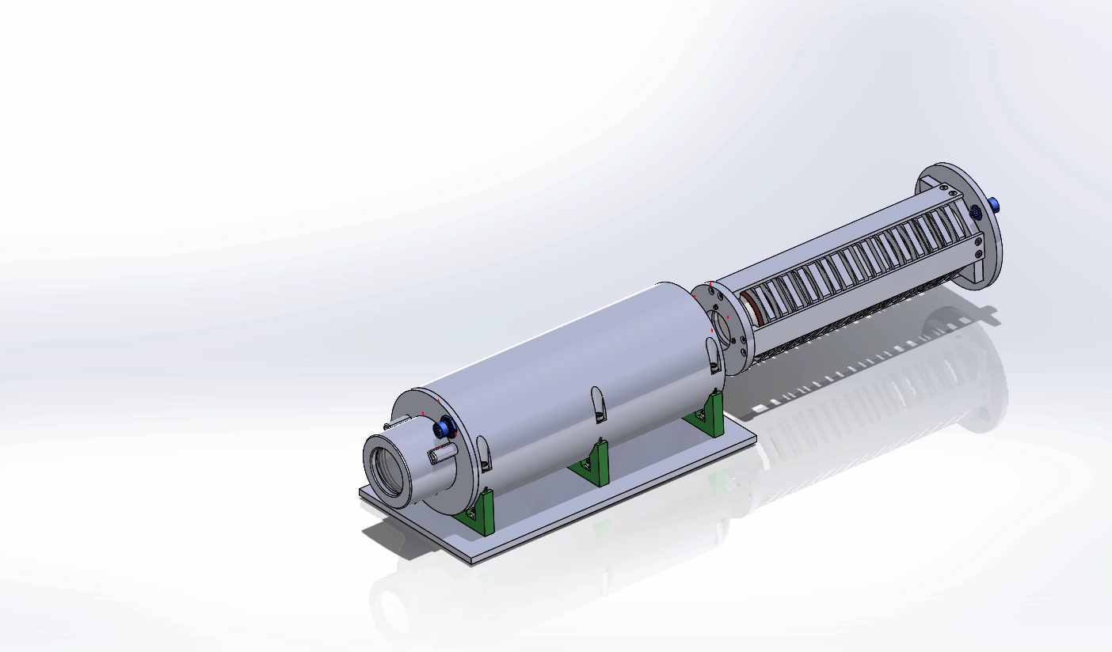
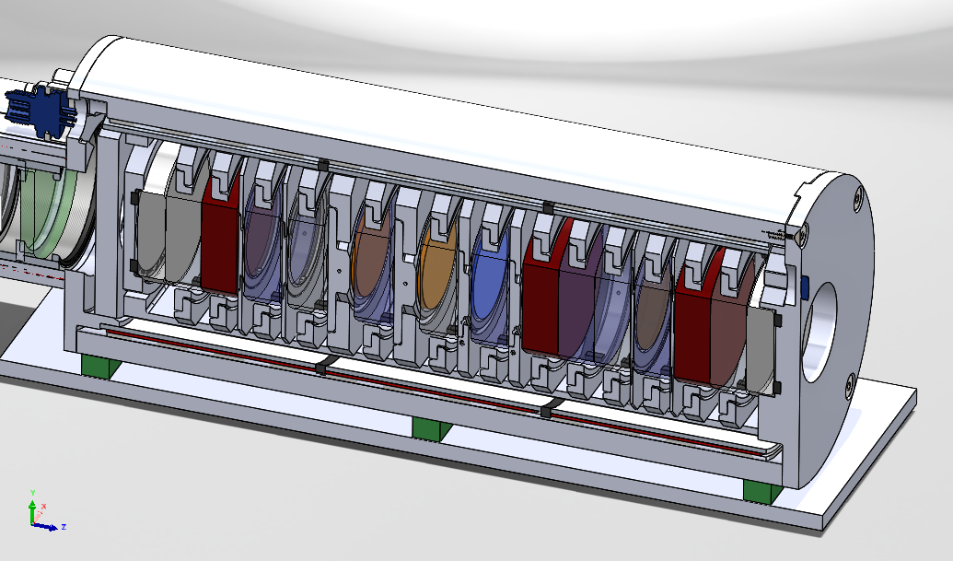

2 Step Single Optic Adhesive Assembly
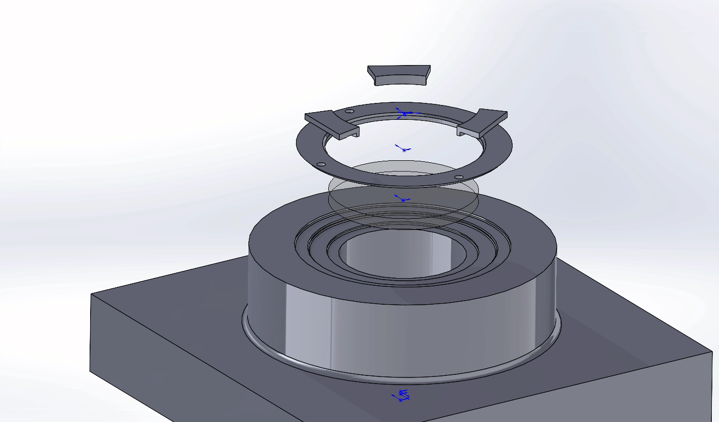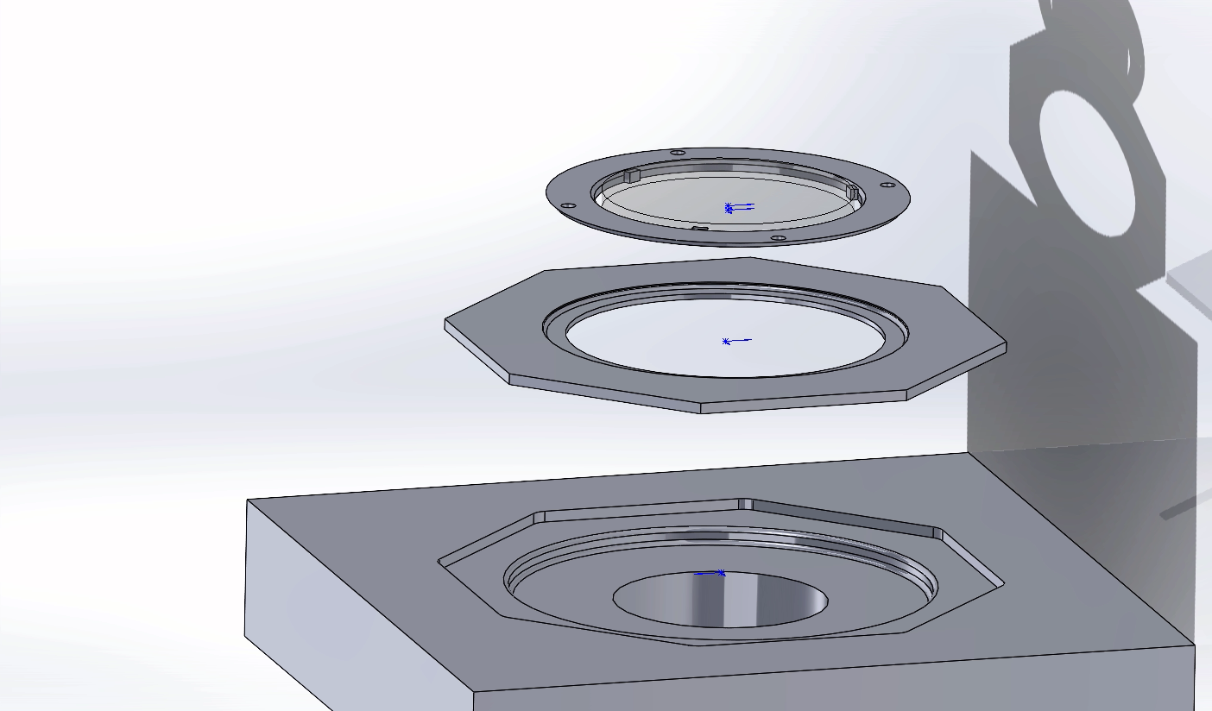
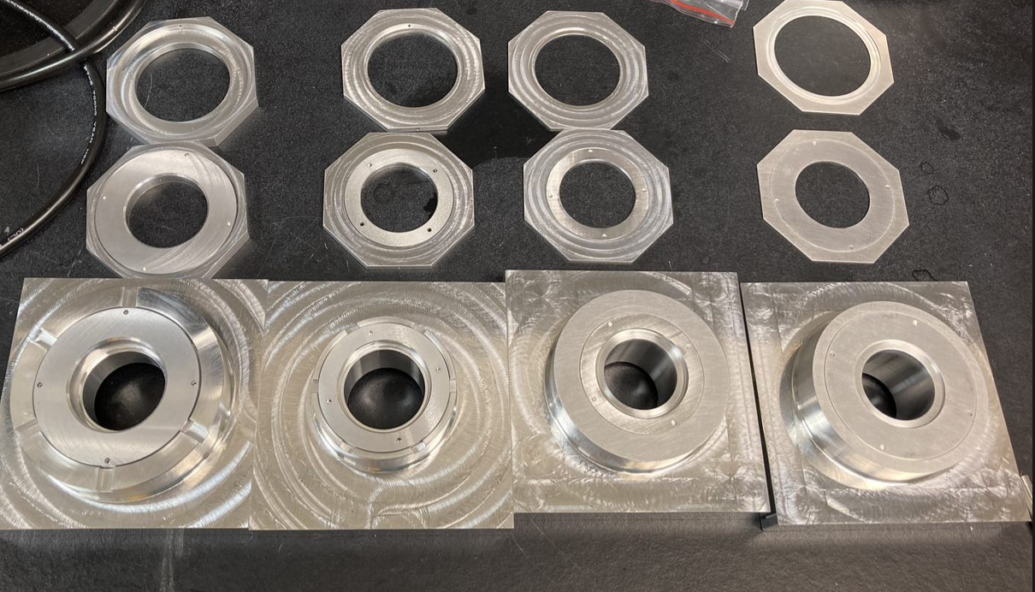

Athermalization test
Pat Zmarzly and I assembled 2 mcmaster windows in a jig very similar to the jigs for the non-calcite optics. One was bonded at room temperature, and 1 at 40 C. 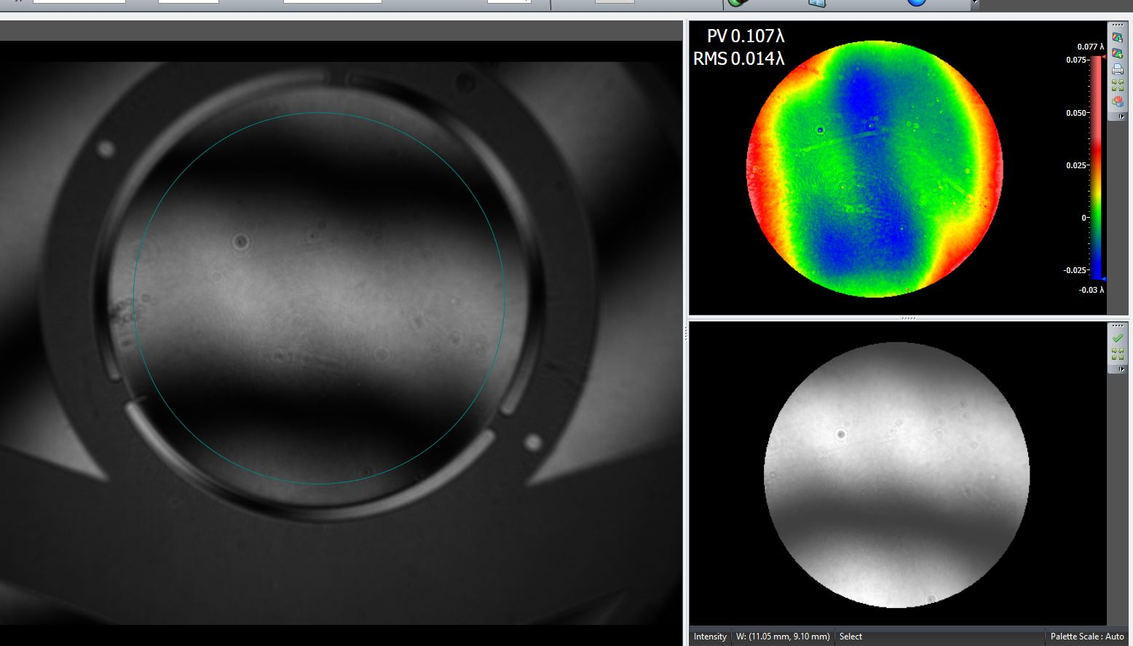
Figure 1 room temp bonded test window
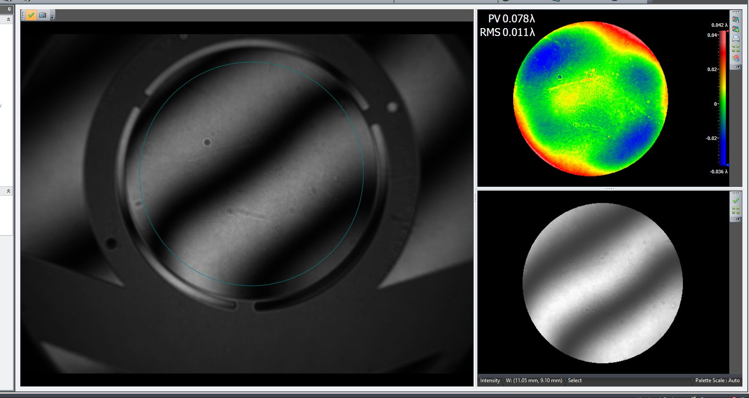
Figure 2 40 C temperature of assembly during bond result
The design is very athermal.

Pictures of Adhesive process
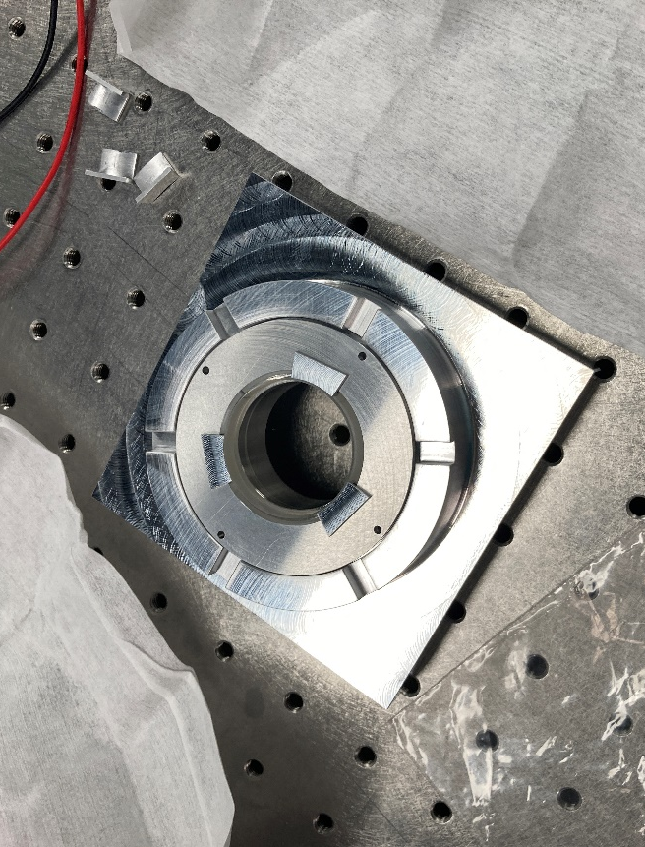
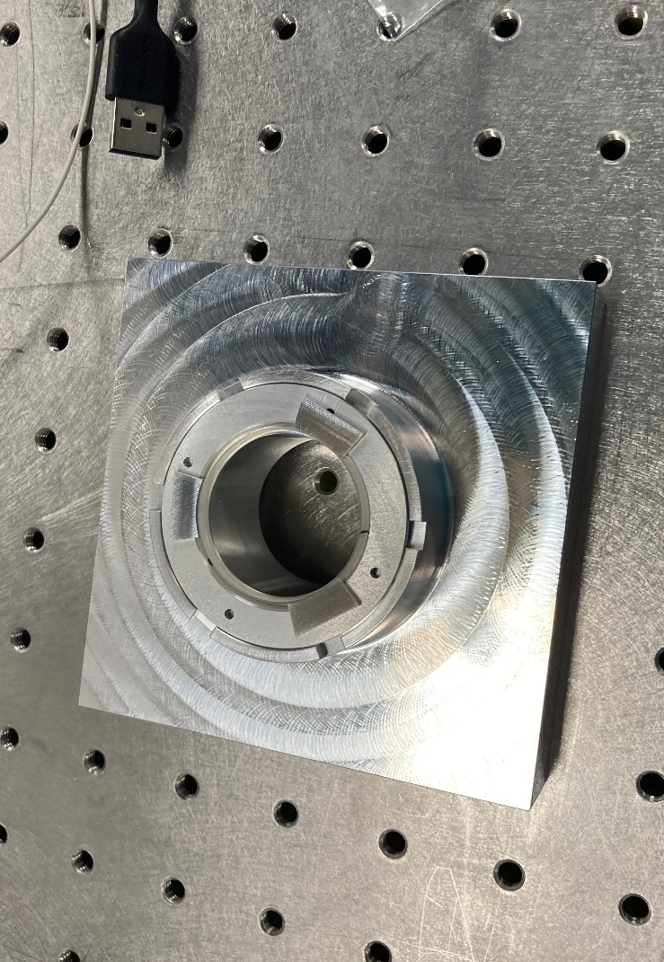

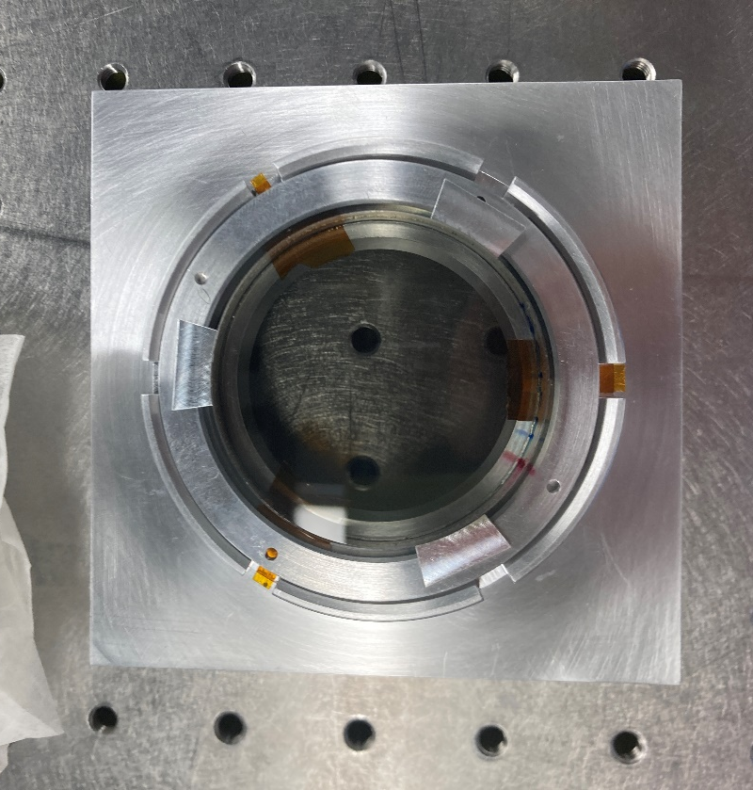

Rotational Alignment Procedure
Procedure from Dr. Steve Tomczyk:

Polarizers
- Remove lower polarizer
- Align the top reference polarizer, and set the KSO polarizer 90 deg from that polarizer

- Rotate in octagonal piece until the minimum voltage is reported, generally it is a good idea to walk through the minimum, then walk back to it once you know what it is

Calcite/Waveplates
- Set bottom polarizer to a minimum
- Then set the optic rotationally to find the minimum voltage through
For KSO, I then Kapton tapped them to the octogon, then on separate jigs used 3M 2216 to adhere the inner ring to the octagon.

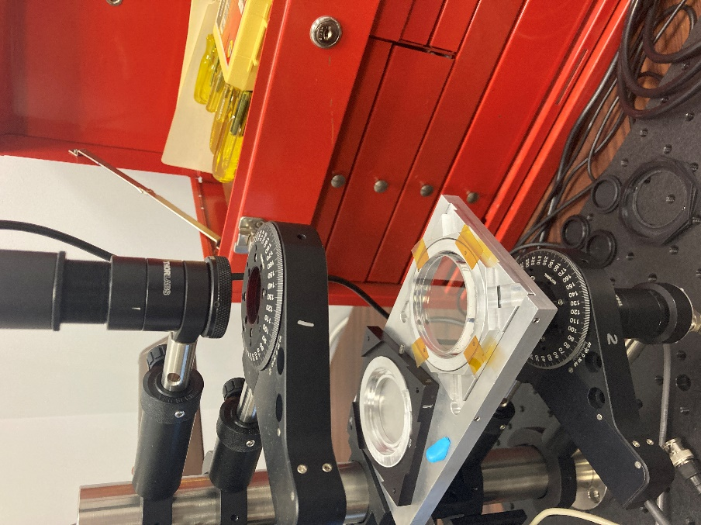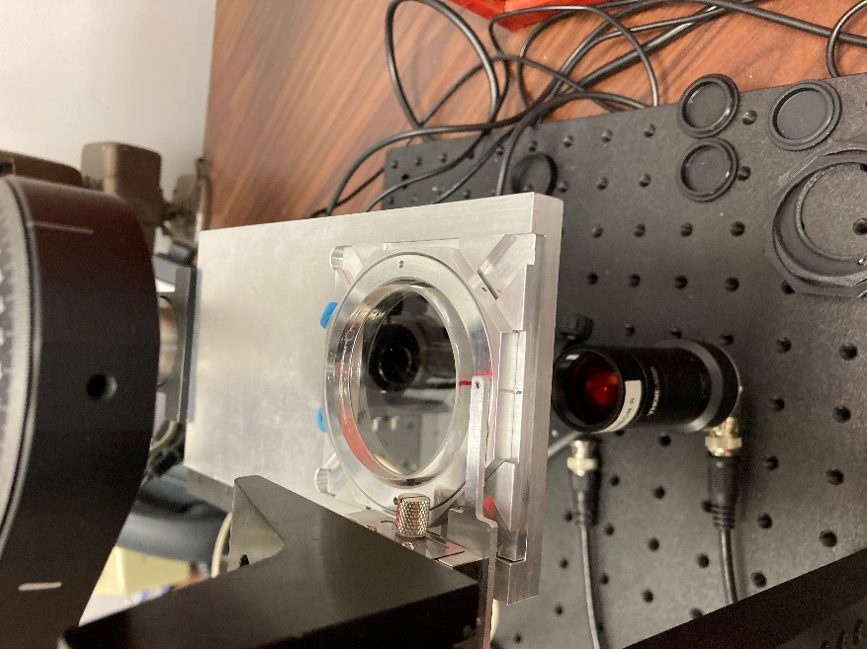
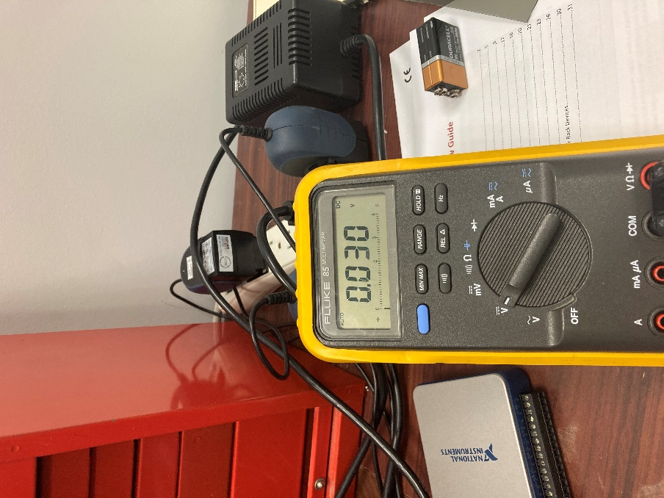

Air Gapped Stages of Lyot Filter
Steve and I then would assembly 1 or 2 stages at a time and confirm the rotational alignment. This did involved realigning and retapping 2 optics due to one pair looking a little oval, but otherwise were happy with the test.
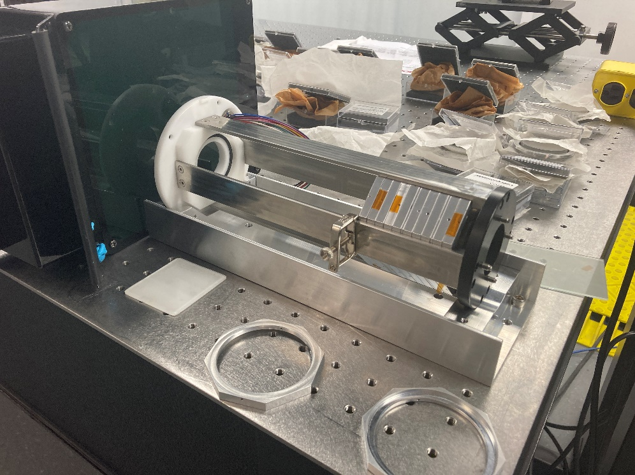
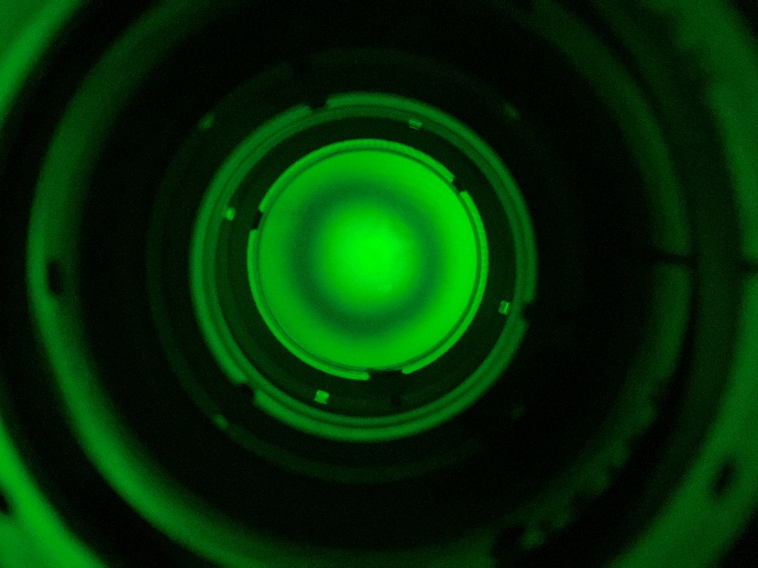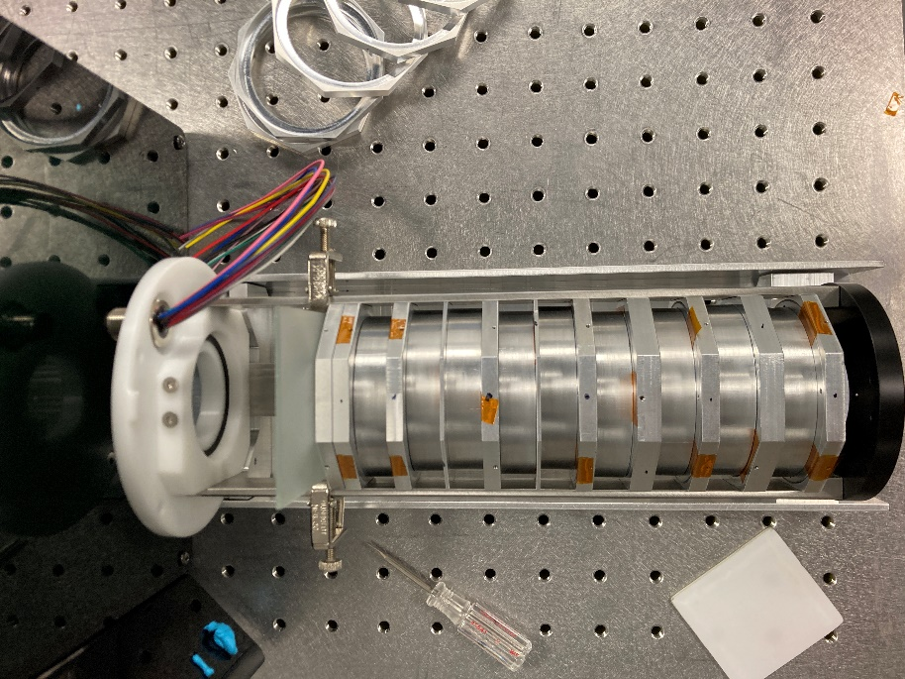

Heater Sleeve and Other Assembly
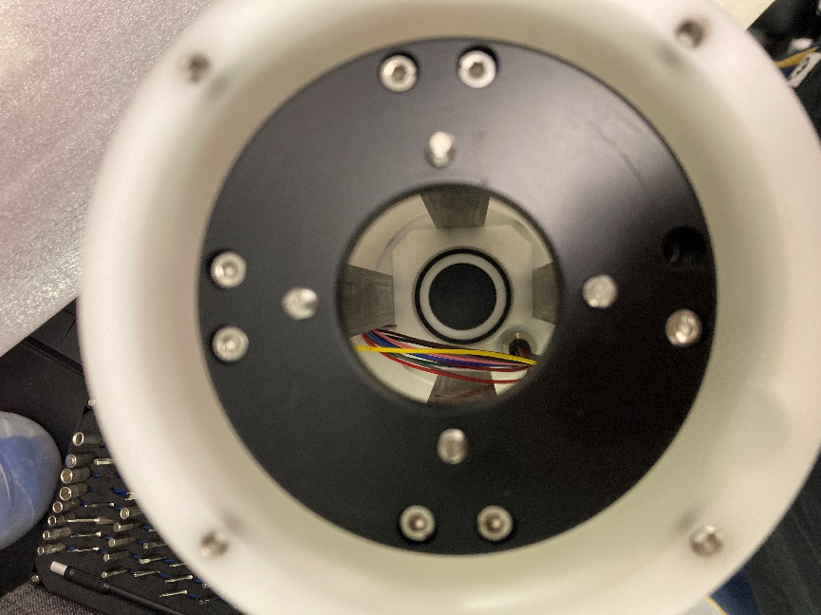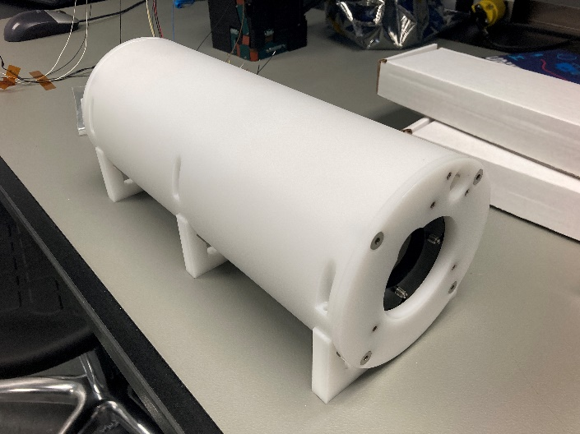
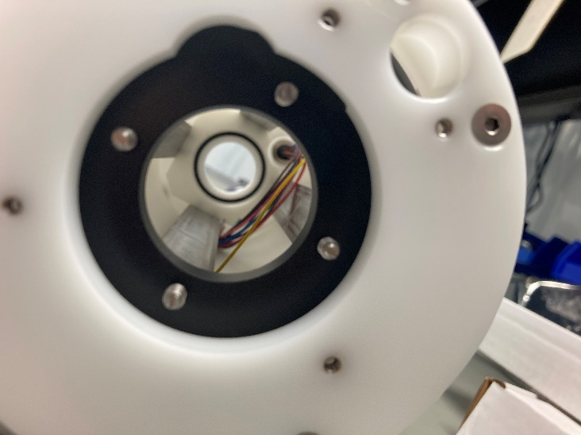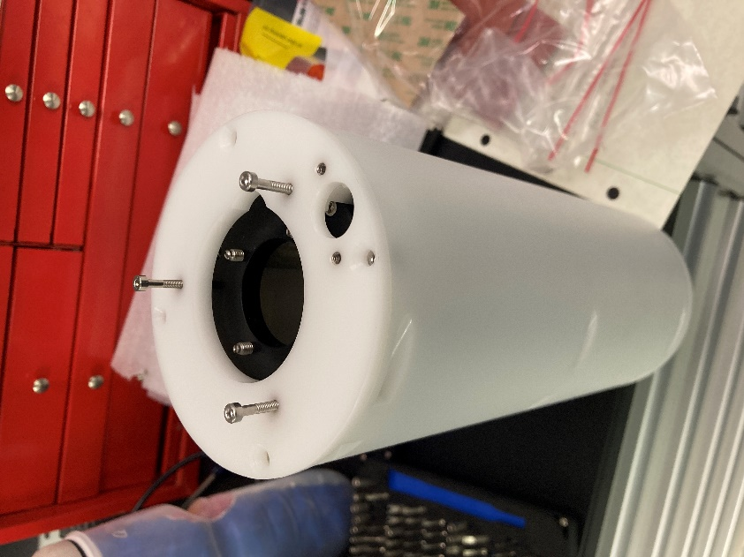

Optical Matching gel/fluid
Procedure generally from Steve and Alfred, some testing had been done with the mcmaster windows
- Set nitrogen tank from 15 to 30 psi, don’t really use the full blast when removing dust from the optics
- Wear gloves and facemask, don’t be creating a lot of particulates
- Peptate if needed, to clean gel/fluid off the optics
- Use lots of cloths and mix of isopropyl and water
- Generally, blow of dust with nitrogen, then clean both sides
- Use gel on fixed optics, fluid on surfaces that still can rotate
- Used OC-452 and OC-440
- Set screw in 3 optics to rotate is a m1.6 L2 92605A711

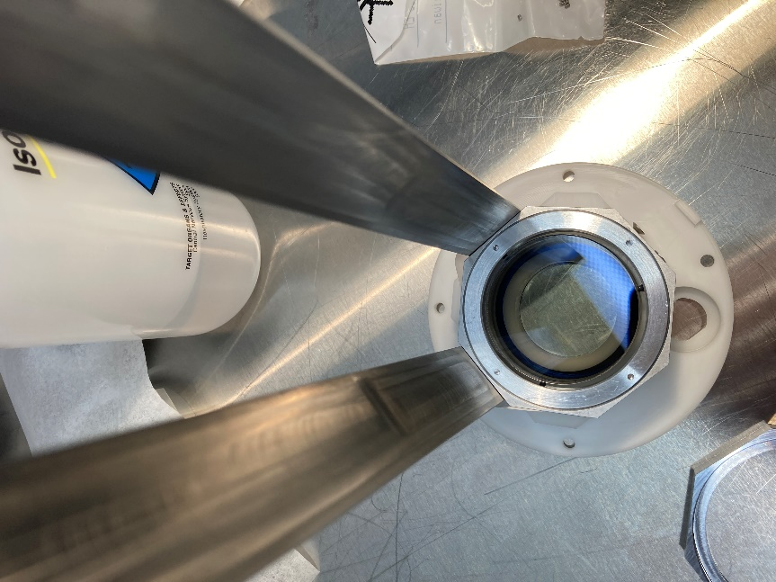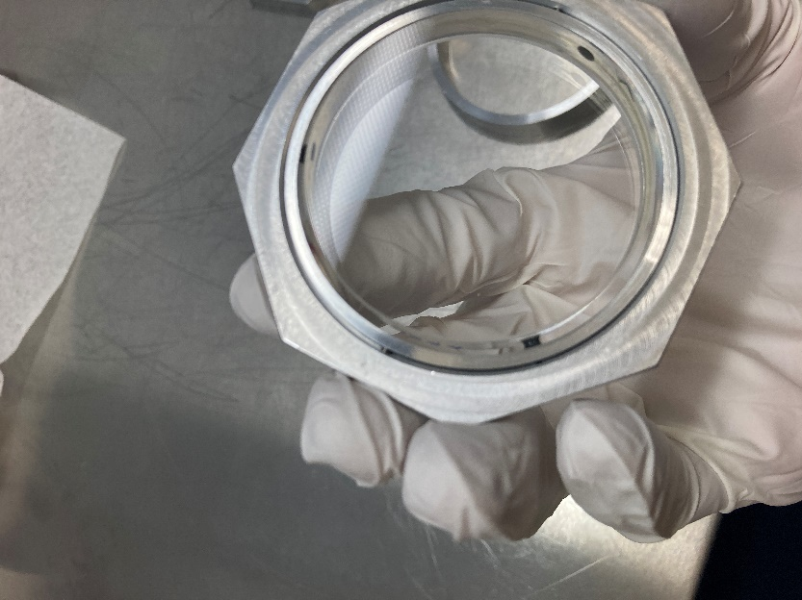
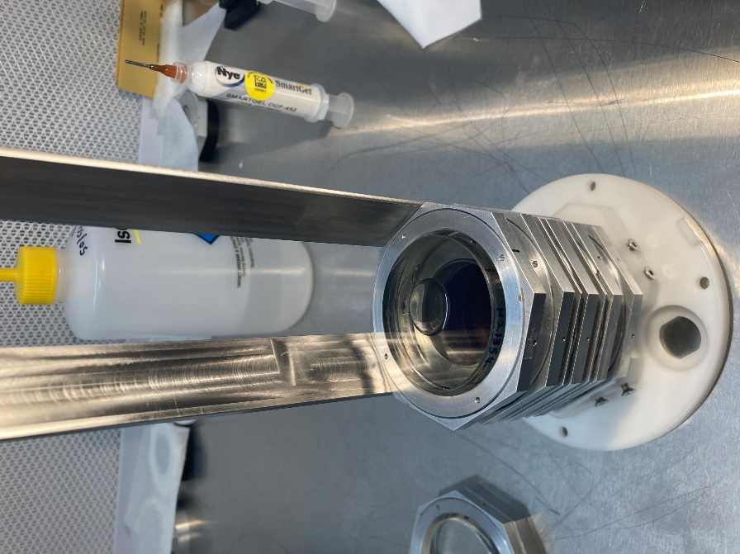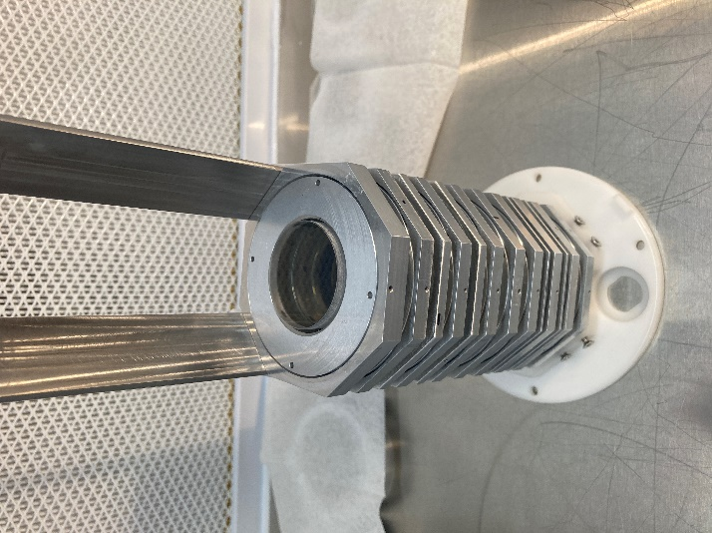

Initial Full Stack Pictures

